2844 - RT – PO - Retrospective Data Updates Options Paper for Consultation

- Executive Summary
Retrospective Data Updates is an industry change, which originated when organisations were seeking an automated solution to help resolve discrepancies they encountered relating to accurate metering and associated consumption data.
Industry processes support correcting metering data prospectively, and certain processes do also support the retrospective correction of meter read and energy data – however asset data cannot be corrected retrospectively, and no central solution exists to automatically calculate and adjust associated charges following identification of such meter asset discrepancies on behalf of customers.
This Options Paper sets out the proposed solution options for consultation with Data Service Contract (DSC) Customers. It’s objective is to allow those organisations to provide consultation responses that can in turn be used to support Xoserve and our customers in reaching a decision on how best to take the change forward.
- Background
As part of Project Nexus, industry participants and Ofgem approved business requirements, business rules and associated legal text associated to delivery of new gas central systems and processes. Included within the scope of this new system and processes was the ability to retrospectively amend asset and supply point data (RAASP functionality) in gas central systems. However, as Project Nexus developed and the design became better understood, Xoserve advised that the functionality required for the introduction of RAASP could not be delivered at the same time as the core Nexus solution. This was outlined as introducing an unacceptable degree of risk to the Nexus Implementation Date.
Therefore Modification 0573 was raised by National Grid Distribution (Cadent) in February 2016 to defer the introduction of the RAASP functionality. Ofgem accepted the proposal for RAASP deferral, resetting the date for implementation of RAASP delivery.
Since the successful introduction of the core Project Nexus, UK Link solution, UNC Request 0624R was raised by Cadent. The Review Workgroup development and consultation activities lead to Modification 0651 – Changes to the Retrospective Data Update Provisions.
This Modification was predicated on a simplified UK Link solution, recommending that an industry wide data cleansing activity be carried out between Xoserve and gas Shippers, in addition to a simplified, enduring data update solution.
Following Ofgem’s decision to approve UNC Modification 0651, a DSC Change Proposal was formally raised – XRN4914 ‘MOD0651 – Retrospective Data Update Provisions.
During the requirements definition phase of this change it became evident that analysis needed to be performed, in order to better inform Xoserve and DSC Customers of the potential data misalignment scenarios and volumes that existed, and to support solutioning of viable data cleanse option. As such, a Proof of Concept (PoC) was commissioned to undertake this analysis and investigative work.

- Proof of Concept and key findings
The Proof of Concept performed an initial (Step 1) ‘Comparison’ phase of data held within UK Link and provided by customers, followed by a further (Step 2) ‘Deep Dive’ analysis phase which sought to establish the root causes contributing to the data misalignment and the relative impact this might pose to a future UK Link solution.
The findings of the Proof of Concept were shared with DSC Customers, and have been appended to this Options Paper for reference. Key findings that were evidenced from the Proof of Concept included;
- Trend between mismatched metering details approx. 1% across portfolio
  - Approx. 100,000 meter data items against sample of 9.5 million MPRNs
- MAM comparison identified further mismatches in Shipper and UK Link data
  - Approx. 50,000 identified against data held in UK Link and Shipper sources
- High proportion of mismatches created within the current Shippers ownership
  - 41% identified as relating to meter activity in current Shippers ownership
  - 28% of mismatches identified where partial updated of meter details have been actioned by the current Shipper
- Billing Critical Analysis remained inconclusive
  - 25% of mismatches identified against billing data items
  - unclear whether these are having a detrimental impact on energy calculation
  - 75% mismatches identified relate to non-billing critical data items
- A high proportion of mismatches were greater than 12 months old
  - Approx. 81% mismatches where identified as relating to metering activity performed greater than 12 months prior to the data extract date
The Proof of Concept exercise supported quantification of the size of an industry data cleansing exercise, including the rules, logic and technology that would need to be in place to support accurate data comparison.

The Proof of Concept analysis found that any enduring Retrospective Data Update solution would not address issues that were identified relating to the alignment and accuracy of asset data activity that feeds into UK Link systems. In addition, the Proof of Concept noted that materiality of retrospective data mismatches remained unclear, and therefore was unable to clarify it what consequential impacts might occur if asset data updates were to be applied into UK Link systems, and how these would need to be managed.

Regardless of the eventual Retro solution, there is an inherent reliance upon customers to find data alignment issues, and construct the relevant data flows to CDSP systems, in order to correct the asset data and energy position – both of which can be addressed to varying degrees by using existing data updates mechanisms.

- Current status and next steps
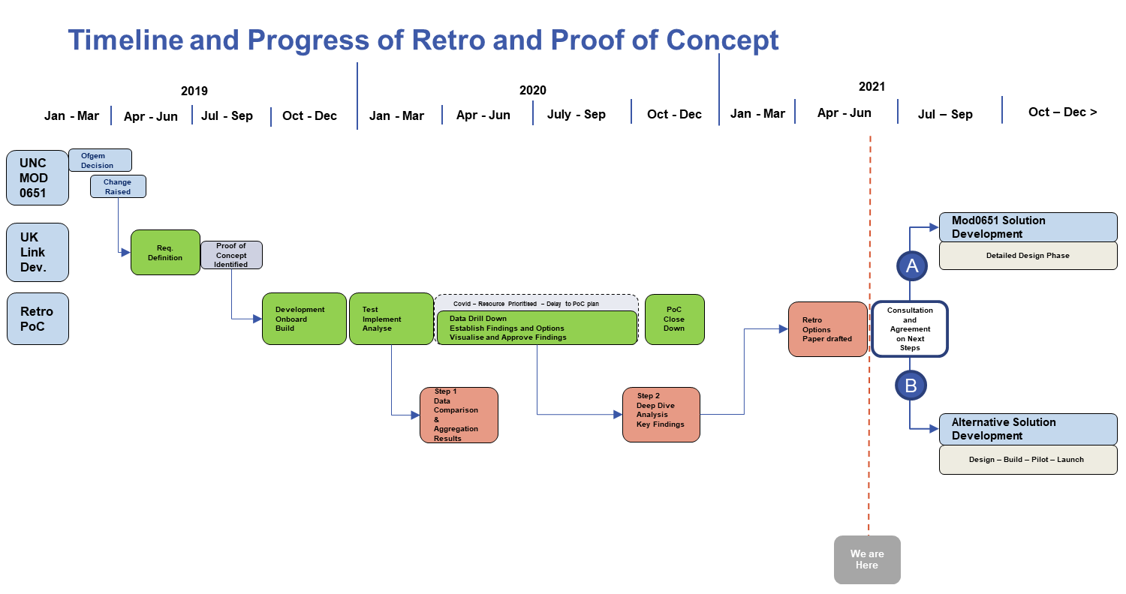
The above timeline illustrates the activities that have been performed to date and highlights the key activities that are being carried out over the coming months.
Xoserve are now consulting on the solution options identified (Options A and B) as detailed within this paper which we feel can support customers to varying levels regarding the challenges of identifying and resolving retrospective data updates.
Xoserve request organisations to provide views and preferences relating to the options presented, and will provide responses to any questions or comments raised as part of the consultation process which will be open for a 15 working day window, commencing on Wednesday 16th June and concluding on Wednesday 7th July
All representations will be collated and shared with DSC Change and Contract Manager members, ahead of a July’s DSC Contract Management Committee where Xoserve will be clarifying responses received and seeking direction on the appropriate actions that need to be taken.

- Option Overview
Option A – Data Cleanse and enduring UK Link Solution
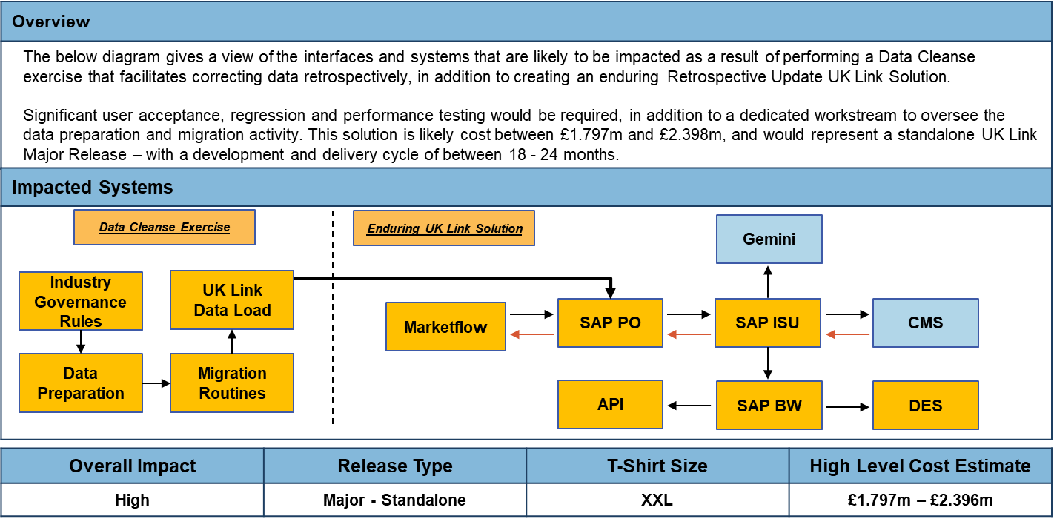
Key Features and Considerations
This option would see a solution aligned to UNC Modification 0651 delivered. This option requires significant development work within the UK Link estate. It would oversee the preparation and cleansing of industry data as part of a Data Cleansing exercise undertaken by Xoserve and Shippers, and would see capability introduced to UK Link that would allow retrospective asset data and energy updates to be supplied by Shippers, and processed within UK Link.
In line with the rules stated within Mod0651, dependencies exist on Shippers to identify occurrences of data misalignment that warrant a Retrospective Data Update Notification and are responsible for identifying the Reconciliation Metered Volumes and Reconciliation Metered Periods, in order for the CDSP to enact an Affected Offtake Reconciliation.
At the time this solution was proposed, it was confirmed that the solution would align to the principles in place for the resolution of Consumption Adjustments, as facilitated through the Contact Management Service (CMS). In the absence of Metered Volume data, the solution would support Shippers by providing an ability to allow correct Meter Asset installation date information to be reflected within UK Link Systems.
It is unclear how the associated consequential impacts following processing of Retrospective Data Update Notifications, most notably those with associated Affected Offtake Reconciliations, should be managed and therefore further design and development of the solution is needed to better understand these impacts and seek decisions on how best to manage such impacts.
Due to CSSC Programme, and related priority industry changes, it is likely that this change would be a candidate for implementation in either a June or November 2023 Major Release. This would be subject to DSC Change Management Committee approval, considering other industry change demand that may arise in the coming year.

Option B – Product Development – Portfolio Analysis and Comparison Service
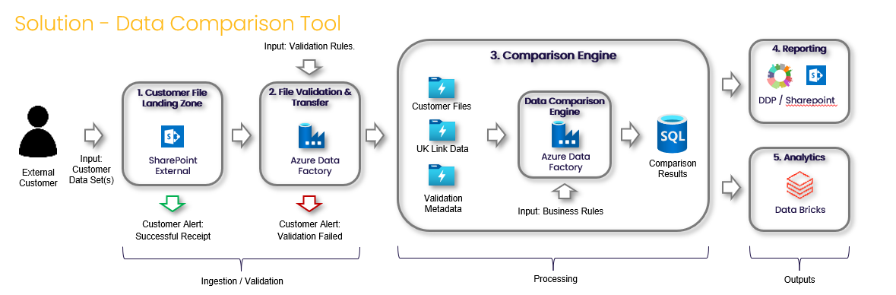
Key Features and Considerations
This option focuses on providing customers with the capability to reconcile data between systems, by providing a service that would allow misalignment, and associated misalignment timescales to reduced, by proactively identifying and tracking data accuracy between the multiple datasets.
Dependent on customers preferred option and direction, work with individual customers could start from in Summer 2021, with delivery timescales being driven by the complexity of customer requirements. Under this option we would work with customers to build out the features of the product and leverage previous development work to support expediating delivery timelines, which are anticipated to run for approx. 6 months.

A subscription to this service will allow Shippers to conduct three (3) data comparison activities for their organisation each year, over a two-year period.
Comparison activities would be scheduled across designated slots, allowing the service to adhere to agreed SLAs and to best accommodate customer demand and the solution capability.
Customers will be provided reporting capability through DDP, affording an aggregated view of comparison results to be presented to customers on completion of each comparison activity performed.
Customers can continue to leverage BAU processes that are in place to update mismatches that have been identified, where the Shipper determines that a Meter Asset update and/or associated consumption adjustment is necessary.

In addition, the product will have the ability to interrogate the comparison results through a data analytics tool if a customer requires a greater level of analysis. This would be an additional service that individual customers can liaise directly with Correla to obtain.
- Option comparison

Assessment Area | Option A – Data Cleanse and enduring UK Link Solution |  | Option B – Product Development – Portfolio Analysis and Comparison Service
 | Key Points | RAG Review | Key Points | RAG Review
Development and Delivery Timescales | - 18 months – 24 months  - Further delay possible prior to Release Scope Approval by ChMC |  | - Approx. 6 months  - Options for customers to trial solution during development as early adopters
Solution Capabilities | - UK Link solution will be improved to offer simplified data update capability  - Allows for Retrospective Data Update Notification to be accepted where Metered Volume and Metered Periods are provided  - Prevents the need to utilise .UPD and Adjustment processes to submit data updates |  | - Offers opportunity to support customers to improve data alignment through existing mechanisms  - Capable of being enhanced to provide additional value add services  - Potential to become integrated into Shipper/Supplier processes
Solution Deliverables | - Adherence to minimum requirements as stated in UNC Mod0651 |  | - Does not deliver against Modification Business Rules
System Impacts | - Complexity of Data Cleanse exercise not defined  - Consequential impacts of data updates and functionality being introduced unknown  - Additional technical and operational performance capability may be needed |  | - Can be progressed independently of UK Link and CSSC changes  - Scheduled approach minimises impacts on performance and offers opportunity to plan data activities in line with customer needs
Benefits | - Achieves relevant objectives as outlined in UNC Mod0651  - Beneficial to Shippers that identify, and subsequently submit, a valid Retrospective Data Update  - The equal and opposite effect of applying a Retrospective Data Update Notification may be felt by other industry parties |  | - Beneficial to those parties that choose to use the service and act on data misalignment findings  - Offers the opportunity to rectify data misalignment within shorter timescales than the UNC Mod0651solution
Solution Costs | - £1.797 – 2.396 Million  - Exceeds remaining Change Budget |  | - £1.1 – £1.2 Million  - Within remaining Change Budget

- governance Requirements
Following the consultation of this Options Paper, Xoserve will seek direction from DSC Customers at Contract Management Committee on how best to proceed with this change.
Should DSC Customers choose to proceed with the original solution option (A), as outlined in Modification 0651, the associated DSC Change Proposal (XRN4914) will be progressed and shall follow the standard DSC Change Management and governance procedures.
If a decision is taken to progress with the alternative option, changes will need to be taken forward to the Uniform Network Code and DSC as necessary.

- Appendices
Step 1 – Comparison Findings

Step 2 – Deep Dive Analysis and Options

Section E: Industry Response Solution Options Review

E1: Organisation’s preferred solution option
User Contact Details: | Organisation: | Northern Gas Networks
 | Name: | Helen Chandler
 | Email: | hchandler@northerngas.co.uk
 | Telephone: | 07580704123
Organisation’s preferred solution option, including rationale taking into account costs, risks, resource etc. | We believe that solution option B is the most cost efficient solution and would deliver industry benefits much quicker than option A, without impacting ongoing CSS delivery.
Implementation Date: | Approve
Xoserve preferred solution option: | Defer
DSG preferred solution option: | Defer
Publication of consultation response: | N/A

E2: Xoserve’ s Response
Xoserve Response to Organisations Comments: | Thank you for your comment. We appreciate the feedback provided on the contents of the options paper. We will look to include this response and feedback, along with all others we have received, to further discuss the matter at July’s DSC Contract Management Committee with all interested parties

E1: Organisation’s preferred solution option
User Contact Details: | Organisation: | Wales & West Utilities Limited
 | Name: | Richard Pomroy
 | Email: | richard.pomroy@wwutilities.co.uk
 | Telephone: | 07812 973337
Organisation’s preferred solution option, including rationale taking into account costs, risks, resource etc. | Option B is better than option A for the following reasons:  1) It delivers benefits much more quickly than option A because it does not require changes to central systems  2) It is much more cost effective  We do not believe that the proof of concept demonstrated that option A was required for the following reasons:  1) metering detail mismatch was only 1%,  2) 75% of data mis-matches were for non-billable items  3) most mismatches occurred while the MPRN was with the same Shipper rather than being inherited from a previous Shipper on change of Registered User.  A further consideration is that option A would also exceed the available budget for this change meaning that further funding would be required to deliver it.
Publication of consultation response: | N/A

E2: Xoserve’ s Response
Xoserve Response to Organisations Comments: | Thank you for your comment. We appreciate the feedback provided on the contents of the options paper. We will look to include this response and feedback, along with all others we have received, to further discuss the matter at July’s DSC Contract Management Committee with all interested parties

E1: Organisation’s preferred solution option
User Contact Details: | Organisation: | Cadent
 | Name: | Andy Clasper
 | Email: | andy.clasper@cadentgas.com
 | Telephone: | 07884113385
Organisation’s preferred solution option, including rationale taking into account costs, risks, resource etc. | Option B is our preferred solution.  It is the more cost efficient solution, delivering benefits much more quickly than Option A. It would not require changes to Central Systems (therefore could be progressed outside of a formal ‘change’ window) so would not be impacted by or impact on the CSS delivery work Xoserve are required to carry out.  The proof of concept which Xoserve started in 2019, in our view, did not demonstrate a compelling business case for the delivery of the more costly and potentially difficult option A i.e metering detail mismatch was only 1%, most identified mismatches (75%) were for non billable items, most mismatches occurred within the same Shippers ownership rather than being created by other Shippers.  In addition Option A would also exceed the available budget so additional funds would be required from industry to progress this option.
Implementation Date: | Approve
Xoserve preferred solution option: | Approve
DSG preferred solution option: | Approve
Publication of consultation response: | N/A

E2: Xoserve’ s Response
Xoserve Response to Organisations Comments: | Thank you for your comment. We appreciate the feedback provided on the contents of the options paper. We will look to include this response and feedback, along with all others we have received, to further discuss the matter at July’s DSC Contract Management Committee with all interested parties

E1: Organisation’s preferred solution option
User Contact Details: | Organisation: | SSE Energy Supply Ltd
 | Name: | Megan Coventry
 | Email: | megan.coventry@sse.com
 | Telephone: | 01738340451
Organisation’s preferred solution option, including rationale taking into account costs, risks, resource etc. | We request more information is provided on each of the options before it's possible for parties to properly impact assess them both. In particular, more detail on how the costings of both options been arrived at is needed. Also, there is not much operational detail within the change pack. Is the assumption that both options will be 100% shipper funded? In addition to a more detailed solution option document, given the importance of this and complex nature of the two options, a dedicated workshop by Xoserve for interested parties would be helpful to explain more about what each option entails/ offer the opportunity to ask questions ahead of parties making their decision on a preferred option.
Implementation Date: | Defer
Xoserve preferred solution option: | Defer
DSG preferred solution option: | Defer
Publication of consultation response: | N/A

E2: Xoserve’ s Response
Xoserve Response to Organisations Comments: | Thank you for your comment. We appreciate the feedback provided on the contents of the options paper. We will look to include this response and feedback, along with all others we have received, to further discuss the matter at July’s DSC Contract Management Committee with all interested parties

E1: Organisation’s preferred solution option
User Contact Details: | Organisation: | EDF
 | Name: | Eleanor Laurence
 | Email: | eleanor.laurence@edfenergy.com
 | Telephone: | 07875117771
Organisation’s preferred solution option, including rationale taking into account costs, risks, resource etc. | We do not support Option B. We believe this is more of a reporting/reconciliation mechanism which we already can do internally and it doesn’t seem to provide us with a retro fix ability which is where the requirement lays.  Regarding Option A – it is unclear without further detail whether this is something that we would support:  - We would need to understand further around what exactly will be possible using this solution/high level requirement.  - We would need to understand further about which industry party would own updates where change in supplier/shipper  - We would need to understand more (at a high level) how this would work in a faster switching world where there may have been multiple shipper changes before an asset data issue is identified  - We would need to understand whether financial adjustments would happen automatically  There may be a further Option C of Do Nothing – depending on the answers to what exactly Option A is delivering and whether this provides the mechanisms we would find beneficial as things have moved on in the industry in the 5 years + that we have been discussing the need for this solution
Implementation Date: | Defer
Xoserve preferred solution option: | Defer
DSG preferred solution option: | Defer
Publication of consultation response: | N/A

E2: Xoserve’ s Response
Xoserve Response to Organisations Comments: | Thank you for your comment. We appreciate the feedback provided on the contents of the options paper. We will look to include this response and feedback, along with all others we have received, to further discuss the matter at July’s DSC Contract Management Committee with all interested parties

E1: Organisation’s preferred solution option
User Contact Details: | Organisation: | EON
 | Name: | Clare Manning
 | Email: | clare.manning@eonenergy.com
 | Telephone: | 07812366727
Organisation’s preferred solution option, including rationale taking into account costs, risks, resource etc. | We do not think there is enough information on what Option A could deliver to be able to make a decision at this point.  For gas, many data discrepancies are down to a missed meter exchange, but currently, if a read has been received after the meter exchange we cannot correct the issue. Is this something that will be addressed as part of this Retro update? Does Xoserve intend to perhaps workshop the options with industry, so that options can be collaboratively developed?
Implementation Date: | Reject
Xoserve preferred solution option: | Reject
DSG preferred solution option: | Reject
Publication of consultation response: | N/A

E2: Xoserve’ s Response
Xoserve Response to Organisations Comments: | Thank you for your comment. We appreciate the feedback provided on the contents of the options paper. We will look to include this response and feedback, along with all others we have received, to further discuss the matter at July’s DSC Contract Management Committee with all interested parties

E1: Organisation’s preferred solution option
User Contact Details: | Organisation: | NG Transmission
 | Name: | Richard Loukes
 | Email: | RICHARD.LOUKES@NATIONALGRID.COM
 | Telephone: | +447342085565
Organisation’s preferred solution option, including rationale taking into account costs, risks, resource etc. | To be clear National Grid gains no benefit from either option as there are no impacts (positive or negative) to either Gemini or National Grid processes.  National Grid Gas would prefer to see further information on each of the options, costs and funding arrangements provided in order to make an informed decision at DSC Contract Management in order to support the industry as a whole.  This decision has been some years in the making perhaps take the opportunity to reflect on industries current requirements via a dedicated workshop(s) whereby each party is able to share their views and come to a joint pragmatic decision.
Implementation Date: | Defer
Xoserve preferred solution option: | Defer
DSG preferred solution option: | Defer
Publication of consultation response: | N/A

E2: Xoserve’ s Response
Xoserve Response to Organisations Comments: | Thank you for your comment. We appreciate the feedback provided on the contents of the options paper. We will look to include this response and feedback, along with all others we have received, to further discuss the matter at July’s DSC Contract Management Committee with all interested parties.

E1: Organisation’s preferred solution option
User Contact Details: | Organisation: | Corona Energy
 | Name: | Emily Wells
 | Email: | emily.wells@coronaenergy.co.uk
 | Telephone: | 07525403589
Organisation’s preferred solution option, including rationale taking into account costs, risks, resource etc. | From the two options put forward, we would have a preference for Option B. However, we do think that Option B also has its limitations, and question whether there is an industry need for this to go ahead at all.  Option A is hugely expensive, is over budget and would need to be funded, plus has a significant lead time before delivery would be possible. Given the Switching Programme changes, and numerous system changes required by both central systems and individual shippers, delivering within 24 months feels ambitious. We do not feel that this level of investment is cost effective given the level of mismatch identified by the proof of concept. Whilst there is a lot of the detail to be worked out, the possibility of the equal and opposite effect being felt by a Shipper when an update is actioned by another Shipper needs careful consideration as to how this would be communicated and given an opportunity to challenge, to mitigate the risk of bill shock after a customer has left supply and possibly no option to recover the cost. We also think that there is potential for an as yet unknown impact on to UIG volatility.  Option B would give xoserve a central view as to the data discrepancies in the industry and the driver behind shipper updates. However, it is lacking in detail and to what additional value will be achieved against the cost of delivery. The data comparison / analysis can already be completed by Shippers based on data already provided by xoserve, and make the updates by existing BAU processes.
Implementation Date: | Reject
Xoserve preferred solution option: | Reject
DSG preferred solution option: | Reject
Publication of consultation response: | N/A

E2: Xoserve’ s Response
Xoserve Response to Organisations Comments: | Thank you for your comment. We appreciate the feedback provided on the contents of the options paper. We will look to include this response and feedback, along with all others we have received, to further discuss the matter at July’s DSC Contract Management Committee with all interested parties

E1: Organisation’s preferred solution option
User Contact Details: | Organisation: | Scotland and Southern Gas Networks
 | Name: | Sally Hardman
 | Email: | sally.hardman@sgn.co.uk
 | Telephone: | 07970019027
Organisation’s preferred solution option, including rationale taking into account costs, risks, resource etc. | Preferred solution Option B  We believe that Option B would provide a cost-effective solution that can be delivered much earlier than Option A with no impact on Central Systems and no additional funding.  As part of the Proof of Concept (POC) carried out by Xoserve with the support of Shippers in 2019/2020, we believe that the findings did not support the requirement for a costly multifaceted systematised solution. The POC identified that most mismatches (75%) were concerning non-billable items and MPRN mismatches occurring within the same shipper within the data set.  Option A provides inherent risks as are to be expected with a large (XXL) project in addition to the current unclear consequential impact to central systems processes which could ultimately lead to increased errors.
Implementation Date: | Approve
Xoserve preferred solution option: | Approve
DSG preferred solution option: | Approve
Publication of consultation response: | N/A

E2: Xoserve’ s Response
Xoserve Response to Organisations Comments: | Thank you for your comment. We appreciate the feedback provided on the contents of the options paper. We will look to include this response and feedback, along with all others we have received, to further discuss the matter at July’s DSC Contract Management Committee with all interested parties

E1: Organisation’s preferred solution option
User Contact Details: | Organisation: | Gazprom
 | Name: | Steve Mulinganie
 | Email: | Steve.mulinganie@gazprom-energy.com
 | Telephone: | 07990972568
Organisation’s preferred solution option, including rationale taking into account costs, risks, resource etc. | We support option A  Only one option A – Data Cleanse and enduring UK Link Solution delivers the intent of the Modification 0651 raised in March 2018 and approved for implementation by Ofgem in March 2019.  Consideration of any other Option other than A is non-compliant with the Modification 0651 that was implemented by Ofgem on the 14 March 2019 over 2 years ago!  https://www.gasgovernance.co.uk/0651  We are not aware of another scenario were an industry Modification once approved by Ofgem has been given solution options some of which do not comply with the Business Rules in the Modification?  We would therefore question the viries for a proposal containing options that do not deliver the intent of the modification business rules. Only Option A adheres to the minimum requirements as stated in Mod 0651.
Implementation Date: | Having delayed delivering the benefits since NEXUS go live and for the last 2 years and 3 months we would expect delivery to be prioritised and delivered ASAP
Publication of consultation response: | N/A

E2: Xoserve’ s Response
Xoserve Response to Organisations Comments: | Thank you for your comment. We appreciate the feedback provided on the contents of the options paper. We will look to include this response and feedback, along with all others we have received, to further discuss the matter at July’s DSC Contract Management Committee with all interested parties

Version control
Version | Status | Date | Author(s) | Remarks
1.0 | Approved | 16/06/21 | Paul Orsler | Final version - Approved

