Xoserve Services Portal – XRN 5040 Information Pack
Overview
Following the Change Pack for this project that was issued to yourselves earlier in June this year, we would like to provide further information about roll out of this change.
This document prepared with a running assumption that mid of April 2022 is the go-live date for this change.

User Migration Activities & Support
- Current UK Link Portal users will be migrated to the Azure hosted Portal nearer to the release.
- Point of contact related to the user migration and access issues will be communicated in the Business readiness pack.

User Preparation
- A password reset for the new UK Link Portal will be required for all users when user login for the first time, so you will receive a temporary password to your email address one week in advance of go live date by a system generated email.
- Please ensure that you have received this email and check your Junk Folder before contacting the helpdesk for assistance.

User Login (Go Live Day)
- User will need to enter the temporary password on the login screen, as per the screenshot below, and this will prompt you to create a new password.
- Password here should be the temporary password provided in email.
- New Password should align to the below password policy.

- UK Link Portal Password Policy applies to all account types including privileged users (LSOs).
- Password must be at least 14 characters.
- Password must contain 4-character types one from each of the following –
- uppercase alphabet characters,
- lowercase alphabet characters,
- numbers – Base 10 digits (0-9),
- Non-alphanumeric characters (symbols like £, $, # and etc).
- Account locks out after 5 failed attempts.

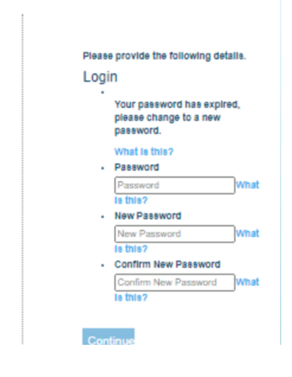
- Once the New Password has been created successfully, all users will be prompted for Multi Factor Authentication (MFA) by Email. User press the ‘Send verification code’ button.

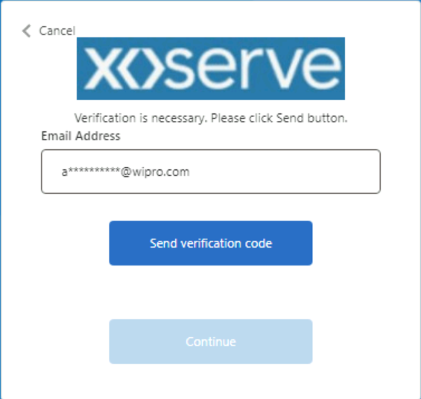

- The verification code will be delivered to the email address. User enters the code received via email in the verification code input box.

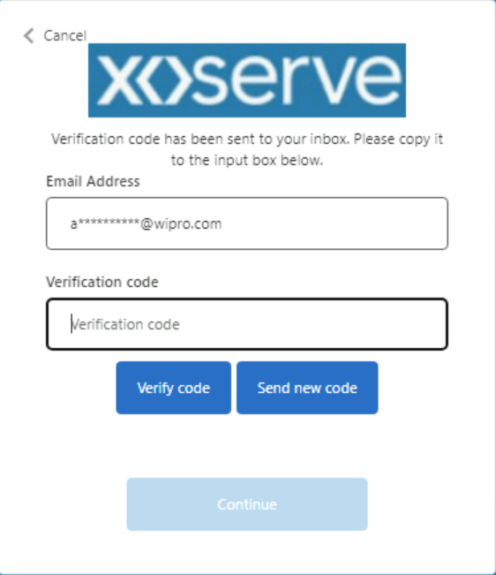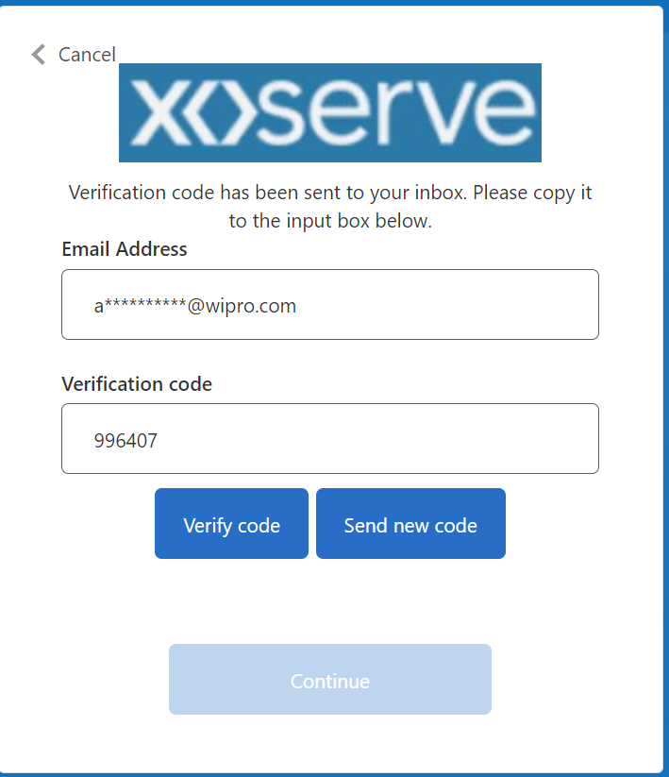

- Once the code has been validated successfully, user gets a message confirming that their email address is verified. User press the Continue button.

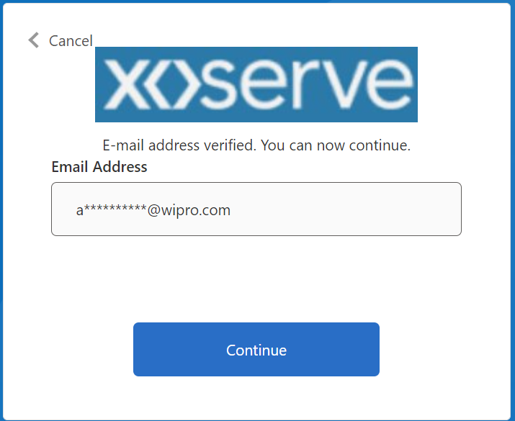

- User will have gained access to the UKLink Portal based on their authorised role.

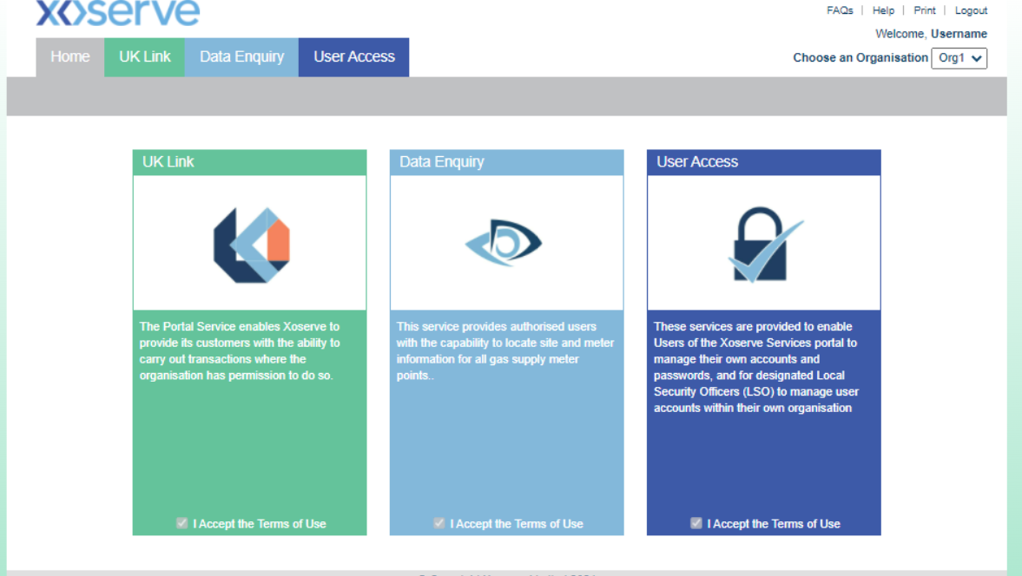

Login Screen Changes

After the password is created, from the next time on wards, user login to the portal using the portal login screen. Portal login screen will look very similar to the current screen apart from the minor changes highlighted here.
- User Name
The Username field is changed to Email Address
- Forgot My Password
Forgot My Password link is changed to Forgot your password and placed next to Password field
- Login
Login button is changed to Sign in
- Terms and Conditions, Privacy Notice
The Terms and Conditions check box is removed and the Terms and Conditions link has been added in the left block.

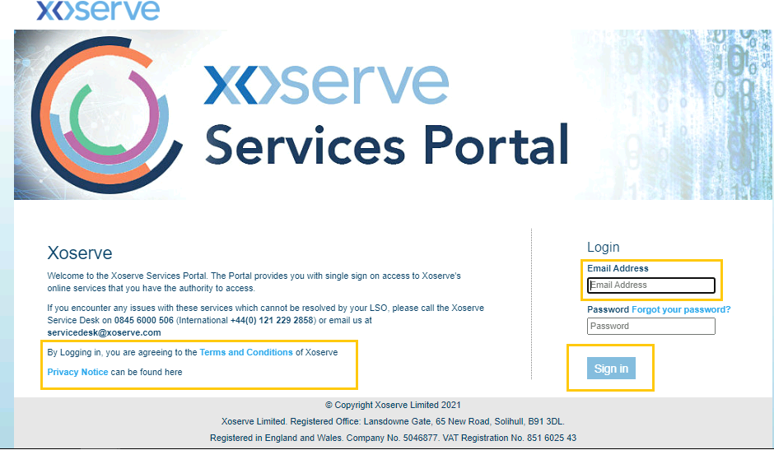

Single Identity and Multiple Role Access Changes

- Single Identity –Users will now have a single identity based on their corporate email address for UK Link Portal Services.
- Multiple Roles - Multiple user accounts held by a user have now been combined into a single user account.
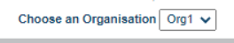

- User with multiple roles can select a role from a dropdown list in the landing page.

Password Reset
- User will be required to reset their password from time to time and will receive a password reset prompt as a reminder.
- The updating of this policy will allow password reset self-service by individual users rather than an admin function.
- To reset password, use the “Forgot your password” link on the Portal login page.

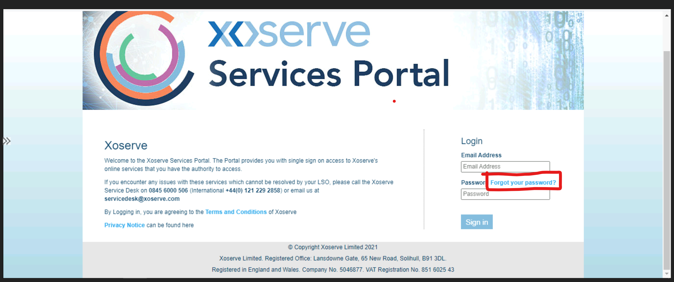

- Enter your email address in the pop-up box that appears, as per below, to initiate the password reset process.
- Your email address will then be verified in the system, a security measure, to ensure you are a valid user and a verification code will be sent to your email address.

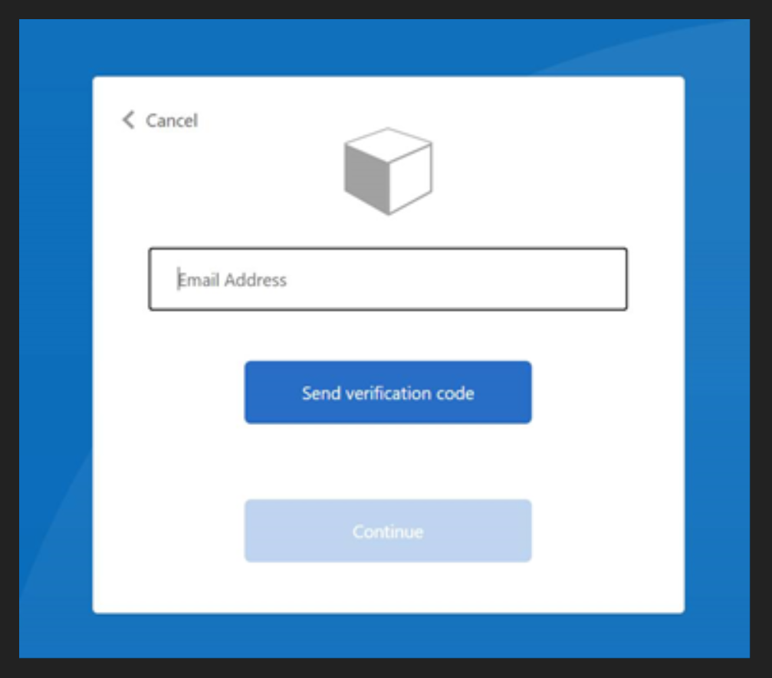

- To verify your email address, enter your email address in the top field and the verification code into the bottom field in the pop-up box as shown below and press Verify code.
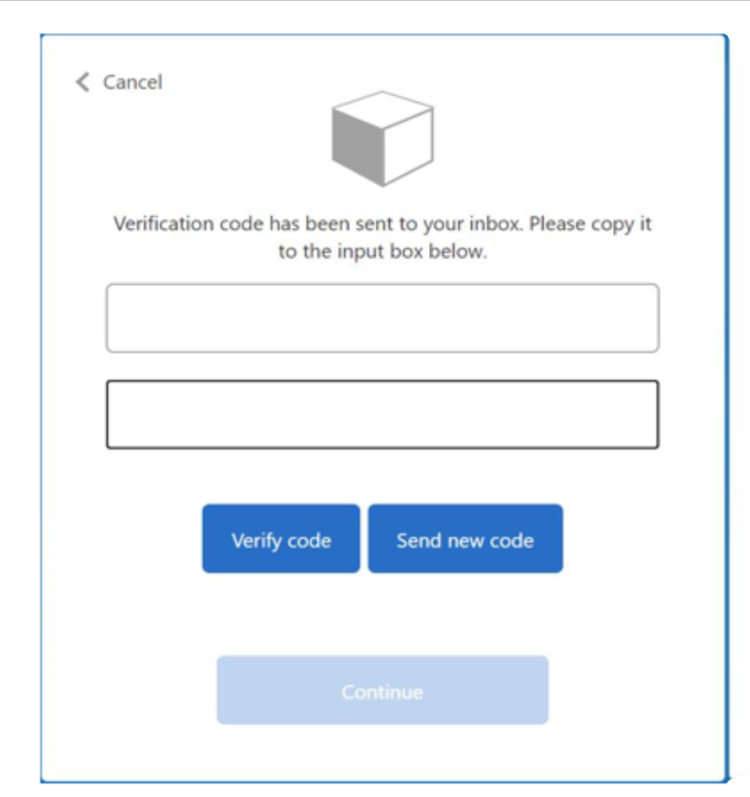
Enter Verification Code here
Email address

- Once this code has been successfully verified, the below pop up screen with your email address pre-populated, will appear for you to be able to continue.

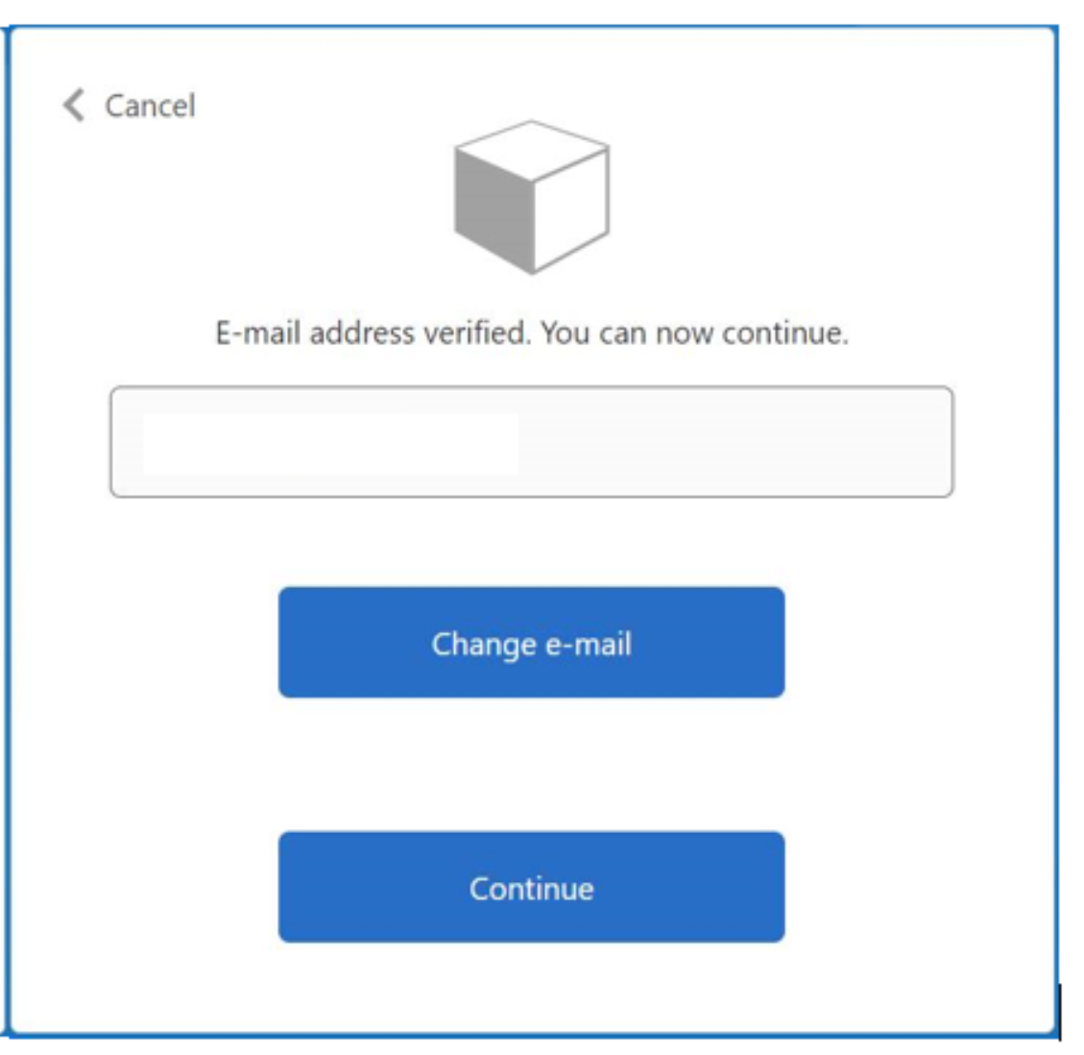
john.smith@xoserve.com

- Enter your new password and confirm the same in the second field, press Continue.
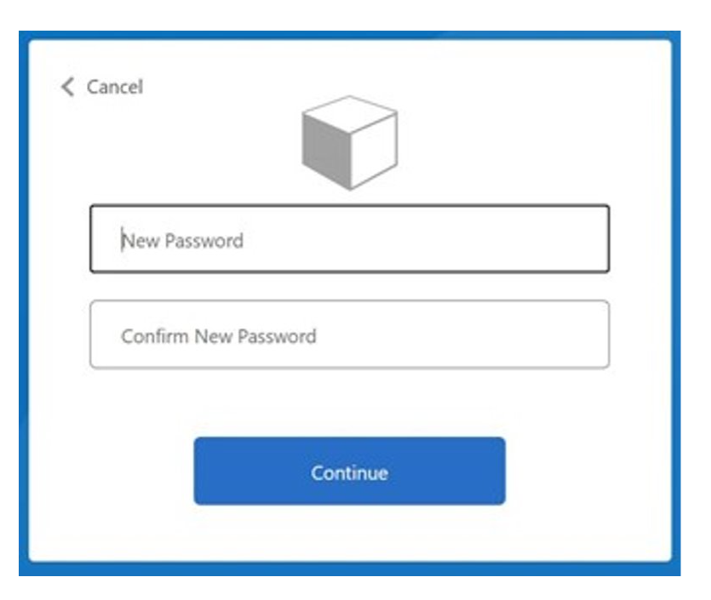

- Once the password is successfully reset, you will be returned to the Xoserve Services Portal login screen so that you may now enter the Portal.

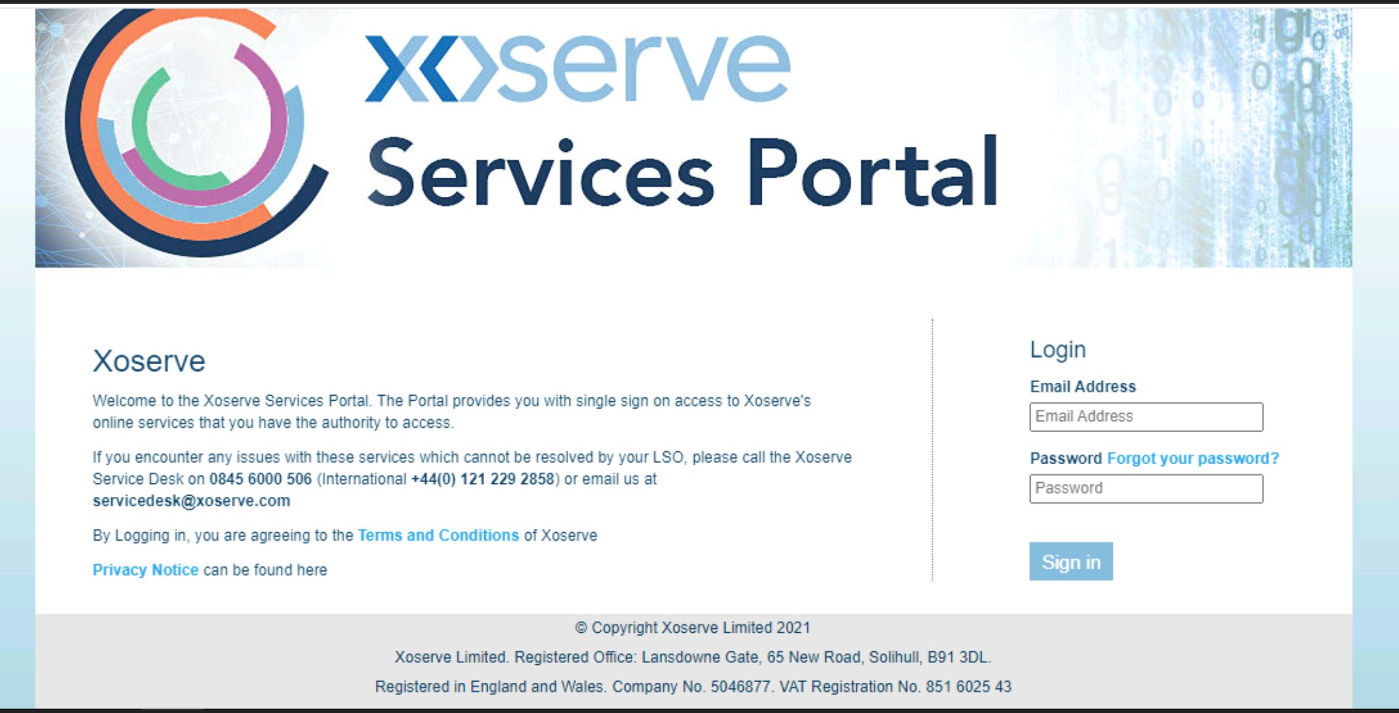

Validation Messages
- Validation messages in the Portal will be displayed as Toaster messages at the bottom right side of the screen.
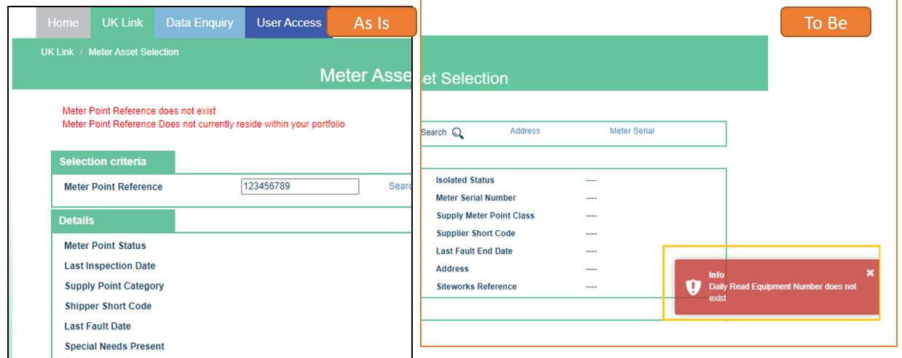

- If any of the field data is not available on the screen, it will be displayed with “---” to maintain the field alignment in the two-column layout.

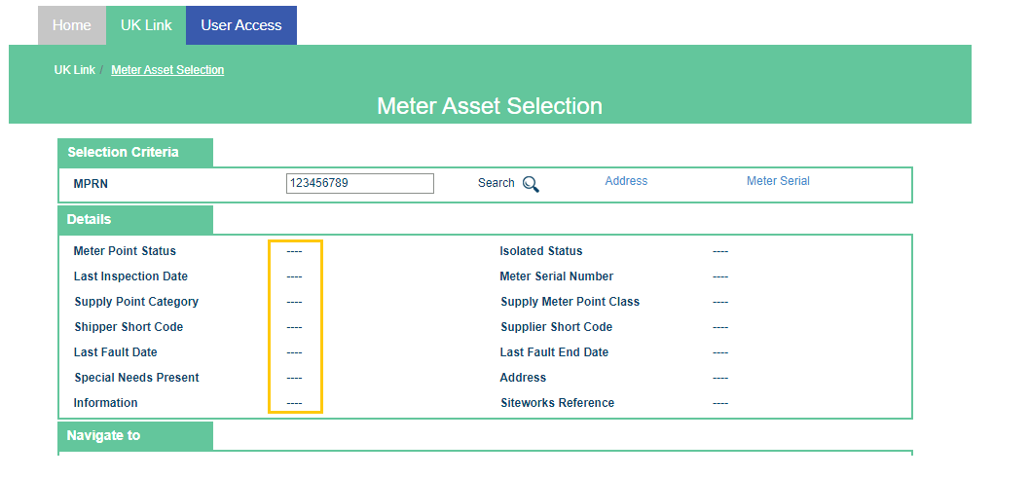

FAQ
A FAQ, frequently asked questions page has also been included here to help answer any questions that may arise from this change.
Link to FAQ

Section H: Representation Response

«RangeStart:HDS»
H1: Change Representation
(To be completed by User and returned for response)

Please consider any commercial impacts to your organisation that Xoserve need to be aware of when formulating your response

User Contact Details: | Organisation: | «h1_organisation»
 | Name: | «h1_name»
 | Email: | «h1_email»
 | Telephone: | «h1_telephone»
Representation Status: | «h1_userDataStatus»
Representation Publication: | «h1_consultation»
Representation Comments: | «h1_userDataComments»
Confirm Target Release Date? | «h1_targetDate» |  | «h1_userDataAlternative»

H1: Xoserve’ s Response
Xoserve Response to Organisations Comments: | «h1_xoserveResponse»

Please send the completed representation response to uklink@xoserve.com

«RangeEnd:HDS»

