Section G: Change Pack

G1: Communication Detail
Comm Reference: | 2944.2 - RT - PO
Comm Title: | XRN5368.2 Gemini Single Sign-On Design
Comm Date: | 13/12/2021

G2: Change Representation
Action Required: | For Representation
Close Out Date: | 29/12/2021

G3: Change Detail
Xoserve Reference Number: | XRN5368.2 (Delivery Reference)
Change Class: | Non-Functional
ChMC Constituency Impacted: | Shippers, Distribution Network Operators, NG Transmission
Change Owner: | Manisha Bhardwaj on behalf of National Grid
Background and Context: | The Gemini IT system underpins the commercial gas transmission regime and accounts for all capacity and energy transactions. It is owned by National Grid with technical support provided by Xoserve under the Data Services Contract.  National Grid have a commitment to customers and Ofgem to maintain compliance with the UNC and ensure that Gemini meets the needs of its users. Over the last few years, various projects have been completed to focus on system upgrade and enhancements in order to respond to the user feedback.  Under the Gemini Change Sustain portfolio, Gemini Single Sign On delivery is responding to one of the key pain points and is planned to address the pain point associated with 2 stage Gemini Online Login In process. Along with this the project will deliver 2 other improvements to meet customer expectations.

G4: Change Impact Assessment Dashboard (UK Link)
Functional: | None
Non-Functional: | Gemini Online Screen Access, Access over internet via XP1 Tokens
Application: | Gemini
User(s): | Shipper, DNs, NTS, Xoserve and / or Gemini System Users
Documentation: | NA
Other: | NA

Files
File | Parent Record | Record | Data Attribute | Hierarchy or Format  Agreed
NA | NA | NA | NA | NA

G5: Change Design Description
What is the change

The following key changes are being made as part of the project: Single Sign - On Delivery

Introduction of:

- Single Sign On via existing Gemini Citrix IDs to delivery SSO

  - Pre-Requisite: Users are expected to have matching Citrix and Gemini IDs for Single Sign On functionality to work
  - Those users who access the Gemini system via Gemini Citrix gateway will experience a single sign on login process via their existing enabled IDs, eliminating the need to log in to Gemini via separate credentials
  - Where the existing Citrix and Gemini online IDs match these will go through one on one mapping
  - Please note: Single Sign on will be available over both internet and IX routes via Gemini Citrix Gateway

- Multi Factor Authentication (MFA) via Authentication App over the internet

  - Pre-Requisite: An android or IOS based phone is required for this authentication to support either Google or Microsoft authenticator
  - The MFA solution will publish Gemini over the internet and provide an alternate access route to reduce dependency on the existing IX Link for the Gemini Citrix Log In page
  - This solution is also being introduced to simplify the alternative access route and keep the system access in line with the industry security best practices
  - New Gemini Citrix URL will be published over the internet in addition to the existing IX based URL
  - Please ensure Citrix Receiver version 1809 or above is installed on your device to allow compatibility

- Self-Serve Password Reset facility for Gemini online screen users

  - In addition to the above, internet-based self-serve password reset facility is planned to be introduced for the Gemini Citrix users.
  - With this facility Gemini Citrix users will be able to re-set their password themselves in the event of a password expiry or a lock out via the Citrix home page
  - Please note: there is a key dependency on enabling MFA access (over the internet route) to benefit from this feature (as this will be part of new URL being published over the internet access route)

Removal of XP1 token support:

  - The XP1 tokens are utilised to access Gemini system over internet as a current contingency method for online screen users
  - The support for existing XP1 tokens will be ceased at the end of June 2022, as this is being replaced by the introduction of MFA as an alternate route
  - Once the tokens expire, these will not be renewed and can be disposed by the users who currently use these

Key information

In order to ensure the Single Sign-On Option meets the security best practises, the following activity is planned:

- There is likely to be a change in the password policy associated with Gemini Citrix IDs to meet minimum security best practise standard as per the existing password policy (please refer to the appendix)
- There will be One on One mapping between Citrix IDs and Gemini online IDs, with this in mind:
  - Where the Gemini Citrix IDs do not have associated Gemini Online access ID, these IDs will be deleted from the Citrix System
  - Where the Gemini Online Screen user IDs do not have matching Citrix IDs, these users will not be able to access the system unless additional Citrix ID has been created and the mapping has been completed as part of this delivery

Additional considerations for this change:

- To ensure access issues are not experienced post Go Live, all Gemini online screen users are requested to take the following actions:
  - Contact the project team to request Citrix ID creation (if you do not currently have one) for mapping with their existing Gemini online log in IDs no later than 11th February 2022
  - For the small number of accounts, that we are aware do not have matching Citrix IDs we will contact the organisations via their nominated LSOs and / or Contract managers, please look out for an email from the project team for this specific scenario
- The URLs for internet-based access and access via OTP (One-time Password) will be different to the existing IX access URLs
- Look and feel changes are likely to be experienced for example, there will be an additional button on Gemini Citrix Log in page for self-serve password re-set over MFA
- There may be an extended outage on the Gemini System for implementation activities on 24th April
- User Training and Trials are scheduled from 21st February to 25th March ’22. Last week of this phase will only be used for re-test and completion activities please contact the project team should you wish to participate
- If you have any queries, please contact geminichanges@correla.com box account for further information.

Appendix:

Snippet from the existing password policy:
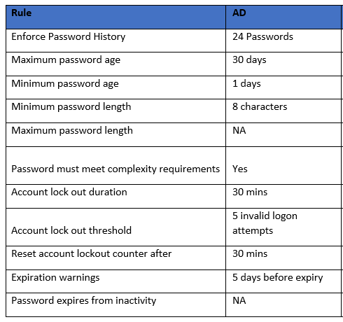

G6: Associated Changes
Associated Change(s) and Title(s): | XRN5368 Gemini Change Programme - Sustain

G7: DSG
Target DSG discussion date: | Click here to enter a date.
Any further information:

G8: Implementation
Target Release: | Release: 24th April ‘22
Status: | For Approval

Please see the following page for representation comments template; responses to uklink@xoserve.com

Section H: Representation Response
«RangeStart:HDS»
H1: Change Representation
(To be completed by User and returned for response)

Please consider any commercial impacts to your organisation that Xoserve need to be aware of when formulating your response

User Contact Details: | Organisation: | «h1_organisation»
 | Name: | «h1_name»
 | Email: | «h1_email»
 | Telephone: | «h1_telephone»
Representation Status: | «h1_userDataStatus»
Representation Publication: | «h1_consultation»
Representation Comments: | «h1_userDataComments»
Confirm Target Release Date? | «h1_targetDate» |  | «h1_userDataAlternative»

H1: Xoserve’ s Response
Xoserve Response to Organisations Comments: | «h1_xoserveResponse»

Please send the completed representation response to uklink@xoserve.com

«RangeEnd:HDS»

