Section G: Change Pack

G1: Communication Detail
Comm Reference: | 2955.6 – MT – PO
Comm Title: | XRN5463 – Technical Debt reduction- Prime and Sub process enhancement – Detailed Design Change Pack
Comm Date: | 17/01/2022

G2: Change Representation
Action Required: | For representation
Close Out Date: | 31/01/2022

G3: Change Detail
Xoserve Reference Number: | XRN5463
Change Class: | Functional System
ChMC Constituency Impacted: | Shipper Class A; Shipper Class B; Shipper Class C
Change Owner: | James Barlow  james.barlow@xoserve.com
Background and Context: | Technical Debt reduction is an internal project managed within Technology Operations under ‘UKLink Optimisation’. The core objective is to reduce any technical debt around system, process or resource to effectively utilise these savings towards the fulfilment of UK Link system stability, reduce risk in daily operations and drive operational enhancements as required.  Due to the nature of the change, the solution and design are presented together in this Change Pack. For reference the Change Proposal can be viewed here.  Currently, there are two scenarios in the Prime and Subs site process where the Prime net-off may not be accurate or completed in a timely manner, these are:  - When a sub site is Isolated, consumption of the isolated sub site is not taken into account for the net-off calculation which then feeds into downstream processes such as Reconciliation and AQ calculation  - Read replacement on sub sites does not trigger re-reconciliation. Net-off consumption should be re-calculated for the prime sites based on the read replacement on sub sites.  These scenarios are currently manually monitored and corrective actions taken accordingly. However, delays in manual resolution could impact timely reconciliation of Prime & Sub meter points.  This change seeks to enhance the reconciliation process for Prime &  Sub sites within the CDSP central systems to remove the need for  manual monitoring and data correction. Delivery of this change  proposal will address the problem scenarios as defined within the  problem statement.

G4: Change Impact Assessment Dashboard (UK Link)
Functional: | Meter Readings; Reconciliation; RGMA transactions
Non-Functional: | None
Application: | SAP ISU
User(s): | Shipper Class A; Shipper Class B; Shipper Class C
Documentation: | None
Other: | None

Files
File | Parent Record | Record | Data Attribute | Hierarchy or Format  Agreed
MBR | None | M03 | Reason Code – Description only | File Format

G5: Change Design Description
Scenario 1 – Meter Isolation at a Sub Site
Where the metering is isolated at a sub site this change will ensure that estimated coterminous reads are generated, by the CDSP, on the related sub sites to allow the net off calculation/reconciliation of the Prime Site to be completed on time.

The coterminous reads generated by the CDSP will be issued to the respective Shipper User(s) within the M03 record of the MBR file. These will have a Read Reason Code of ‘CYCL’ and Read Type of ‘E’ (As per existing process – No Change)

There will be the need for a documentation only change to the M03 record format to provide clarity on when the Reason Code of ‘CYCL’ can be used with a Read Type of ‘E’. For the avoidance of doubt, there is no change to the M03 record, nor to the MBR file format, as this is already a valid combination. As per the attached, proposed, version of the M03, the Reason Code description will be updated as highlighted in red:
-----------------------------------------------------------------------
The reason why the read was taken.
VALUES:

CYCL – Cyclic Reads, Actual or Estimated, (Prime & Sub Reads) / Estimated Read for Confirmation Effective Date in Back Billing Processes

MRUN – Must Reads

OPNN – Install Opening Read
OPNX – Exchange Opening Read
OPNT – Estimated opening Read (Transfer)
FINX – Exchange Final Read
FINT – Estimated final read (Transfer)
FINC – Final Remove Read
FICC – Final Class Change Read (Same Shipper)
LDEX - Estimated read for LDZ or Exit Zone Change
LISR –Line In Sand Read (Code Cut Off )
-----------------------------------------------------------------------

Link: M03 BILLREADS V12FA

Scenario 2 – Read Replacement for a Sub Site
This change will ensure that the net off calculation of a Prime Site is triggered when a read is successfully Replaced on a related Sub Site.

There will be no changes to the reconciliation process itself, the only change is to enable the trigger at the correct point to remove the requirement of manual monitoring and intervention.

Impacted Systems
As per the detail provided above, the only functional area impacted by this change is SAP ISU.

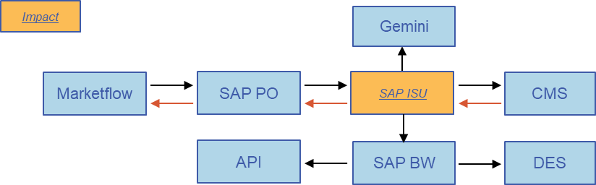

As part of the impact assessment it has been verified that this change will not impact any ongoing releases or changes.

Implementation
As per section G8, the aim is to deliver these changes as soon as possible post approval so please consider this objective when submitting your representations.

G6: Associated Changes
Associated Change(s) and Title(s): | None

G7: DSG
Target DSG discussion date: | 20th December 2021
Any further information: | Solution option was discussed, minutes available here, and there were no challenges or objections to the proposed solution.

G8: Implementation
Target Release: | Ad hoc – ASAP post approval
Status: | Awaiting approval

Please see the following page for representation comments template; responses to uklink@xoserve.com

Section H: Representation Response
«RangeStart:HDS»
H1: Change Representation
(To be completed by User and returned for response)

Please consider any commercial impacts to your organisation that Xoserve need to be aware of when formulating your response

User Contact Details: | Organisation: | «h1_organisation»
 | Name: | «h1_name»
 | Email: | «h1_email»
 | Telephone: | «h1_telephone»
Representation Status: | «h1_userDataStatus»
Representation Publication: | «h1_consultation»
Representation Comments: | «h1_userDataComments»
Confirm Target Release Date? | «h1_targetDate» |  | «h1_userDataAlternative»

H1: Xoserve’ s Response
Xoserve Response to Organisations Comments: | «h1_xoserveResponse»

«RangeEnd:HDS»

