Detailed Design Change Pack

Communication Detail
Comm Reference: | 3364.2 - RT - PO
Comm Title: | XRN5888 Minor Release 14 Design Clarification
Comm Date: | 14/04/2025

Change Representation
Action Required: | For Information only
Close Out Date: | 30/04/2025

Change Detail
Xoserve Reference Number: | XRN5888
Change Class: | Functional
*ChMC Constituency Impacted: | Distribution Networks  Independent Gas Transporters (IGTs)  *Assumed impacted parties of the proposed change, all parties are encouraged to review
Change Owner: | uklinkdelivery@xoserve.com
Background and Context: | DNOs and IGTs have the ability to request end consumer contact details via the Extract Request service under one of five defined Use Cases. These are:  - Unplanned interruptions including purge and relights.  - Planned interruptions including reinstatement of ground (for example mains replacement).  - Gas Safety Regulation (GSR) cut-offs.  - Appointments for Multiple Occupancy Buildings (e.g. riser replacements).  - Guaranteed Standards of Performance compensation payments.  Based on the feedback gathered from customers, an improvement has been identified in the way the Extract Service within the UKLink Portal operates while displaying the results from the address search. This will enhance the customer experience while utilising the Broadcast Services.  This change has therefore been raised to amend the order for displaying Extract Request search results as below:  - Extract Request search results will be displayed ordered by postcode (alphabetically).  - Within the same post code, all entries will be shown in the order of House Number' (ascending) and 'Principal Street' (alphabetically)  This ordering of address results will enhance the user experience of the extract service for DN’s and iGTs which is further utilised for the broadcasting purposes.

Change Impact Assessment Dashboard
Functional: | Amend the order of displaying the address search results for extract services
Non-Functional: | Ensure performance and functionality of the extract request search are not affected
Application: | UKLink Portal (Extract Request Services)
User(s): | DNs and IGTs
Documentation: | None
Other: | None

Files
File | Parent Record | Record | Data Attribute | Hierarchy or Format  Agreed
N/A | N/A | N/A | N/A | N/A

Change Design Description
Solution Overview

Change Scope:

- Functional change to amend the order of displaying the address search results for extract screen within the UKLink Portal.
- Search results will be amended to be displayed as below:
  - Sort the results ordered by postcode (alphabetically).
  - Within the same post code, all the results will be shown in the order of ‘House Number' (ascending) and 'Principal Street' (alphabetically)
- There are no other changes to the extract or broadcast functionality as part of this XRN.

Application changes:

- Changes in UKLink (SAP ISU)

There will be changes done to the Proxy interface that is invoked by the UKLink Portal to pull the address data from UKLink (SAP ISU) so that the search results will be passed back to the Portal in the desired order.

- Changes in the EXTRACT Search Outcome screen
The Extract Search Outcome screen will be changed to display the Extract Request search results in the following order: Meter Point reference, House number, Street or building name, Principal Street, City and Postcode.

This enhancement will provide a better user experience to feed the results into the broadcast services as required

Mock Up of the Address Search results post this change goes live

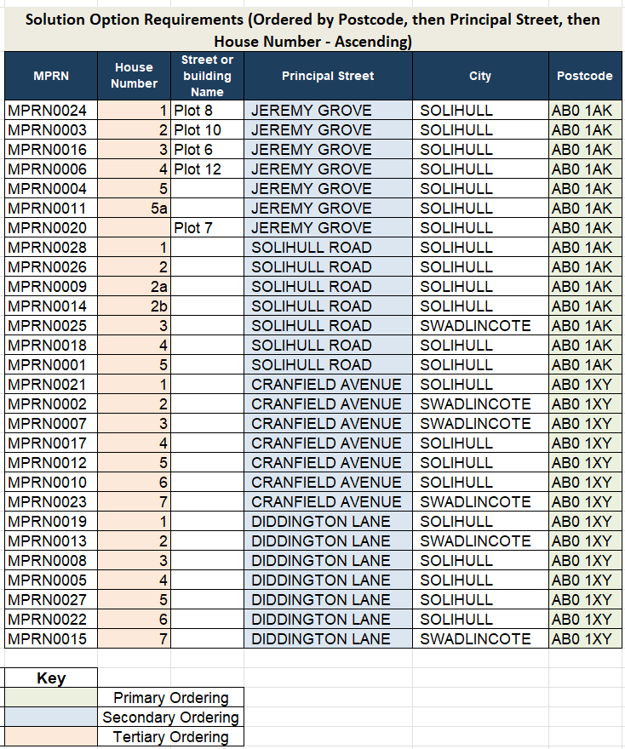
(This does not use real data: all data is fabricated to illustrate the intended address results ordering logic)

As shown, this change will
- Sort the address results alphabetically by the “Postcode” field first. This will ensure all addresses from the same postcode are grouped together for ease of navigation.
- The results will then be sorted by the “Principal Street” field. This will be done in alphabetical order, and group all addresses from the same street together for ease of navigation.
- Finally, the results will be sorted by “House Number” field in ascending order.

Associated Changes
Associated Change(s) and Title(s):

DSG
Target DSG discussion date: | 22/04/2025
Any further information: | None

Implementation
Target Release: | Release: Minor Release 14
Status: | Approved

Industry Response Detailed Design Review
«RangeStart:HDS»
Change Representation
(To be completed by User and returned for response)

Please consider any commercial impacts to your organisation that Xoserve need to be aware of when formulating your response

User Contact Details: | Organisation: | «h1_organisation»
 | Name: | «h1_name»
 | Email: | «h1_email»
 | Telephone: | «h1_telephone»
Customer decision on Change Pack: | «h1_userDataStatus»
Commercial impacts: | «h1_commercial_impacts»
Representation Publication: | «h1_consultation»
Representation Comments: | «h1_userDataComments»

Xoserve’ s Response
Xoserve Response to Organisations Comments: | «h1_xoserveResponse»

Please send the completed representation response to uklink@xoserve.com

«RangeEnd:HDS»

Version Control

Document
Version | Status | Date | Author(s) | Remarks

