High Level Solution Options Change Pack

Communication detail
Comm Reference: | 3407.2 - KL - KG
Comm Title: | XRN5914 Amend the Code Cut-Off Date to a Rolling Period (Mod0886) & XRN5922 Shorten the current code cut-off date (or Line in the Sand) from a 3 to 4-year period to a 2 to 3-year period (Mod 0896)
Comm Date: | 18/08/2025

Change Representation
Action Required: | For Information
Close Out Date: | 02/09/2025

Change Detail
Xoserve reference Number: | XRN5914 and XRN5922
*ChMC Constituency Impacted | Shipper, All Classes  Distribution Network Operators (DN)  Independent Gas Transporters (IGT)  *Assumed impacted parties of the proposed change, all parties are encouraged to review
Change Owner: | uklink@xoserve.com
Background and Context: | Modification 0886 seeks to amend the Code Cut-Off Date from an annual change on the 1st April every year, to a monthly rolling date which is effective on the 1st of each month.  Other than a move to a monthly rolling Code Cut-Off Date, all other existing rules are to remain the same. In particular:  - The Estimated Read process outlined in TPD M 5.4.5 will remain an annual process.  - The Customer Settlement Error Claims process outlined in TPD E 1.3.8 will continue to apply as it does now.  For reference, the UNC modification documentation for 0886 is located here.  Separately, Modification 0896 seeks to Shorten the current Code Cut-Off Date (or Line in the Sand) from a three to four (3 to 4) year period to a two to three (2 to 3) year period. This will mean there will be a 2-year jump in the Code Cut-Off Date (or Line in the Sand) in the initial year of implementation.  NB: Subsequent Code Cut-Off Date (or Line in the Sand)  updates will revert to a 1-year jump post the initial year’s  transition.  For reference, the UNC modification documentation for 0896 is located here.

Solution Options
Solution Option Summary: | This solution change pack has been combined for changes XRN5914 and XRN5922 given the commonalities and overlap in functional and process areas and implementation timeline. However, for the avoidance of doubt, the changes can be delivered independently should that be required.  Solution Approach  In order to deliver the objectives of modification 0886 and 0896 a single solution approach has been identified and consists of two key area:  - Update to the Code Cut-Off Date (to be referred to as Line in the Sand (LiS))  - Existing process will persist  - For 896 the LiS will be moved by two years once. Subsequent changes will be a singular year step  - For 886, the LiS will be updated on a monthly basis  - For the proposed two year “jump” under Mod 0896, a one-off timeline schedule will be defined for industry stakeholders to work towards in submitting requests and transactions to the CDSP  - This will see the “normal” activity brought forward to mitigate the risk of an increased volume of transactions and requests not all being processed ahead of the LiS update  - For the proposed rolling monthly LiS update under Mod 0886, a new and enduring monthly schedule will be provided to industry stakeholders  - Further to this, new internal reporting will be developed to support the required CDSP processes and ensure they can be completed within the proposed new timeframe  - A change to the Contact Management System (CMS) will be required to ensure the system’s view of a more frequently changed LiS is accurate  - An annual timeline will be published to customers by the CDSP to provide a view of key dates across the forthcoming year  With reference to Mod 0886 specifically, no quantifiable impact to Service and Operate (S&O) resource or cost has been identified based on the assumption that the existing annual workload will be spread evenly across the year. Therefore, customer behaviours and transaction volumes will be monitored and should a capacity impact be identified as a result of this change that cannot be absorbed by the CDSP, this will be raised to customers to discuss and agree mitigation measures.  Indicative Timeline  As per the above summary, the solution is centred around the development and publication of process timelines. These timelines will provide a guide to key stakeholders as to when transactions must be submitted by in order for them to be processed ahead of an update to the LiS.  Below are two high level timelines that set this out for the two changes in the context of this change pack. Please note, the timeline for XRN5914 is based on the XRN5922 process having been executed however both can be completed independently should both modifications not be approved.  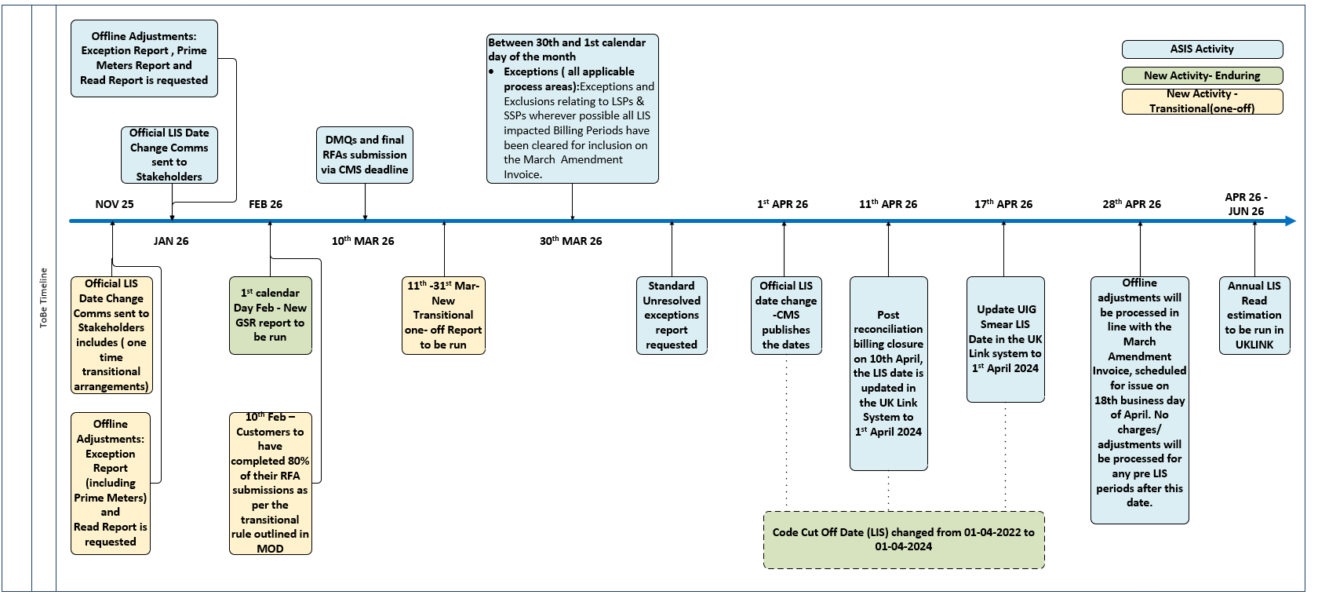  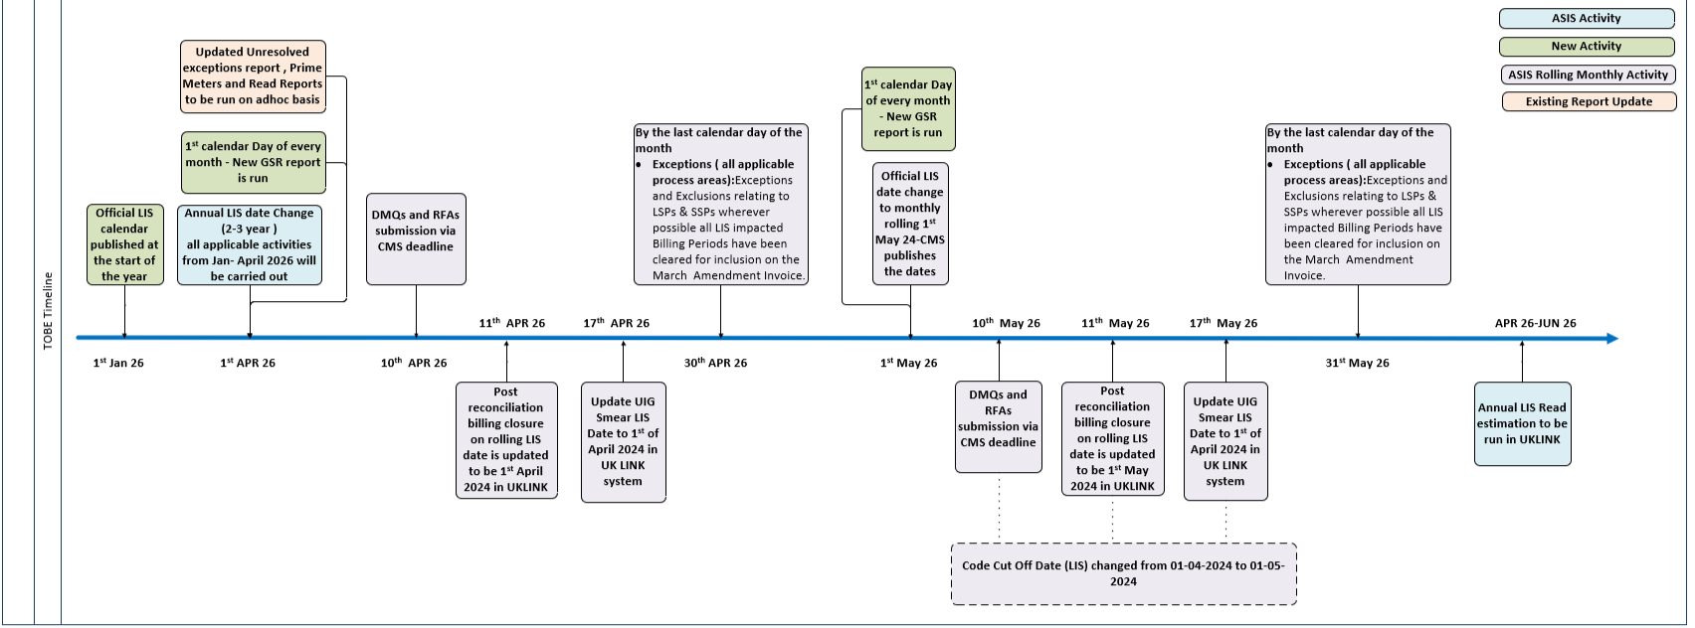  As the changes progress communications will start to be issued to customers, this will be out of line with standard major release time scales and done so that the CDSP can provide as much notice to customers as possible ahead of transactional cut off dates.  Solution Cost Range  The cost range for the required solution is £47,000 - £90,000.  Market Trials High Level Analysis and Recommendation  The option of a market trials (MT) phase has been reviewed:  - If MT was required a 3 month period would be suggested, as such the changes would not be available for the February ’26 release  - The overall cost of MT would be in the region of £155,000 - £165,000  Based on the majority of change being internal process impacts to the CDSP MT is not being recommended in this instance. In addition, as the above highlights, it’s inclusion would cause a large delay to implementation and increase in costs.  Implementation Timeline and Funding  It is recommended to deliver the solution within a major release to provide the full support and lead time for the changes and related testing. As per discussion at Change Management Committee (ChMC) on 9th July 2025, the aspirational proposal is that the solution approved by customers should be considered for scoping within the February 2026 major release, with implementation of the modifications aligning to 1st April 2026, noting that both Modification are subject to approval (Authority Direction).  The modification proposers have both proposed the funding of these changes be 100% Shipper.  Representation being Sought  As there is a single solution option and the changes are driven by industry code Modifications, this pack has been issued for information only. However, customers are encouraged to provide comments via representation should they so wish. Any comments raised will be discussed at the Change Management Committee meeting on 10th September.
Proposed Implementation Date: | February 2026 Major Release (aspirational/proposed)
Xoserve preferred option:  (including rationale) | Single solution option
DSG preferred solution option:  (including rationale) | To be presented and discussed at DSG on August 26th 2025.

Service Lines and Funding – for each option
Service Line(s) Impacted - New or existing | No related service line exists  A new service line will be investigated during detailed design. This will ensure the process and actions being undertaken by the CDSP is clearly defined.
Level of Impact: | Major/ Minor/ Unclear/ None
Impacts on UK Link Manual/ Data Permissions Matrix | None

Industry Response Solution Options

«RangeStart:EDS»

Please consider any commercial impacts to your organisation that Xoserve need to be aware of when formulating your response

Organisation’s preferred solution option
User Contact Details: | Organisation: | «e1_organisation»
User Contact Details: | Name: | «e1_name»
User Contact Details: | Email: | «e1_email»
User Contact Details: | Telephone: | «e1_telephone»
Organisation’s preferred solution option, including rationale taking into account costs, risks, resource etc: | «e1_preferredSolutionOption»
Commercial impacts: | «e1_commercial_impacts»
Customer decision on preferred solution option: | «e1_dsgSolutionOption»
Publication of consultation response: | N/A

Xoserve’s response
Xoserve Response to Organisations Comments: | «e2_xoserveResponse»

«RangeEnd:EDS»

Version Control

Document
Version | Status | Date | Author(s) | Remarks
v0.2 | Peer Review | 15/08/2025 | James Barlow | All sections Created
v1.0 | Final | 16/08/2025 | James Barlow | Updated following review

Template
Version | Status | Date | Author(s) | Remarks | Approved by
1.0 | Approved | 09/03/2022 | Rachel Taggart | Initial Review Change Pack transferred to own document | Change Management Committee on 09/03/2022
1.1 | Approved | 25/04/2023 | Rachel Taggart | Updated with new font branding | Emma Smith
1.2 | Updated | 14/08/2023 | Kate Lancaster | Updated Representation tabs | N/A
1.3 | For Approval | 21/07/2025 | Kate Lancaster | Updated branding | To be approved by ChMC

