Section G: Change Pack

G1: Communication Detail
Comm Reference: | 2514.2 – JLR - JR
Comm Title: | XRN4550 Gemini Re-Platform
Comm Date: | 13/01/2020

G2: Change Representation
Action Required: | For Information
Close Out Date: | 27/01/2020

G3: Change Detail
Xoserve Reference Number: | XRN4550
Change Class: | Infrastructure Upgrade
ChMC Constituency Impacted: | Shippers, Distribution Networks, National Grid Transmission
Change Owner: | Manisha Bhardwaj manisha.bhardwaj@xoserve.com  0121 229 2394
Background and Context: | In 2016 Xoserve undertook a review of its Data Centre Strategy and the strategic hosting options. The conclusion of this review was for Xoserve to move away from owning assets and instead to move to a managed service model. Xoserve’s Data Centre Hosting Strategy is to consolidate to a single supplier for all non-Software as a Service (SaaS) hosting requirements and to move to a more commodity cloud-based consumption service.  When Gemini was moved from the National Grid Data Centres to the Xoserve Data Centres, the life of the Gemini service was planned to be from June 2013 until June 2018. In 2016 National Grid Transmission took the decision to defer the planned rewrite of the Gemini system until beyond the end of the RIIO-T1 period. As a consequence, a health assessment of Gemini was undertaken in order to understand the options for extending the Gemini service into RIIO-T2. The recommendation of this health assessment was to re-platform Gemini to a cloud based solution

G4: Change Impact Assessment Dashboard (UK Link)
Functional: | None
Non-Functional: | Access to Gemini
Application: | Gemini
User(s): | Shippers, Distribution Networks, National Grid Transmission
Documentation: | None
Other: | N/A

Files
File | Parent Record | Record | Data Attribute | Hierarchy or Format  Agreed
N/A | N/A | N/A | N/A | N/A

G5: Change Design Description
What is the change

Design Changes for Information:

- As part of Gemini Re-platform, the Gemini system is going through an Infrastructure Upgrade and also moving to private cloud based model (virtualised infrastructure). In order to continue to support the Gemini system, a number of software’s are being upgraded to ensure compatibility with the Private Cloud based model. This upgrade is required to :
  - Maintain software support for all Gemini components
  - Meet industry best practices

While there are no functional changes to the systems in relation to this change, users accessing the system should note the following visible changes:

- Citrix Receiver client being used by the users to access the system is being upgraded from V6.5 to V7.15 This will not impact the industry users who do not wish to upgrade their Citrix Version as the option to access Citrix via web browser is also available. Please note details in the appendix 2.

- In order to be compliant with the Security standards, Transport Layer Security (TLS) version is also being upgraded. This means Gemini system will be compatible with TLS Version 1.2 and TLSV1.0 is not being decommissioned at this stage.

- Please also note an enhancement:
As part of the upgrade Gemini Application Log In screen resolution manual change will no longer be required. This will be automated. Post Implementation, this screen with detect resolution required to match the device used for log in.

Extended Outage
There will be an Extended system outage on Sunday 5th July 2020 to support implementation activities. The extended outage window is currently anticipated to be between 8 to 12 hours. Details as follows:
  - Gemini Maintenance Window: 03:00 to 5:00
  - Extended outage: 05:00 to 13:00
  - In the event of a rollback an additional outage will be required from 13:00 to 17:00
Implementation planning is currently underway, any actions required from the external users to complete their system related activities and processes prior to the implementation day will be communicated via industry communication nearer the time.

Functionality
  - The Gemini functionality will remain exactly the same along with how Industry participants interact with the system. Therefore, apart from the Citrix login, the look and functioning of Gemini will remain the same.

External Connectivity Testing
  - User Connectivity to the Gemini Production system is not affected as part of this change.
  - The current User Trials environment utilised by external users for testing is impacted and will have new URL. It is strongly recommended that users participate in the External Connectivity Testing being offered from 13th April to 8th May2020. This will allow users to ensure their access to the new test environment has been established and tested.
  - The primary objective of the External Connectivity testing phase is to ensure connectivity via different routes i.e. API, Citrix Receiver client or Web browser (into Citrix) has been tested. If an opportunity is available, we would also like to offer additional functional regression testing of API.
  - All Industry participants are invited to test connectivity to the new data center during the period 13th April to 8th May 2020, please confirm intended participation by contacting
box.xoserve.geminire-platform@xoserve.com

G6: Associated Changes
Associated Change(s) and Title(s): | XRN 4869 – DC Exit Programme  XRN 4870 – Data Centre Exit (Shared Components) Delivery

G7: DSG
Target DSG discussion date: | 01/01/0001
Any further information: | None

G8: Implementation
Target Release: | Adhoc Release 05 July 2020
Status: | Approved at August ChMC 07/08/2019

Please see the following page for representation comments template; responses to uklink@xoserve.com

Section H: Representation Response
H1: Change Representation
(To be completed by User and returned for response)
User Contact Details: | Organisation: | Npower Ltd
 | Name: | Alison Price
 | Email: | alison.price@npower.com
 | Telephone: | 07557202065
Representation Status: | No comment
Representation Publication: | Publish
Representation Comments: | No comment
Confirm Target Release Date? | Yes |  | «h1_userDataAlternative»

H1: Xoserve’ s Response

Please send the completed representation response to uklink@xoserve.com

Appendix 1

Dear Colleague,

We would like to invite all Users to participate in the Connectivity Testing related to the Gemini Re-Platform change, which will take place 13 April – 5 May2020. To aid the testing, a short training video will be available before the testing window commences and we would expect the resource commitment required by you during the testing window to be 1hr.
As connecting to Gemini is key to many Users we would like to take this opportunity to encourage you to participate in this connectivity testing.
If you would like to participate in the Connectivity Testing please email .box.xoserve.GeminiRe-Platform@xoserve.com to register your involvement.
If you have any questions related to this communication, please contact Xoserve via email .box.xoserve.GeminiRe-Platform@xoserve.com.
Kind regards,

Address: Xoserve Limited, Lansdowne Gate, 65 New Road, Solihull, B91 3DL
Company Website: http://www.xoserve.com

Appendix 2
Screenshots for Gemini Re-Platform
The following screenshots show the existing screens used for logging into Gemini, and then the new screens that will occur following Gemini Re-Platform

Existing Screen
Currently when logging onto Gemini Via Citrix you see the following screen
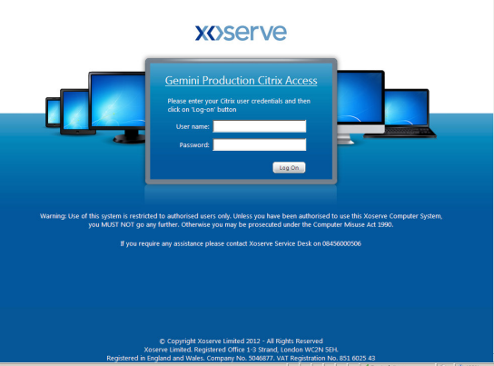
Once the log on details are entered to Citrix the following appears
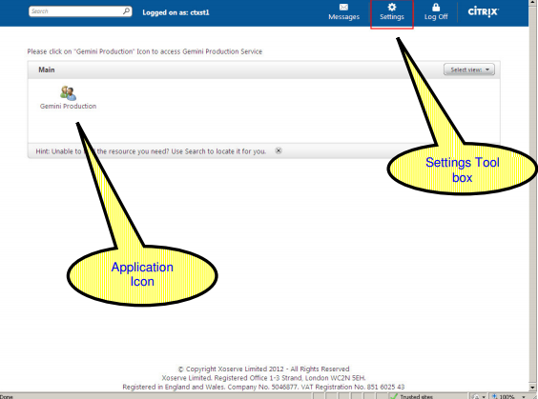

The new screen
Once the change has been implemented you will see the following screen
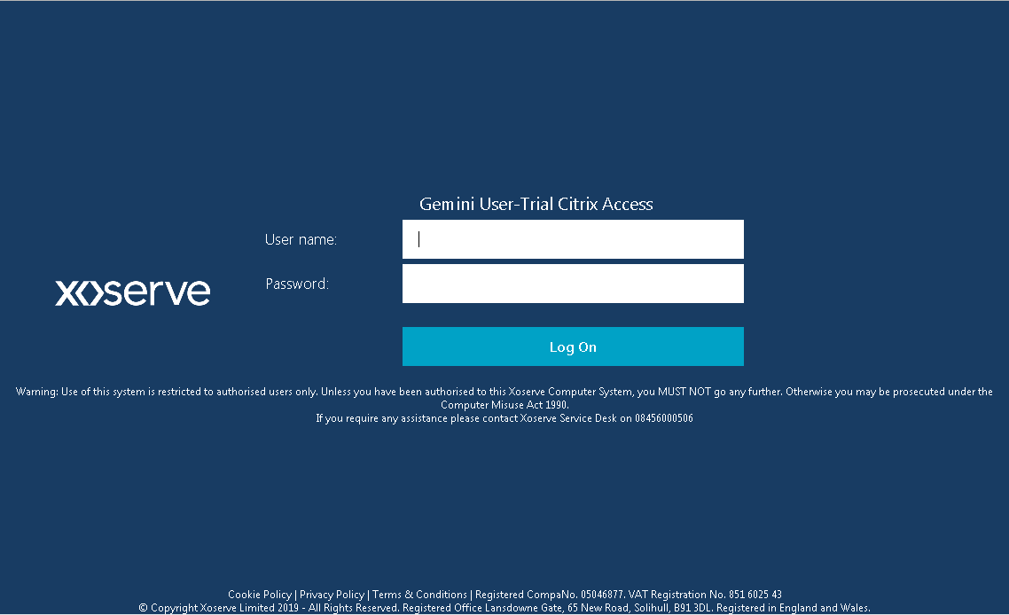

Once the log on details are entered to Citrix the following appears
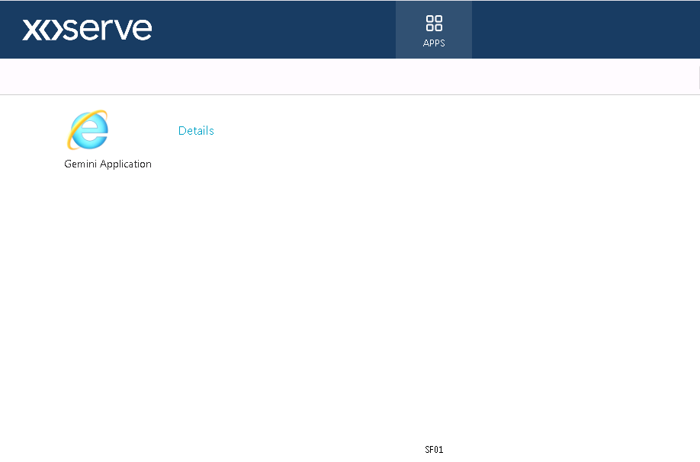

When the Gemini Application icon above is clicked it launches Gemini as below
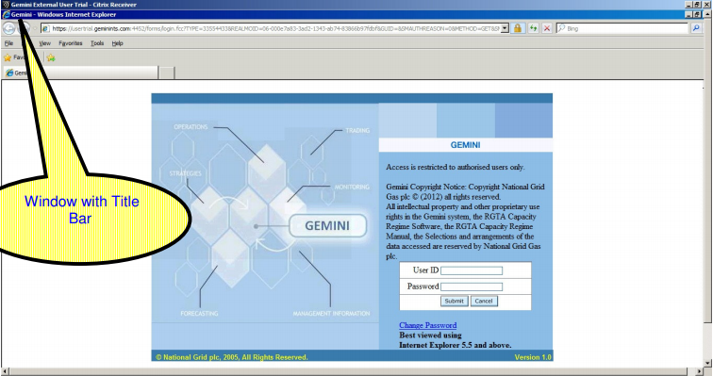

The new screen when launching via Browser (HTMLS client)

When launching via the browser (HTMLS Client), in this case you don’t need Citrix receiver software, and this is the screens you would see
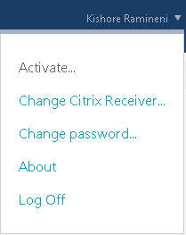
User
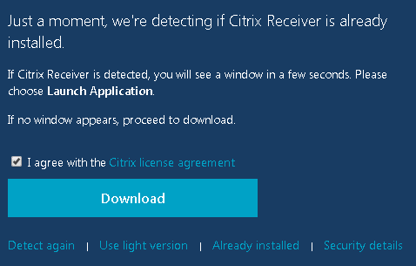
Use the light version of Citrix Receiver
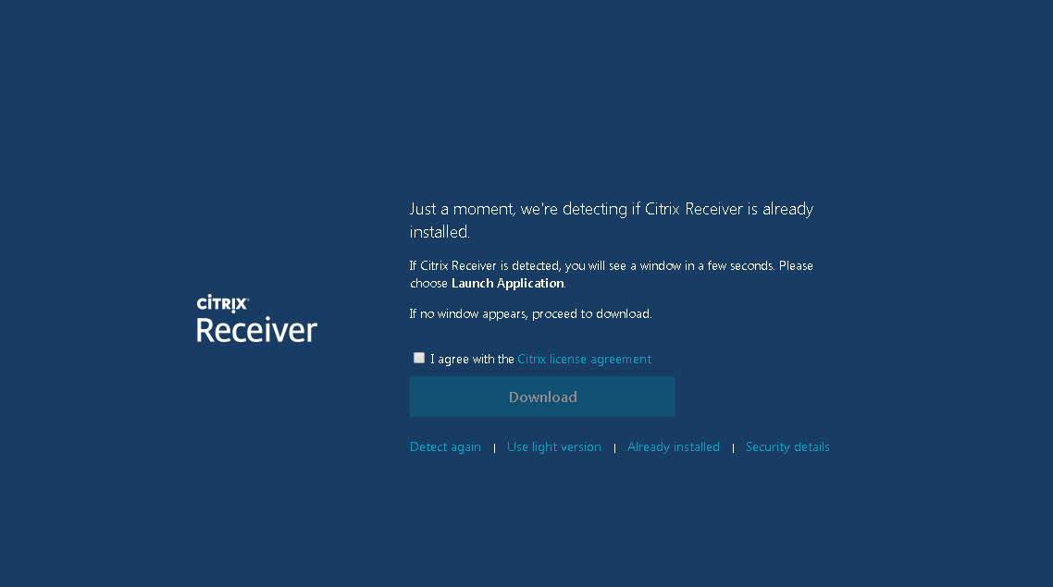

Automatic resolution adjustment

The system will now automatically adjust the resolution
