Detailed Design Change Pack

Communication Detail
Comm Reference: | 3256.3 – LO – PO
Comm Title: | XRN5573B – Update To Priority Consumer Process
Comm Date: | 12/02/2024

Change Representation
Action Required: | For Representation
Close Out Date: | 26/02/2024

Change Detail
Xoserve Reference Number: | XRN5573B
Change Class: | Functional change
*ChMC Constituency Impacted: | Shipper (All Classes)  Distribution Network Operators (DNO)  *Assumed impacted parties of the proposed change, all parties are encouraged to review
Change Owner: | uklinkdelivery@xoserve.co.uk
Background and Context: | XRN5573 was raised to carry out the changes to the existing Priority Consumer process where the categorisations and qualifying criteria were amended in line with governmental directive.  The Priority Consumer categories are now as follows:  - Category A: Relevant customers where a failure in the supply to their premises could put lives at risk  - Category B: Relevant customers for which the sudden loss of gas causes or threatens to cause serious damage, for an unacceptably prolonged period, to human welfare, the environment or the security of the United Kingdom that cannot be reasonably mitigated  - Category C: Relevant customers taking over 2 million therms per annum for which the sudden loss of gas would result in repair or replacement costs amounting to 10% or more of the Site Fixed Tangible Asset Value  Due to the urgency of the change needing to take effect at that time, it was agreed with ChMC that Priority Consumer category B changes would be applied as manual workarounds until XRN5573 Part B is implemented as part of a later change.  The below details the current Priority Consumer process following the implementation of the manual workarounds:  - Shippers download the Priority Consumer Application Form, which is completed and emailed to the Customer Operations team along with any supporting evidence.  - The Customer Operations team update the Priority Consumer request using an internal UK Link screen to input category values of A and C in the system. Once the details are updated a response is sent to the requester via email.  - All Priority Consumer category requests for C are referred to relevant DNOs through the existing portal. Post receipt of the referral response the final status is updated in UK Link. The Priority Consumer reports contain the Accepted referrals.  - For Priority Consumer category B request, the Department for Energy Security and Net Zero (DESNZ) sends an email to the Customer Operations team. This information is stored offline and manually added to the Priority Consumer reporting.  The principle of the proposed solution is to update UK Link and Gas Enquiry Service (GES) Online Portal for category B to be captured to align with category A and C and be automatically added to the Priority Consumer reporting.

Change Impact Assessment Dashboard
Functional: | New Portal screen  Existing internal UK LINK screen  Priority Consumer Report
Non-Functional: | None
Application: | UK Link  SAP PO  SAP BW  SAP BO  Portal  GES Online Portal
User(s): | Shippers  Distribution Network Operators  Department for Energy Security and Net Zero (DESNZ)
Documentation: | File Format changes  GES User Guide
Other: | None

Files
File | Parent Record | Record | Data Attribute | Hierarchy or Format  Agreed
TMC, TRF, TRS | S15 | S15 | Description update for the PRIORITY_CONSUMER_CATEGORY field to include category B and amended guidance for category C | Format is submitted for representation in this Detailed Design Change Pack (see Appendix).

Change Design Description
An enhanced method of raising Priority Consumer requests was chosen to replace the existing Priority Consumer Application Form process. The key changes being implemented are listed below:
- New portal screen to receive Priority Consumer category updates from Shippers and/or DESNZ to replace the existing Priority Consumer Application Form.
- Changes in UK Link to capture Priority Consumer category B data.
- Existing category B values, currently held offline, to be assigned to the associated MPRNs within UK Link
- Automate Priority Consumer reporting to include category B.
- GES Online Portal will include Priority Consumer category B as an allowable value as per A and C.
- Changes to the S15 record to include Priority Consumer category B as an allowable value. The S15 record is used within the .TMC, .TRF and .TRS files.

Priority Consumer Category Request Process
It is proposed that the information currently provided using the existing Priority Consumer Application Form will be submitted, by the Registered Shipper or DESNZ, for all category A, B and C requests via a new portal screen. The Meter Point Reference Number (MPRN) will be used to add Priority Consumer details as per the mock ups below.

The main screen:
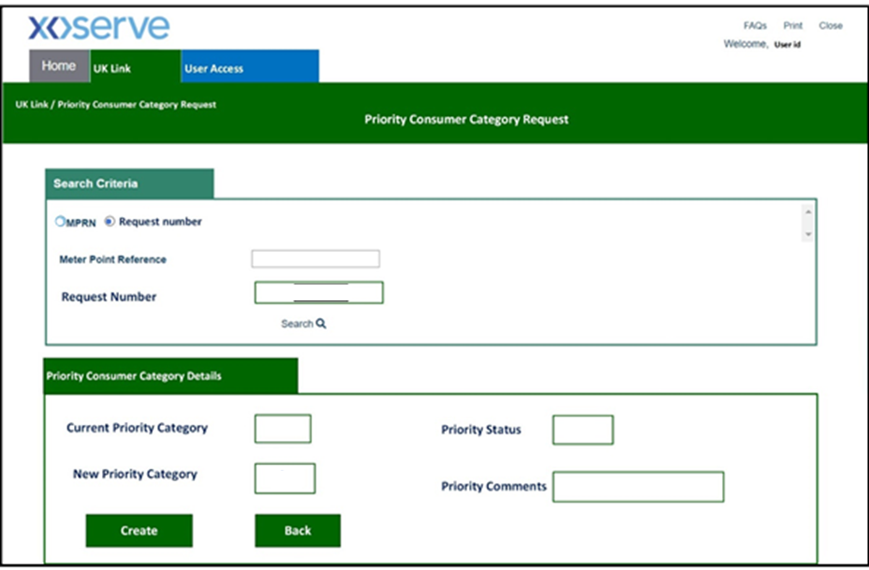

Searching for an MPRN:
Input MPRN and click Search. For awareness the Request Number can be used to view the status of Priority Consumer requests, further detail of this functionality is provided in the ‘View Status’ section of this document.

Adding the category details:

Clicking create will populate the next screen

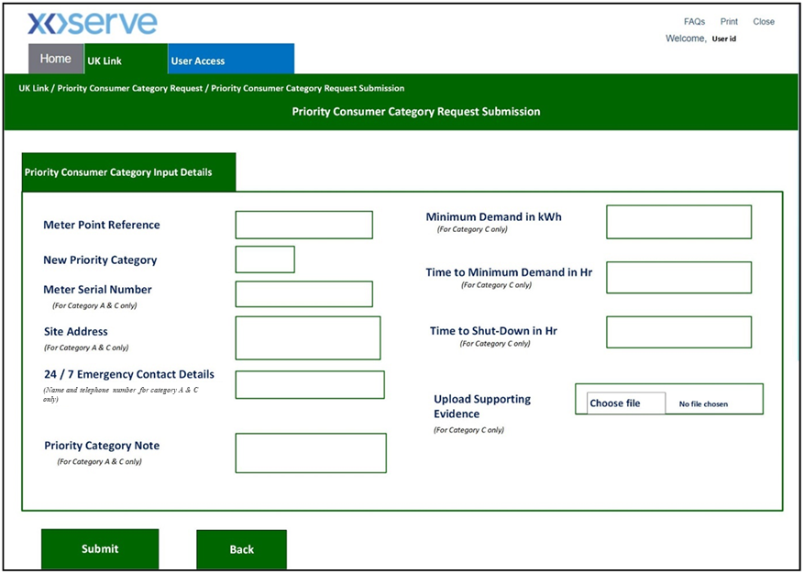
Within this screen the relevant fields must be completed, and any supporting evidence uploaded. Upon submission, the request will be processed as detailed below.

Category A
The Registered Shipper can submit Priority Consumer category A requests. Once submitted, the request will show a status of ‘In Progress’ while it is sent to the Customer Operations team for internal validation. Following a successful review, the status will be manually updated to ‘Authorised’ or ‘Rejected’ and the requester will be notified of the outcome by email.

Category B
Only DESNZ can submit Priority Consumer category B requests. If the request passes validations performed within the Portal, the Priority Consumer category B will be applied immediately which will feed directly into UK Link tables and relevant reports.

Category C
The Registered Shipper can submit Priority Consumer category C requests. Once submitted, the request will show a status of ‘In Progress’ while it is sent to the Customer Operations team for internal validation. Following the review, the Customer Operation team will either ‘Reject’ the request back to the requestor or ‘Refer’ the request to the relevant DNO using an existing internal screen. The request details will be validated by the DNO and either ‘Authorised’ or ‘Rejected’. Customer Operations team will notify the requester via email.

Category Not Applicable (NA)
Users can remove the Priority Consumer category for a given MPRN by submitting a request with a Priority Category value of NA. For the avoidance of doubt, Registered Shippers can only perform this action where the existing category is A or C. DESNZ will be permitted to do the same where the category is set to B.

Additional Validations

The data entered in the new portal screen will be subject to the following validations:

The MPRN will be validated to:
- Ensure it exists in UK Link
- Ensure the Shipper is the registered Shipper. Please note this validation does not apply to DESNZ.

The Request Number will be validated to:
- Ensure the Request Number exists.
- Ensure the Shipper is the registered Shipper. Please note this validation does not apply to DESNZ.

Once a request is submitted the following validations will apply and the request rejected where:
- A Priority Consumer request has already been submitted for the MPRN in the same day
- The Annual Quantity (AQ) does not meet the threshold for the category. To note these thresholds have not been amended as part of this change but have been provided for completeness.
    - Category A – the AQ must be greater than 732,000
    - Category B – the AQ must be greater than 732,000
    - Category C – the AQ must be equal to or greater than 58.6 million kWh (2 million therms)
- For category A and C requests the following has not been provided:
    - Meter Serial Number
    - Address details
    - Emergency contact details (Name and contact number)
    - Priority Category Note. This field will not accept these special characters in line with the UK Link manual; ('!"£$%^&*:;@~#<>/?|\[]{}_=+-¬`)
- For category C requests the following has not been provided:
    - Minimum demand
    - Time to Minimum Demand
    - Time to shut down
    - Supporting evidence. The supporting evidence must be uploaded in a .docx format.

Where the request is accepted the Shipper or DESNZ will be provided, on the portal screen, with a Request Number which can be used to view the status of their request.

View Status

The requester will have the ability to view the status of their Priority Consumer request using either the MPRN or the Request Number as shown in the mock up screens below:
Input Request Number and click Search.

The results will be populated as below:
In this example, a request for a Priority Consumer category A has been made by the Shipper. The request is currently being reviewed internally hence the in progress (IN) status. Once the request has been validated, the status will show as authorised (AU) or rejected (RJ).

UK Link

Reports
The authorised Priority Consumer categories values will be included in the Priority Consumer reporting. Changes will be made to SAP PO, SAP BW and SAP BO in order to ensure the reporting is updated.

Files
The S15 record contained within the .TMC, .TRF and .TRS files contains the Priority Consumer category values. This will be updated to include category B within the PRIORITY_CONSUMER_CATEGORY field. The description field has also been updated to provide more clarity on category C.

Data Migration
Within the implementation of this change the existing category B values, currently held offline, will be assigned to the associated MPRNs within UK Link

GES Online Portal
GES Online Portal will include Priority Consumer category B as an allowable value as per A and C.

We are progressing with an amendment to the GES user guide which will be progressed via the appropriate code change process.

Support

Should you experience any issue with the new Portal screen then please use the existing Service Desk process available via this link.
If you have any urgent queries regarding Priority Consumer requests then please email the Customer Operations team on priorityconsumers.cpm@xoserve.co.uk.

Appendices

Appendix 1

S15 TRANSFER OF OWNERSHIP V9FA and Shared Supply Meter Point Transfer of Ownership Notification Template TRS_File Formats_V6FA file records:

Associated Changes
Associated Change(s) and Title(s): | N/A

DSG
Target DSG discussion date: | 19/02/2024
Any further information: | To present the key points of this pack and discuss any comments as a result or already provided from the Detailed Design Change Pack representations.

Implementation
Target Release: | Release: June 2024
Status: | For Approval

Industry Response Detailed Design Review
«RangeStart:HDS»
Change Representation
(To be completed by User and returned for response)
Please consider any commercial impacts to your organisation that Xoserve need to be aware of when formulating your response

User Contact Details: | Organisation: | «h1_organisation»
 | Name: | «h1_name»
 | Email: | «h1_email»
 | Telephone: | «h1_telephone»
Customer decision on Change Pack: | «h1_userDataStatus»
Commercial impacts: | «h1_commercial_impacts»
Representation Publication: | «h1_consultation»
Representation Comments: | «h1_userDataComments»

Xoserve’ s Response
Xoserve Response to Organisations Comments: | «h1_xoserveResponse»

Please send the completed representation response to uklink@xoserve.com

«RangeEnd:HDS»

Change Management Committee Outcome
Change Status: | ☐ Approve | ☐ Reject |  |  | ☐ Defer
Industry Consultation: | ☐ 10 Working Days |  | ☐ 15 Working Days
 | ☐ 20 Working Days |  | ☐ Other [Specify Here]
Date Issued: | Click here to enter a date.
Comms Ref(s):
Number of Responses:
Solution Voting: | ☐ Shipper |  |  | Please select.
 | ☐ National Gas Transmission |  |  | Please select.
 | ☐ Distribution Network Operator |  |  | Please select.
 | ☐ IGT |  |  | Please select.
Meeting Date: | Click here to enter a date.
Release Date: | Release: Feb / Jun / Nov XX or Adhoc DD/MM/YYYY or NA

Please send the completed representation response to uklink@xoserve.com

Version Control

Document
Version | Status | Date | Author(s) | Remarks

Template
Version | Status | Date | Author(s) | Remarks | Approved By
1.0 | Approved | 09/03/2022 | Rachel Taggart | Detail Design Change Pack transferred to own document | Change Management Committee on 09/03/2022
1.1 | Approved | 25/04/2023 | Rachel Taggart | Updated with new font branding | Emma Smith

