Detailed Design Change Pack

Communication Detail
Comm Reference: | 3248.1 - LO - PO
Comm Title: | XRN5564 Gemini Sustain Plus Programme
Comm Date: | 15/01/2024

Change Representation
Action Required: | For representation
Close Out Date: | 29/01/2024

Change Detail
Xoserve Reference Number: | XRN 5564
Change Class: | Functional
*ChMC Constituency Impacted: | National Gas Transmission, Shippers, DNOs, Traders
Change Owner: | Geminiengagement@correla.com
Background and Context: | The Gemini system first went live in 2005 (it replaced the previous RGTA and AT Link systems) and has since undergone a regular programme of change including major industry changes such as Exit Reform and EU Network code. Gemini is now an aging system, and its technology has fallen behind the market in terms of flexibility and cost to run. This makes changes to Gemini more difficult and expensive than could be the case. The pace of market change is accelerating, and this trend is likely to continue with areas such as the use of hydrogen. Therefore, there is an opportunity to both accelerate change and decrease costs by updating the Gemini technology platform.  The purpose of the Gemini Sustain Plus Programme is to deliver the technical approach of sustaining the Gemini platform by modernising and transforming current legacy components into a modern, cost efficient and scalable solution that reduces operating costs and the ongoing cost of change.  The key benefits of this change are:  - Improve business capability and the user/ customer experience (e.g. extending the gas day to 24 hours availability).  - Achieve improved efficiency through reduced operating costs.  - Increase flexibility to accommodate increasing pace of Regulatory Change.  Customer Focus Group sessions will continue the customer engagement and will allow all Gemini Users the opportunity to understand Programme progress and exposure to system demonstrations of newly tested processes and areas of functionality pertinent to them. This will help with familiarisation of the updated interface ahead of Go Live and will also provide the opportunity for customers to ensure that they can connect and log in to the System in preparation for Day One.  If you would like to register for future sessions, please contact Geminiengagement@correla.com  All material shared during these sessions along with FAQs will be made available on the programme website; Gemini Sustain Plus (xoserve.com)  The Change Description section below provides detail on the structure of the upgraded system and highlights the key differences from the Legacy platform.

Change Impact Assessment Dashboard
Functional: | The modernisation of the Gemini platform has resulted in a multitude of changes that has impacted the various parts of the application. Users of the system will mainly notice the look of each User Interface (UI) layer and every screen has changed along with some of the functionality. Unless specifically identified in the sections, the below functionality has remained the same as the legacy system.  Whilst there are cosmetic changes to all screens and to some functionality, there will be no change to file flow or API definitions.  To support and prepare Users in readiness for Go Live the programme will conduct the following:  - Share lower-level details and screen changes in the Gemini Sustain Plus Focus groups.  - Provide supplementary training e-modules through the Learning Management System (LMS) the programme is introducing.  - Give Gemini users the opportunity to familiarise themselves with the updated Gemini system during Market Trials.  This will help provide advanced familiarity of the system and opportunity to address any initial questions. A further Change Pack will be shared at a later point in the Programme to share detail on relevant screens, for the changes listed below, which will be for information only.  The enhancements and functionality changes are grouped into the following Gemini process areas below:  - Capacity processes  Auction Calendar Dashboard Enhancement - The Auction Calendar Dashboard is being enhanced as follows:  - Will display the Auction Type data in ascending order.  - The information for each Auction Type will include the Sold/Unsold Capacity for that Method of Sale (MoS).  - The facility to extract the auction information in Excel format.  - The ability to select a Live auction and be taken directly to the relevant screen to place bids.  Bid and Trades Dashboard Enhancement - The Bids and Trades Dashboard is being enhanced to automatically update to reflect the bid status.  Offtake Capacity Statement (OCS) Enhancement - For the Gemini OCS and Offtake Pressure Statement (OPS) process the bulk upload facility is being enhanced to include a predefined template that can be downloaded in order to be populated by the DN user and uploaded.  - Energy Balancing Processes  Over the Counter (OTC) Enhancement - For OTC, once a shipper has placed a trade nomination, an automatic email notification will be triggered to the counter party * which will look as follows:  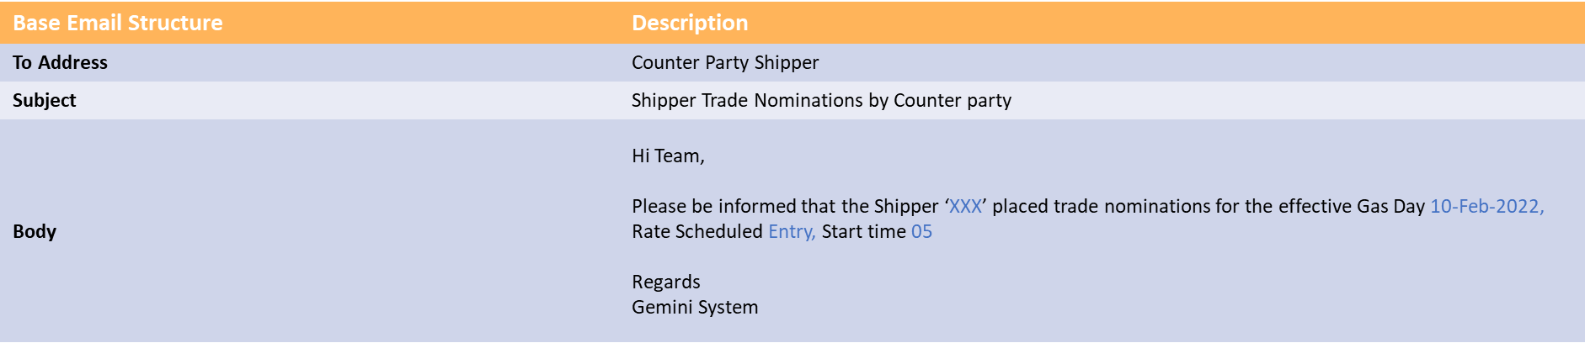  *Unless no specific email address has been provided for the OTC counter party notification.  Storage Exit Meter process enhancements – For Storage Exit Meter IDs created either by Batch process or Online Screen, a new Batch job is automatically triggered for the Activity number creation for the respective Meter IDs.  Unique Site Energy Enhancement - There will be enhancements to the Unique Site Energy Query screen with the addition of an “upload” button that will allow Agents to upload the Unique Site Energy data at Site Level and Meter Level into Gemini Screen whenever Energy is Modified.  New Nomination vs Allocation screen – A new screen will be added to be able to view Nomination, Trade and Allocation data at an aggregate level which further can be drilled down to meter type and meter ID level information and be able to download a report.  - Constraint Management  Constraint Management Enhancement - In the event of a Constraint on the network an additional notification will appear as a pop up or “Toaster” message to any user logged into Gemini at the time.  - Invoicing  Shipper Indebtedness report Enhancement - The “View and Print Cash Call Report” Screen will be enhanced to provide the access to the shippers to run and view their own indebtedness report.  - TSO only Energy Balancing enhancement – For information only  TSO Nomination Enhancement - A Excel Report will be generated which contains Nominated (Requested) v/s Confirmed (Scheduled) EU Nomination Data (Requested Energy is not equal to Scheduled Energy). Nomination matching at IP enhancements for Gas Day D-1, D and D+1. This report will be sent to the Transmission System Operators (TSOs) via e-mail*. An example of the email is as follows:  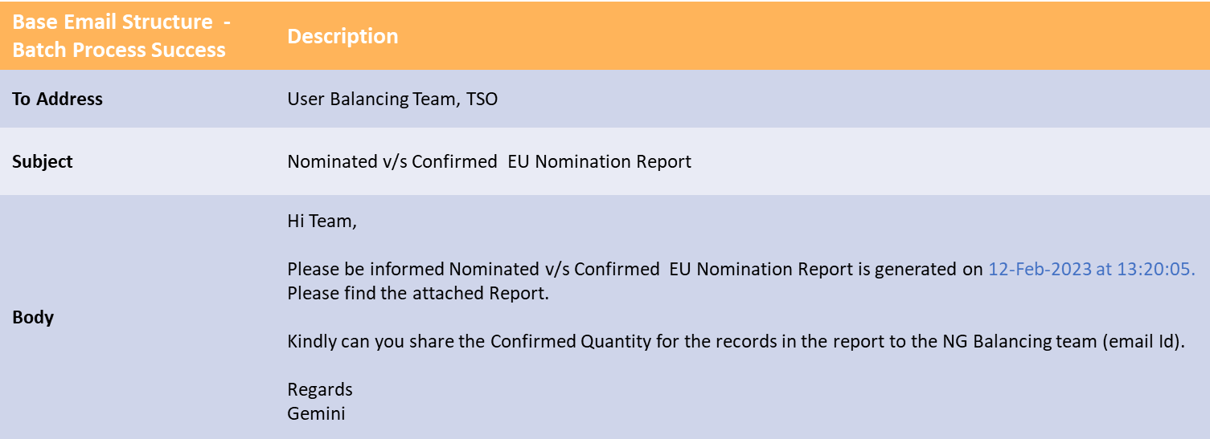  * Unless no specific email address has been provided for the EU nomination report.  - Additional functional changes that impact the whole of the Gemini platform  Service Now Enhancement - Service Now integration will be available in the Gemini platform to ease the customer journey when raising an issue or request without having to close their current session or use another tab to raise a ticket.  Gemini Data retention - To keep the data needs of Gemini in line with the UNC obligations it will retain transactional data for 10 years with the exception of auction data which will be retained for 20 years. This meets the industry UNC requirement with 3 additional years if customers require it. Any data older than the retention periods mentioned above will transferred from the production version onto a cold storage facility, which can be retrieved if required in the future.  Gemini Reports Enhancement - The modernisation of Gemini will allow Users to generate and view reports in the system relating to their user role all within one screen.
Non-Functional: | Non-functional enhancements that are being delivered with the Gemini Sustain Plus Programme:  - Non-Functional enhancements  Gemini Bi-annual Clock Change Enhancement - The bi-annual Gemini clock change activity will now be automated in Gemini via the system automatic settings and will change in line with the UK clock change. Thus, removing the impact on the whole industry to implement the change with an outage.  Gemini Architecture Enhancement - The type of architecture used provide the ability to remove the maintenance window leading to Gemini having 24-hour, 7 day availability. This will allow all Gemini Users access to the system at any time.  Gemini System Unification - Gemini and Gemini Exit are being brought together as a single application enabling the User to navigate more easily between the various processes and screens.  Gemini User Interface (UI) Enhancement - The Gemini UI will provide a new look and feel as well as additional functionality that will enhance the User experience. A full list of the common components and features can be found in Appendix B. For demonstrations of the updated Gemini UI please see the Previous Sessions of the Focus Group on Gemini Sustain Plus (xoserve.com).  Gemini Accessibility Enhancement - All Users will be able to access the Gemini platform application via any device that has a standard modern web browser.  Gemini Inactivity change – In order to enhance security the Gemini system will automatically timeout and the User must log in again after a set period of time, which will be included in the UKLink manual.  To understand the current legacy position of these change vs the new enhancements please see Appendix A.
Application: | Gemini
User(s): | All Gemini system Users including shippers, agents and DNs.
Documentation: | There will be updates to the UK Link Manual and NG code contingency documents
Other: | None

There are no File changes that are part of this Change Pack.
File | Parent Record | Record | Data Attribute | Hierarchy or Format  Agreed
NA | N/A | N/A | N/A | N/A

Change Design Description
- Solution Overview

The Gemini Sustain Plus programme will modernise and enhance the current Gemini system and move the platform to a public cloud environment, transitioning the current monolithic architecture into a microservice platform primarily running on PaaS services.

This approach will allow a more agile approach to delivering and managing change, reduce operational overheads and improve the security, scalability and availability of the system.

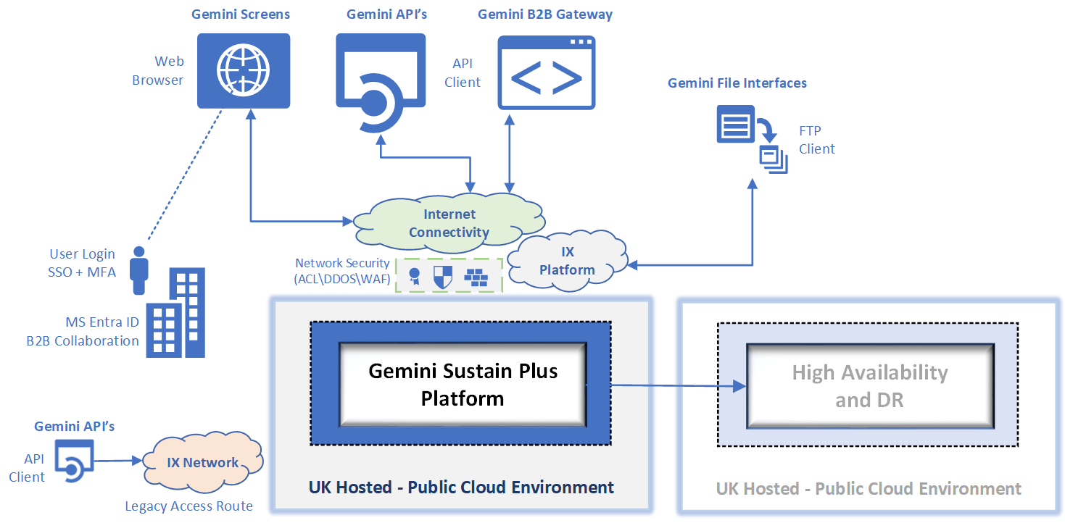

The diagram above highlights key endpoints of the Gemini platform that will be affected by this change. Building on previous system enhancements that made access to Gemini APIs and Screens more readily accessible over the internet, these will be further enhanced and will become the new default connectivity option for these aspects of the Gemini platform.

- UI / UX Framework / System Design

We will be making amendments to all screens within the Gemini system and part of best practices we have created a framework which each of the screens and buttons will follow to ensure consistency across the application.

Examples of this will be shared in the later change pack for information along with the system screens.

10.1 API access Current

Currently for external users of Gemini, access to the APIs is supported by 2 different connectivity options.
- From a location connected to the IX network – access to Gemini APIs is possible over the IX network using an API client and system that is managed by the organisation accessing Gemini.
- From an internet connection – access has also been made available over an internet connection, also using an API client that is managed by the organisation accessing Gemini.
For IX based access to APIs only SOAP\XML API support is available with cookie-based authentication through the use of a username and password.

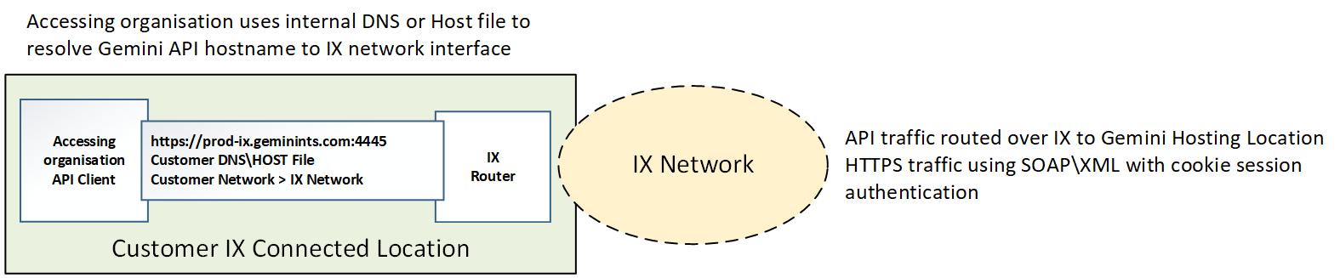

For internet-based access to APIs REST using either XML or JSON is supported with Java Web Token
(JWT) authentication which uses a more secure combination of oAuth2 credentials and API subscription keys.
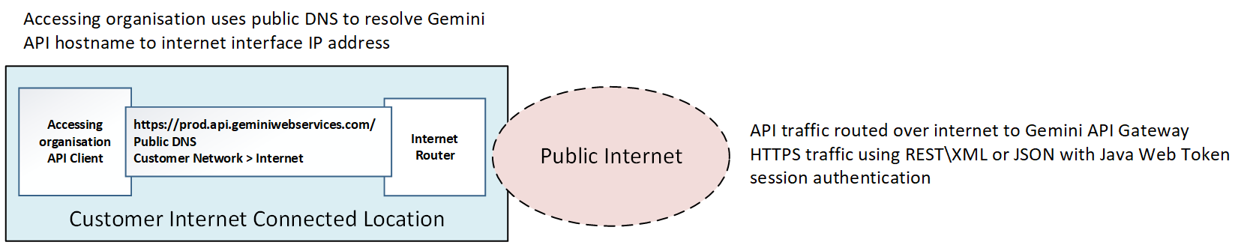

10.2 Future
As part of the delivery of the Gemini Sustain Plus programme, connectivity to APIs will use internet-based access as the primary and preferred route but there will be support for connectivity over the IX network for customers who require this.

For either approach the method of interacting with APIs will move to the new REST model (supporting either XML or JSON as is currently the case) and moving to the new authentication mechanism of JWT. This change is necessary to support new security standards.

The new access model is illustrated below:

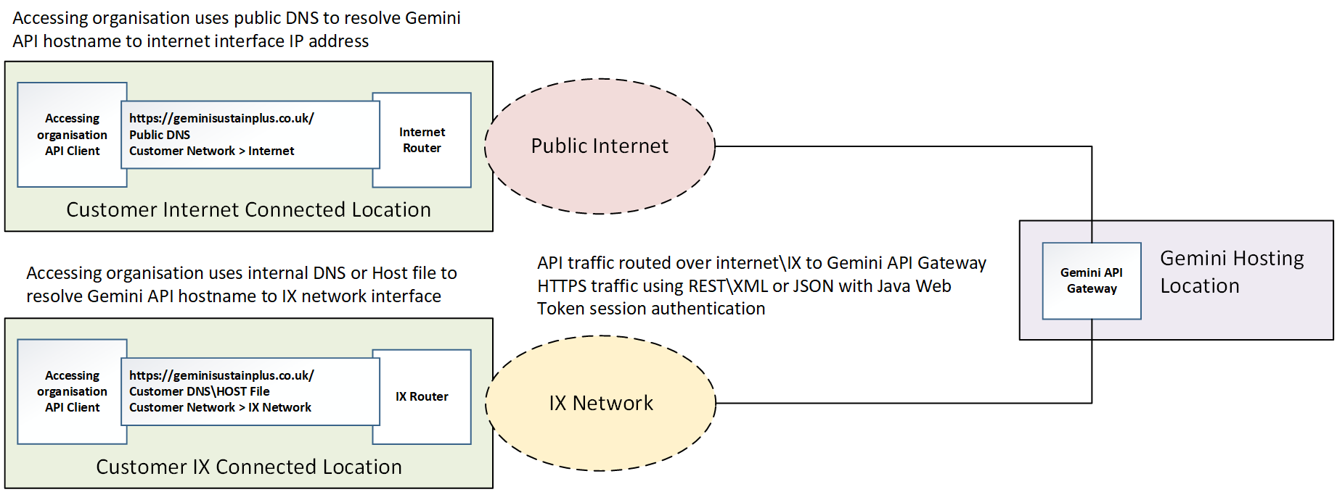

As is currently the case, connectivity will be via an API client that is managed by the organisation accessing Gemini. Current API functional specifications will remain the same, these specifications will continue to be published and made available to Gemini System Users.

11.1 Screen Access Current
Access to the user interface is supported by 2 different connectivity options.
- From a location connected to the IX network – access to the Gemini screens is possible over the IX network using a device that has a web browser and Citrix Receiver installation.
- From an internet connection – access has also been made available over an internet connection using a web browser, this option also requires multi-factor authentication.

For either of the above options Citrix is used as the application delivery platform – this is illustrated below:

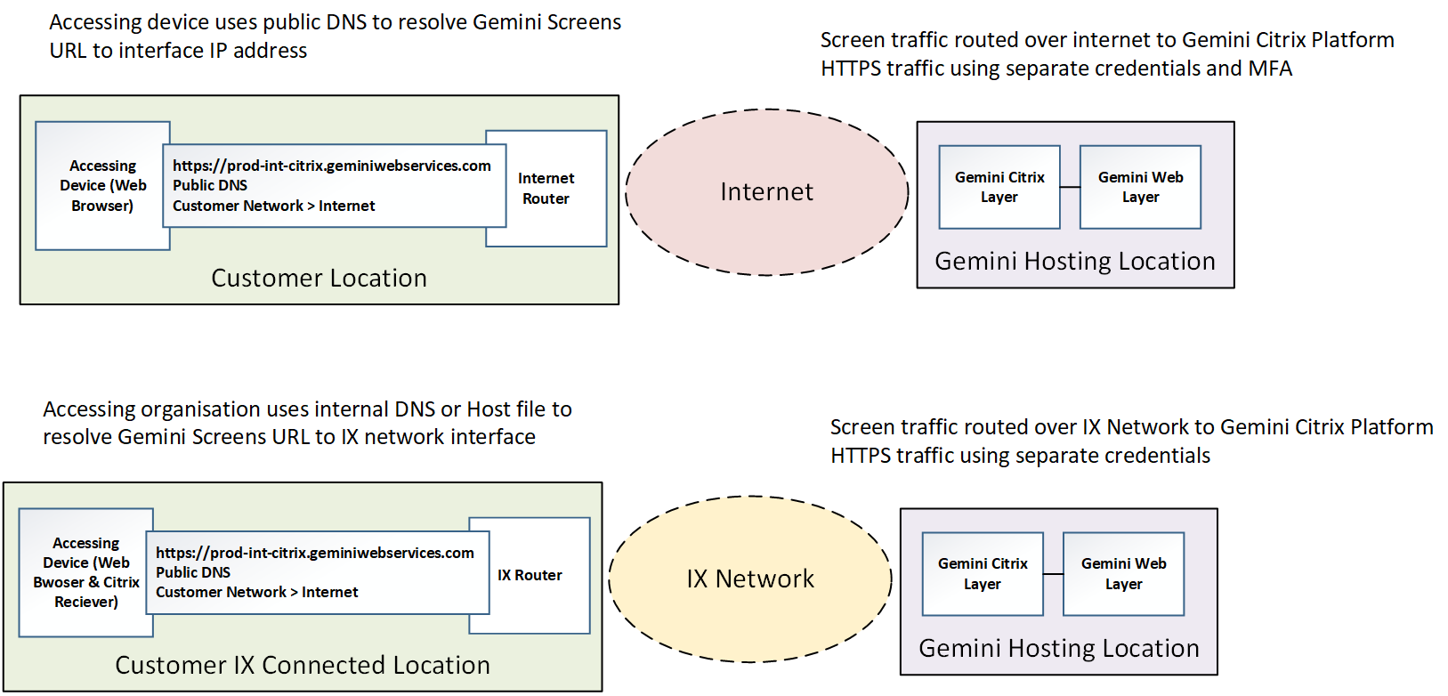

11.2 Future

As part of the delivery of the Gemini Sustain Plus programme, future access to Gemini screens will only be available via the internet route. This will simplify connectivity and support access from any internet connected location used by the connecting organisation.

Access will be supported using any modern web browser (Edge, Chrome, Firefox, Mozilla) and will also still require multi-factor authentication (authenticator app will be the preferred method of MFA).
The Gemini screens will be directly accessible as a web page and therefore will no longer require the use of Citrix, this means that there will be no requirement to install the Citrix Receiver or any other supplemental software to access the system.

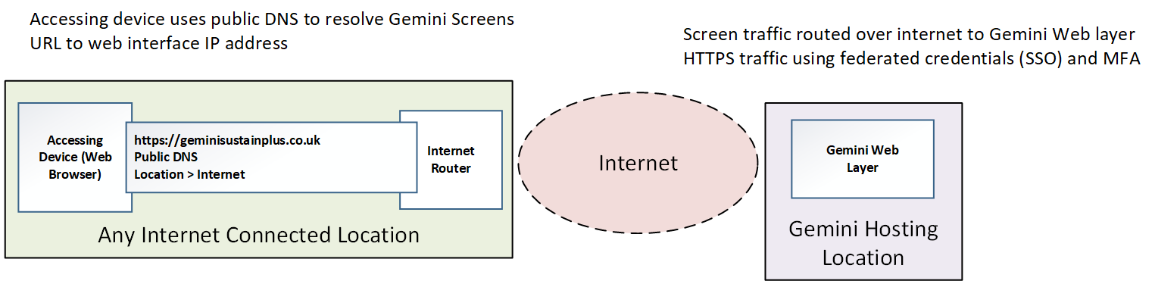

12. IP and Domain Details
Access to the Gemini APIs and Screens endpoints will use new IP addresses and Domain\URL details to those currently being used.

The domain details for the new URL will be resolvable via standard public DNS services and the connectivity will utilise standard HTTPS protocol (port 443), this means that connectivity should not require any special configuration on the customers network if standard internet access is available.

If more restrictive access controls are in place for internet connectivity then the IP addresses, ports and domain names being used are provided in the table below, these may need to be permitted in the access control policies for any internet firewall or proxy services if these do not allow access by default.

Service | URL | IP Address | Port | Protocol
Gemini APIs | https://api.geminiplus.co.uk/* | 40.120.32.44 | 443 | HTTPS
Gemini Screens | https://ui.geminiplus.co.uk/* | 40.120.32.81 | 443 | HTTPS

13. User Roles/ User IDs

The unification of Gemini and Gemini Exit has provided the opportunity to combine user roles for ease of use going forwards. The table below lists the current Gemini user roles available to external users with the proposed new user roles listed on the right.

An audit of Gemini user accounts will be undertaken because each Gemini user will require a new log in that uses their organisation email address, this will be used as part of the federated access being introduced as part of the Gemini Sustain Plus Programme which is listed further down in this change pack. This will require LSOs to provide details of who in their organisation requires access to the Gemini system. Failure of the LSOs to do this will mean their users will not have access to Gemini in readiness for Go Live. The legacy Gemini system will no longer be available post go live, and there will be no parallel running. Historic data will be transferred to the system.

It is important that all customers take the opportunity to undertake connectivity testing, onboarding, Market Trials and training to ensure they have the correct access to ensure smooth transition for go live.

The following table is the proposed Gemini Roles:
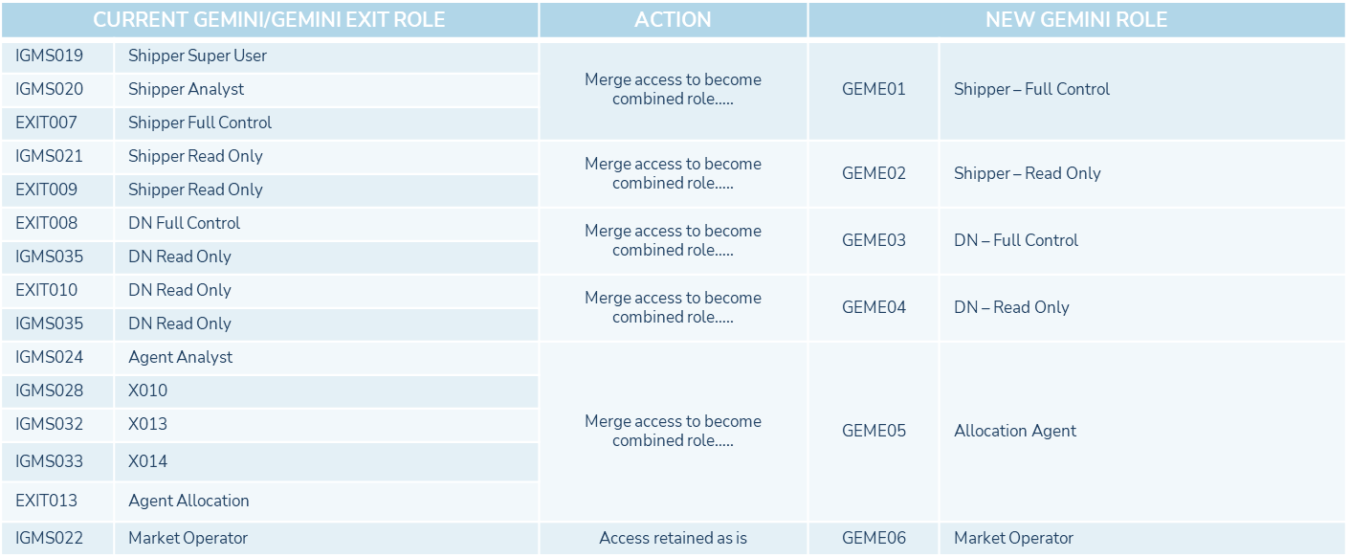

14. Connectivity, onboarding and Market Trials
As part of the programme we will be running a period of Connectivity, onboarding and Market Trials in Q2 2024 to ready the industry for the implementation of the new Gemini application.

The connectivity and onboarding phases will provide a period in which the programme will be supporting the industry to connect to both the Gemini Market Trials environment and to be production environment as well to onboard both individual & API users. Successful completion of these activities will ensure that organsiation will have the connectivity and set up required for them to access the upgraded Gemini Platform come Go-live.

The Market trials phase which will follow connectivity and onboarding, will allow successfully connected and onboarded Gemini Users to access and familiarise themselves with the new Gemini UI and be able to undertake a select number of key processes using dummy data.

Further detailed communication will follow in Gemini Sustain Plus Focus Group, Industry Forums and communications.

15. Training

The existing e-learning currently available on the Xoserve website for Gemini will be replaced by a Learning Management System (LMS). The new LMS will house e-modules that will cover the various Gemini processes that are undertaken by the industry in their own training domain.

The LMS provides a user-friendly interface to allow for self-learning for users to understand background and undertake the Gemini processes relevant to their roles as well as processes that may be outside of their role but within their market segment i.e., Shipper, DN, Agent etc. The LMS also provides the user and organisations, via a super user, the ability to track and report on progress of the e-modules. Details on how to access the new LMS with be shared in Q2 2024.

16. File Interfaces

For the majority of organisations that use Gemini, file interfaces use the IX solution which provides an FTP mechanism for sending and receiving files from Gemini as well as other organisations and systems such as UK Link.
Any changes to the current IX FTP file transfer solution and processes around this are not in the scope of the Gemini Sustain Plus programme and so there are no details included in this Change Pack.
17. Security Enhancements

The delivery will include security enhancements that will be integrated into the public cloud services being used. These enhancements will strengthen the security posture of the Gemini platform and will remove or mitigate certain areas of technical debt from the existing Gemini platform. This approach will allow the removal of the Citrix content delivery mechanism that is currently used to support access to Gemini user screens and will also support the introduction of more friendly methods of managing user identities, providing greater flexibility with connectivity options and device compatibility. Some of these enhancements are described in more detail below:

18. Federated Identity

Customers will be able to federate using their own identity provider to access the service. This will give users the ability to use Single Sign on (SSO) from accounts which they use on a day-to-day basis and do not have to maintain another set of credentials which could be stored insecurely. This gives the customer the flexibility to manage identities for Gemini in the same way that they would manage identities for other applications and services that SSO has been configured for within the customers organisation. This will allow password resets, password strength and complexity, account security monitoring and account decommissioning to be managed by the customer who may have compliance requirements they need to adhere to. Authentication shall be enhanced with the introduction mandatory MFA and geolocation filtering through conditional access policies to reduce the risk of compromised accounts accessing the platform. This will then be supported by OAuth 2.0 to manage authorisation to the application. Customers shall be able to support their user identities under their own corporate policies and are responsible for making sure that each account is governed in a way that is appropriate to their security and compliance requirements.

19. Internet Accessibility

It shall be hosted within Azure and be publicly accessible over the internet. Requirements to access via Citrix will no longer be in place. Web services shall be accessible via Azure Front Door which is enabled with Azure WAF v2 and scans all inbound traffic coming into Front Door using a Microsoft managed ruleset that is based off the OWASP common web application security risks. If the WAF detects that there are malicious payloads submitted through a HTTP request, then it shall block the attack before traffic is routed to any of the microservices. This shall help to prevent common types of attack techniques at the application edge. The platform operates a defence in depth strategy which accounts for remediating vulnerabilities in the platform discovered through penetration testing and vulnerability scanning. This is to ensure that any attacks that manage to bypass the WAF are unlikely to trigger publicly released vulnerabilities on the backend.

20. Security Monitoring

The new Gemini platform will include a comprehensive set of security monitoring, threat detection and intrusion prevention systems maintained by the system operator. The use of Cloud PaaS services will also help to ensure that the underlying platform is continuously maintained and protected with improved security standards being introduced in relation to access control and authentication of system users and interfaces.

Associated Changes
Associated Change(s) and Title(s): | Not applicable

DSG
Target DSG discussion date: | Not Applicable
Any further information:

Implementation
Target Release: | We will aim for the implementation date of the new Gemini platform for Sunday September 8th 2024, with a contingency date of Sunday 22nd September 2024 with extended outages required.  This will be confirmed in industry forms and comms at a later date.
Status: | For approval

Appendixes

Appendix A – Legacy Gemini current process

Appendix B –Gemini New UI features

Industry Response Detailed Design Review
Change Representation
(To be completed by User and returned for response)

Please consider any commercial impacts to your organisation that Xoserve need to be aware of when formulating your response

User Contact Details: | Organisation: | E.ON
 | Name: | Kirsty Dudley
 | Email: | Kirsty.Dudley@eonenergy.com
 | Telephone: | 07816172645
Customer decision on Change Pack: | approved
Representation Publication: | Publish
Representation Comments: | We support the direction of this change and welcome developments with Gemini. We have a few points we’d like to clarify in the design:  1) Logins – we have multiple Market Participant IDs (MPID) as part of the portfolio we manage and having a login per MPID is quite cumbersome, we would like to have a ‘group login’ approach where we can manage all our portfolio under a single login where required, as well as having a MPID level login. This would mean either 1 MPID is accessible or everything within the affiliated group is accessible. This was raised at the workgroup discussions and looks to be included in the design but is yet to be added into the design explicitly, we’d like to see documentation to confirm the approach.  2) The design outlines an email response for every OTC trade change, although we recognise why this would be in the design, it could mean a vast number of emails for parties. We would like to suggest that there is a refinement to this process and there is the introduction of one or both of these suggestions below:  a) The ability to opt out of receiving the emails (but the ability to opt back in at any time)  b) The emails to be consolidated into a single round up of the days notifications which are cascaded at [x] time per day  This was raised on the recent workshop and was taken away as an action to review.  3) The high-level information relating to APIs gives a general understanding, however we are unable to fully impact assess this as the technical specification doesn’t go into the detailed level we require e.g. URL information, test system details. Can you confirm when this will be provided so we can complete a thorough impact assessment?  Also, will any sandbox API setup be given before Market trails? We request this is as it will be really helpful for us to test/review the changes on our side.  4) Browser timeout, although we support having this functionality there might be longer periods of inactivity than 15 minutes due to the BAU tasks completed, we would support extending this to allow users time to do their day to day tasks in-between Gemini browser activity.

Xoserve’ s Response

Please send the completed representation response to uklink@xoserve.com

Change Representation
(To be completed by User and returned for response)

Please consider any commercial impacts to your organisation that Xoserve need to be aware of when formulating your response

User Contact Details: | Organisation: | BUS
 | Name: | Lee Greenwood
 | Email: | lee.greenwood@britishgas.co.uk
 | Telephone: | 07557612456
Customer decision on Change Pack: | approved
Representation Publication: | Publish
Representation Comments: | We are confident in the Gemini Sustain Plus Programme’s ability to achieve its goals, and will submit any feedback on the changes through engagement in the ongoing programme meetings.

Xoserve’ s Response
Xoserve Response to Organisations Comments: | Thank you for your representation, we will feed this into ChMC for a final decision

Please send the completed representation response to uklink@xoserve.com

Change Management Committee Outcome
Change Status: | ☐ Approve | ☐ Reject |  |  | ☐ Defer
Industry Consultation: | ☐ 10 Working Days |  | ☐ 15 Working Days
 | ☐ 20 Working Days |  | ☐ Other [Specify Here]
Date Issued: | 01/01/0001
Comms Ref(s):
Number of Responses:
Solution Voting: | ☒ Shipper |  |  | Please select.
 | ☒ National Grid Transmission |  |  | Please select.
 | ☒ Distribution Network Operator |  |  | Please select.
 | ☒ IGT |  |  | Please select.
Meeting Date: | 01/01/0001
Release Date: | Release: Feb / Jun / Nov XX or Adhoc DD/MM/YYYY or NA
Please send the completed representation response to uklink@xoserve.com

Version Control

Document

Version | Status | Date | Author(s) | Remarks
0.1 | Draft |  | Correla | Internal Review with NG and Correla
0.2 | Draft |  | Correla | Informal Review with Xoserve
0.3 | Draft |  | Correla | Updates from Reviews
0.4 | Draft |  | Correla | Updates from Reviews
0.5 | Finalised Version |  | Correla | Updates from Xoserve review
1.0 | Final Version |  | Correla | To be represented at ChMC

