Detailed Design Change Pack

Communication Detail
Comm Reference: | 3394.3 - KL - PO
Comm Title: | XRN5808 - Providing Notification to DNs and IGTs for Capacity and Nomination Referrals Awaiting Action
Comm Date: | 14/07/2025

Change Representation
Action Required: | For representation
Close Out Date: | 28/07/2025

Change Detail
Xoserve Reference Number: | XRN5808
Change Class: | Process change
*ChMC Constituency Impacted: | DNOs, IGTs. (Please note that NTS is out of scope for this change)  *Assumed impacted parties of the proposed change, all parties are encouraged to review
Change Owner: | Paul Orsler
Background and Context: | Requests by Shippers are referred through the UK Link Portal for Distribution Network Operators (DNOs)/Independent Gas Transporters (IGTs) to action. Currently there is no proactive notification e.g. email sent to the DNO to inform it that there is either a new or outstanding Referral within the UK Link Portal that is awaiting assessment and action. IGTs currently receive the IGR file which details new referrals only.  The UK-Link Portal (UKLP) is not checked daily and as a result, DNO/IGT referrals are only known when a DNO/IGT either:  - Reviews the UKLP on an ad-hoc basis;  - The DN/IGT is chased by the Shipper for a response to a referral (usually by email outside of the UKLP)  Note: An IGR file is sent to IGTs; this file contains Nomination, Capacity & Priority Consumer referrals only  The creation of a specific notification to the DNOs/IGTs will reduce the potential of undue delay in responding to Shippers and their customers when a referral decision is required.  Original Change Proposal: https://www.xoserve.com/media/xwsbjhbm/xrn580-1.pdf  The solution option assessed will be a manual process whereby CDSP resource will be allocated to identify and circulate relevant Referrals Notifications.  For the avoidance of doubt, the CDSP does not anticipate any system impacts /changes as a consequence of implementing this manual solution.  Please note: This new process is an ‘elective service’ whereby a DNO/IGT will need to opt-in to receive the Referral Notification Summary. A DNO/IGT will also have the flexibility to opt-out should it decide it no longer wishes to receive the Referral Notification Summary.

Change Impact Assessment Dashboard
Functional: | None – No system impacts/changes have been identified, manual process only
Non-Functional: | - New email with a Referrals Summary attachment to be issued to agreed DNO/IGT contacts  - CDSP to develop/maintain a new ‘Referrals Summary’ email distribution list
Application: | None
User(s): | Users nominated by DNOs & IGTs to receive the Referrals Summary
Documentation: | None
Other: | None

Files
File | Parent Record | Record | Data Attribute | Hierarchy or Format  Agreed
None | None | None | None | None

Change Design Description
The High-level process;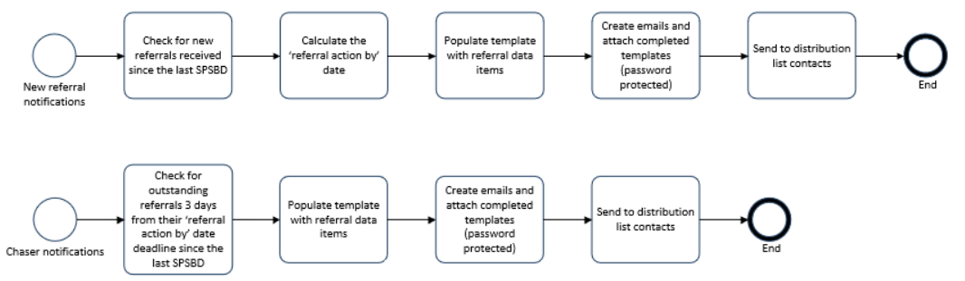
CDSP resources will manually collate and inform elected DNO/IGT contacts, as identified on the distribution list, for new and outstanding referrals.

Referral Type | Referral Description
CAPACITY | Capacity Relevant Referrals
DISTANCE | Distance Relevant Referrals
GRIDREF | Grid Reference Relevant Referrals
PRIORITY | Priority Consumer Updates Referrals
SIGNATORY | Signatory– Shipper, Temporary or CSEP NeXA Referrals
SLSP | Seasonal Large Supply Point Referrals

- A new Referral will be notified once to the DNO/IGT in the Referrals Summary; the day following the Shipper Referral submission into the UKLP.
- An outstanding Referral approaching its SLA (action by date) will be notified once to the DNO/IGT in the Referrals Summary; three days prior to the Referral SLA (action by date).
- When there are no new or outstanding Shipper Referrals (as per 1 and 2) in the UKLP, the CDSP will not issue a Referrals Summary.
Referral Type | Referral Source | SLA Period | Chaser Notification
SLSP | NOM | 12 SPSBDs | 3 SPSBDs prior to the SLA
Capacity | NOM | 12 SPSBDs | 3 SPSBDs prior to the SLA
Capacity Decrease | AMD | 5 SPSBDs | 3 SPSBDs prior to the SLA
Capacity Increase | AMD | 21 SPSBDs | 3 SPSBDs prior to the SLA
Grid Reference | NOM or AMD | 12 SPSBDs | 3 SPSBDs prior to the SLA
Distance | NOM or AMD | 12 SPSBDs | 3 SPSBDs prior to the SLA
Priority | AMD | 12 SPSBDs | 3 SPSBDs prior to the SLA

Use of Referral Status for the Referral Summary

- NW (New) will be considered for any new Referral notifications issued in the Referral Summary and;
- PR (In Progress) and IN (In-Use) will be considered for any Chaser Notifications that should be issued

Multiple Party Referral

When a Referral requires multiple parties to review and action, for example, for an IGT site or Nested CSEP sites, the Referrals Summary will be issued to all those parties. The Referral ‘chaser’ Notification will only be sent to those parties where the action remains outstanding.

Referrals Notification Summary - Distribution List
- The Referral Summary (email attachment) will be issued by the CDSP to relevant contact(s) (from the agreed distribution list) via a single shared box account. The email can be responded to for queries but no decisions to action should be returned by email.
- For each DNO & IGT that wish to receive the Referrals Summary, contact details (email account) will need to be provided to the CDSP. This should include 2 contact points unless a box account is provided.
- The Referrals Summary distribution list will be maintained by the CDSP.
- DNOs & IGTs will need to advise the CDSP of any updates required to the contacts.

Email Template

An email will be issued with the Referral Notification Summary as an attachment, for example;

Dear Colleague,

Please find attached the Referral Notification Summary for referrals that are held in the UK-Link Portal (www.xoserveservices.com) which are either new and/or are within 3 SPSBD of the appropriate SLA and require your attention.

The Referral Notification Summary may include the following;

- SLSP
- Capacity
- Capacity Decrease
- Capacity Increase
- Grid Reference
- Distance
- Priority

The progression of the Referral Notifications remains the responsibility of your organisation and should be completed with the UK Link Portal.

Please do not respond to this email to action any referral decisions.

In the case of any queries associated with the attached Referral Notification Summary, please contact [….contact name…]

The email will contain a password protected Excel attachment; using the standard reporting password list currently used across other reports.

The Excel attachment will contain details of the new and outstanding referrals that require the DNO/IGT to action as outlined above.

The Excel attachment will contain the following data items:
- Type of Referral
- Associated MPRN
- LDZ
- Shipper
- IGT Short Code
- CSEP Reference
- Referral submission date
- Referral 'action by' date

Additional information
- The CDSP will not issue Referral Notifications for those referrals beyond the three 3 SPSBD reminder date
- The DNOs will continue to receive the Monthly Nomination Referral Report from the CDSP as-is
- The IGTs will continue to receive the IGR file from the CDSP as-is
- The CDSP will not action any Referrals in the UKLP at any point; the responsibility for actioning Referrals will remain with DNOs & IGTs

Associated Changes
Associated Change(s) and Title(s): | N/A

DSG
Target DSG discussion date: | 21/07/2025
Any further information:

Implementation
Target Release: | TBC
Status:
Cost Range: | The CDSP is proposing that associated costs will be absorbed by existing DSC S&O funding. The CDSP will monitor the levels of referral activity and reserve the right to seek approval from DNOs/IGTs for additional funding should it become necessary.

Industry Response Detailed Design Review
Change Representation
(To be completed by User and returned for response)
Please consider any commercial impacts to your organisation that Xoserve need to be aware of when formulating your response

User Contact Details: | Organisation: | Wales & West Utilities
User Contact Details: | Name: | Tom Stuart
User Contact Details: | Email: | tom.stuart@wwutilities.co.uk
User Contact Details: | Telephone: | 07964937739
Customer decision on Change Pack: | approved
Commercial impacts: | The notification will positively impact the referral process by improving the efficiency.
Representation Publication: | Publish
Representation Comments: | Currently, the way that Transporters are made aware of capacity or nomination referrals is by physically monitoring the UKLink system and this is done by periodically logging in to check if a referral requires action. Notifying the relevant transporter that a nomination requires actioning will make the process more efficient.  We therefore support this change and would like to opt-in to receive capacity and nomination referral notifications. Notifications that are for the attention of WWU should be send to the following mailboxes: DSM@wwutilities.co.uk & LTSAnalysisRequests_NMU@wwutilities.co.uk

Xoserve’ s Response
Xoserve Response to Organisations Comments: | Thank you for your response, this will be discussed at ChMC in August.

Please send the completed representation response to uklink@xoserve.com

Version Control

Document
Version | Status | Date | Author(s) | Remarks
1.0 | For issue | 14/07/25 |  | For consultationFor consultation

