Detailed Design Change Pack

Communication Detail
Comm Reference: | 3165.2 - VO - PO
Comm Title: | XRN5556.C –Contact Management Service (CMS) Rebuild – v1.2 – Revised Detailed Design Change Pack
Comm Date: | 17/04/2023

Change Representation
Action Required: | For Representation
Close Out Date: | 02/05/2023

Change Detail
Xoserve Reference Number: | XRN5556.C
Change Class: | Functional System
*ChMC Constituency Impacted: | Shipper All Classes  Distribution Networks (DNs)  Independent Gas Transporters (IGTs)
Change Owner: | James Barlow  James.Barlow@xoserve.com
Background and Context: | Please note: This Change pack is an update to the approved XRN556.C change pack, issued in October 2022, and following further customer feedback, proposes to add specified response files. This is a re-submission following a rejection and representation responses of the initial update issued in March 20  For clarity, all changes to the original text have been highlighted in grey with any removed text struck through.  What is the CMS Rebuild?  The current CMS system provides the ability for DSC Customers to query and update the data within their own portfolio. It is an ageing system that needs to be updated to cater for new ways of working and make it easier for customers to use. An extensive study was carried out with CMS users to understand their current pain points, requirements for a new version of CMS, and where possible business process improvements.  CMS Rebuild Delivery  CMS is being re-built using a family of methods and practices for flexible product delivery, called Agile. One of the key principles of this approach is to “satisfy the customer through early and continuous delivery of valuable solutions”.  The project will develop and test small parts of the product every few weeks, which can then be demonstrated to users during the customer focus groups, allowing early and frequent feedback. These small deliveries will be grouped into releases and a change pack will be issued per release.  Customer focus groups will continue the customer engagement and will allow users to feed into the delivery of the new solution and demo the latest developments in the Alpha Trials environment. If you would like to register for future sessions, please use this link. All minutes from these sessions will be published on the CMS Rebuild Page.  To support customers in learning and adopting the system and processes, we have launched ‘Alpha Trials’ in July to customer focus group attendees. This provides the trialists access to a test environment where they can try out the system and gain familiarity with new functionality and processes. Alpha Trials will also enable the CDSP to obtain real-time feedback from customers on the solution.  Further training on the new CMS solution and processes will be provided prior to go live.  The new version of CMS will start rolling out from Q4 2022, the first processes to be moved over to the new system will be Shipper Raised Meter Number Creation (MNC) and the Supplier Theft of Gas (SUT). Additional processes will then be released as detailed in the change packs.  CMS Rebuild Version 1 was launched in October 2022 with the Shipper Raised Meter Number Creation (MNC) and the Supplier Theft of Gas (SUT) processes.  CMS Rebuild Version 1.1 was launched in December 2022 with the Duplicate (DUP) and Set to Ex (STE) processes.  CMS Rebuild Version 1.3 is due to be launched in April 2023 with the Isolation (ISO) and Dead to Live (DTL) processes.  This change pack will cover the changes for CMS Version 1.2  CMS Rebuild Bulk Contact Upload  In consultation with the customer focus group, it is proposed that the functionality to upload a file with multiple contacts, of multiple contact types, is implemented prior to releasing high volume processes, such as Address Amendment Contacts (ADD).  We are targeting to release bulk Contact upload functionality in Q1 2023, this date will be firmed up and confirmed by the end of December 2022.  In consultation with the customer focus group, it is proposed that the following process will be delivered in version 1.2:  - Introduction of bulk contact logging functionality – BCL file  The functionality defined within this pack will continue to be referred to as release 1.2, however it will not be deployed until after release 1.3. The target deployment is June 2023.

Change Impact Assessment Dashboard (UK Link)
Functional: | Upload a file of multiple CMS Contacts, of multiple Contact types  The bulk upload of multiple CMS contacts via file, responses, and updates
Non-Functional:
Application: | New Contact Management Service (CMS)
User(s): | Shipper All Classes  Distribution Networks (DNs)  Independent Gas Transporters (IGTs)
Documentation: | BCL_File_Record_V1.0.pdf  BCL_File_Record_V1.1.pdf  BCL File Records_V1.2pdf  Bulk Contact Logging (BCL) file format backing info  Bulk Contact Logging (BCL) fields map to contact type/ Removals and changes from legacy QMP to BCL  Contact Resolution Response (CRR) file format_V0.2  Contact Status Change (CSC) file format_V0.2  Bulk Contact Rejection (BCJ) file format_V0.2  Bulk Contact Response (BCR) file format_V0.2
Other: | None

Files
File | Parent Record | Record | Data Attribute | Hierarchy or Format  Agreed
BCL | N/A | N/A | N/A | N/A
CRR | N/A | N/A | N/A | N/A
CSC | N/A | N/A | N/A | N/A
BCJ | N/A | N/A | N/A | N/A
BCR | N/A | N/A | N/A | N/A

Change Design Description
Please Note: This Change pack is an update to the approved XRN556.C change pack, issued in October 2022. The original change description, which has been approved, has been highlighted in grey. Where highlighted grey and struck through, the information has now been updated. Changes to the original proposal are detailed below for review.

Current Process for Bulk Contact Upload:

Current “.QMP” File

The existing version of CMS allows multiple contacts, of multiple contact types, to be raised via a file upload. This is done using a CSV file*, with a defined list of mandatory/supplementary data items, it is identified as the CMS file by using the “.QMP” extension, which stands for Query Management Protocol. The existing QMP File format can be found in the UK Link document secured area, the “.QMP” file format document is called QMP_File_Record_V3L.pdf.

* A CSV (Comma Separated Values) file is a plain text file where values are separated by commas. Microsoft Excel Spreadsheets can easily be converted to CSV format.

Current Upload Methods

A file with multiple contacts, of multiple contact types can be uploaded in two ways; either from CMS using the user interface or via the IX file transfer, see below for an illustration of both methods.
Figure 1
Current Method 1 – CMS UI “.QMP” Upload:
The existing version of CMS will check if the file is valid. The user must then initiate a file search to see if the file was accepted. The user can then click on the file to see a row-by-row response. If the requested contact was rejected the user can only see the row number (record id) and the rejection reason. To find the detail about what was submitted for this rejection you would need to open the file that was submitted and find the row number.

Current Method 2 – IX “.QMP” Upload:
For the small number of organisations that use the IX system to upload a “.QMP” file they will get a response file:

- If the QMP file was uploaded via the IX, and the file passed file validation, then a “.QMR” CVS file will be available for download, showing which of the contacts were logged in CMS and which were rejected.
- If the QMP file did not pass file validation, then a “.QMJ” CVS file will be available for download, and the Contacts will not be logged.

NB: If the file was uploaded via existing CMS UI response files are not provided, instead file search is used.

Current Contact Tracking Files:
There are also two files sent out via email to track the progress of Contacts raised.
- Every Sunday a “.QEX” CSV file* is sent via email to each stakeholder with all open contacts in their portfolio. The “.QEX” contains all their contacts that have changed status between Monday and Friday.
- A daily report is created Monday-Saturday (including Bank holidays) containing called “.QCL” CSV file*. A subset of information from the “.QCL file” is sent out via email showing the CRN and resolution message to each user who has a contact that has closed that day.

* Both the QEX and the QCL File include all Contacts raised, whether that was as a single contact via existing CMS, a file via CMS UI or a file via IX.

There is also a QEX and QCL email sent to the contact raising user showing a sub-set of the data included in the QEX or QCL file

Reason For Change:

The process to upload multiple CMS Contacts requires changes to resolve the current pain points.

The key pain point with bulk upload is the high customer effort required to identify and track Contacts submitted via a “.QMP. For example, after uploading a .QMP file it is difficult to identify and manage rejections as the level of detail provided by the CMS response is insufficient, currently only the row number and rejection reason are provided, meaning that this must be mapped back to the original file to link it back to the submitted Contact.

The second reason for changing the bulk contact logging process is that the business processes for each Contact type have been re-engineered to be leaner, resulting in two key differences:

- Less information is needed to raise some contacts (due to process streamlining)
- More Contact types can be raised via file upload (for example ISO)

The key reasons for changing the file format are that the business processes for each Contact type have been re-engineered to be leaner, resulting in three key differences:

- Less information is needed to raise some contacts (due to process streamlining)
- More information is required to raise some contacts to expedite investigation and resolution times (for example Request for Adjustment (RFA))
- More Contact types can be raised via file upload (for example Isolation (ISO))

Proposed Change:

There are two changes proposed, firstly a new file used to upload multiple CMS contacts to the new version of CMS, and secondly changes and improvements to tracking Contacts submitted via bulk upload.

There are three changes proposed:

- A new file format used to upload multiple CMS contacts to the new version of CMS named Bulk Contact Logging (BCL) file
- Improvements to tracking Contacts submitted via bulk upload
- New response file formats and removal of email sub-set.

- Uploading Multiple CMS Contacts

We propose that a new file is used to upload multiple contacts into the new version of CMS. This will also be similar to the current method in that it is a CSV file, with the ability to upload via the new CMS user interface or the IX with two differences:
- New extension “.BCL” (Bulk Contact Logging), instead of “.QMP”, this will help reduce any potential confusion during dual running.
- Different fields within the file, due to process streamlining and inclusion of more contact types (such as ISO, DTL), see attached fields <<LINK>>.

Organisation specific templates for the “.BCL” file will be made available.
The “.BCL” file will allow all of the same contact types as the “QMP” file, with the addition of:
- ISO: A challenge to the status of a Supply Meter Point (service pipe) that is shown on UK-Link to be live but which is not capable of consuming gas.
- DTL: A challenge to the status of a Supply Meter Point (service pipe) that is shown on UK-Link to be dead, but which is capable of consuming gas.
- Shipper MNC: A Shipper raised challenge to create a Meter Point Reference Number (MPRN) for an existing Live Supply Point where UK-Link has no record.
- Set MPRN to Extinct: A challenge to set an MPRN to Extinct, please see XRN5556.B October CMS Change pack

The following Contacts will not be included in the “.BCL” file:
- RECCo Supplier Theft of Gas (SUT) Contacts will not use this file format to upload Contacts, instead they will use a different set of fields, with the standard .CSV file extension.
- Filter Failures, as this is a historic process, which is no longer active.

Please note specific process files for Gas Safety Regulation (GSR) and files for Must Reads (MUR) will be detailed in the change pack for these Contact Types.

File Validation Checks:

The “.BCL” file will be validated to confirm:
- File size is less than 15Mb
- File size is greater than 0Mb
- File name does not already exist
- File name conforms with naming convention (see below)
- Username in the body of the file is a valid CMS user

“.BCL” File Naming Convention:

Characters | 1st - 3rd | 4th | 5th- 6th | 7th – 12th | File Extension
Naming Convention | SSC | . | PN | Sequential number carrying on from the last one from SSC | .BCL
Example | SSC.PN123456.BCL

- Uploading multiple CMS contacts

We propose that a new file is used to upload multiple contacts into the new version of CMS. This will also be similar to the legacy method in that multiple contacts can be logged via the new CMS user interface or through the Information Exchange (IX) to transfer the file to the CDSP which is then loaded into new CMS.
- When uploaded the BCL template via the UI can be saved with any naming convention and CMS will convert it into the necessary file format and assign a unique name e.g. SSC01.PN123456.BCL. Both the file name originally uploaded and the converted file name will be searchable to track the file progress
- When the BCL file is uploaded via the IX, a set naming convention will be used mirroring that used in the legacy CMS e.g. . SSC01.PN123456.BCL
- Different fields within the file, due to process streamlining and inclusion of more contact types (such as ISO and RFA). The proposed process improvements to the RFA process account for the majority of the additional fields and the RFA specific change pack containing all the relevant detail is planned to be issued next month, April 2023.

See attachment for the BCL file format pdf:

See attached for fields and optionality for each contact type mapped to the file format naming, and the fields from QMP file not in BCL and reason why:

See attached file format backing info containing field description, optionality and reason for addition or change from legacy QMP:

Stakeholder specific templates for the BCL file will be made available and downloadable directly from new CMS.

The BCL file will allow all of the same contact types as the legacy QMP file with the exclusion of Consumption Dispute Query (CDQ) which will be logged under the Request for Financial Adjustment (RFA) contact code, and Unconfirmed Address Amendment (UNC) which will be logged under the Address Amendment (ADD) contact code.

Contact type additions to the file are:

DMN – (Network raised MPRN Creation) A request to create a Meter Point Reference Number (MPRN) for a Live Supply Point where UK link has no live record and the MPRN is not known.

MNC – (Shipper raised MPRN creation) A request to create a Meter Point Reference Number (MPRN) for a Live Supply Point where UK link has no live record and the MPRN is not known.

ISO (Isolation Request): A challenge to the status of a Supply Meter Point (service pipe). Customer believes service is removed.

DTL (Dead to Live): A challenge to the status of a Supply Meter Point (service pipe). Customer has evidence that a service has not been removed.

AGG - Challenge to Twin Stream set up: Process used for logging a challenge to the set-up of a twin-stream configuration UKLink, either it is set up as such and shouldn't be or vice versa. Once logged the Contact is closed and the investigation is carried out offline

PSI - Challenge to Prime & Sub invoice: A challenge to the link code currently held on UK Link for a freestanding meter or a prime and sub meter configuration.

DMR - Daily Metered Reconciliation: A challenge to DM sites following or prior to invoice issue.

PRS - challenge to Prime and Sub-Configuration: A challenge to the link code currently held on UK Link for a freestanding meter or a prime and sub meter configuration.

FLE - File Enquiry: An enquiry regarding a rejection response you have received for an SPA File or a Contact Management Service file.

STE - Set to Extinct: A request to set an MPRN to Extinct that was incorrectly created

Please note, not all of these contacts are available for every stakeholder type and, specific process files for Gas Safety Regulation (GSR) and files for Must Reads (MUR) will be detailed in the change pack for these Contact Types.

File Validation Checks:
The “.BCL” file will be validated to confirm:
- File size is greater than 0Mb
- File name is unique
- Generation number is not lower than previous generation number (checked against those submitted via IX and generated when loaded via UI)

- Tracking Contacts Submitted by File

We propose bulk Contact upload files are tracked within the new version of CMS, which will involve changing the process pictured in figure 1 to the diagram below (Figure 3).

One of the differences proposed is that in the new process Contacts submitted via IX will now use the new version of CMS User Interface (UI) to confirm the file has been successfully uploaded and quickly identify any rejected Contact submissions, rather than using response files (.QMR or .QMJ).
Figure 3

Original figure removed and added to section 2 below

The new version of CMS will provide multiple tracking and search options, including:

- File Search (with filtering options)
- File Tracking (with filtering options)
- CRN Search (with filtering options)
- Advanced Search (with filtering options)
- Dashboard Reporting (in future releases)

Additionally, the new version of CMS will provide File Alert notifications.

File Notification Alerts:

When a “.BCL” file is uploaded, either via the new version of CMS or the IX, a file notification alert will be triggered for the username submitted in the file. The alert will only be shown to the raising user, however everyone in the raising organisation can view the files for their organisation.

File alerts will be presented in the same location as Contact alerts, as a small bell icon in the top right corner, as shown in the screen mock-up below. When the alert is selected, they will be taken to file tracking.

Tracking Contacts Submitted via Bulk Upload:

File tracking will be available via clicking on the file notification alert or searching for the file name, see below is a screen mock-up.

Original file tracking figure removed

Figure 4
Please note this mock-up screen have been shared to provide early sight of what the new CMS user interface may look like and, as such, are currently in development and subject to change.

The ‘File Status’ column will show if the file has been “Accepted”, or “Rejected”. If it has been rejected the reason will be displayed in the ‘Result’ column. If the file has been accepted two files that can be viewed:
- CRNs and key submitted contact information
- Rejections with key submitted contact information, this will resolve the pain point around identifying rejections, highlighted in the Reason for Change section.

- Tracking Contacts Submitted by File

Contacts submitted via the BCL can be tracked in different ways:

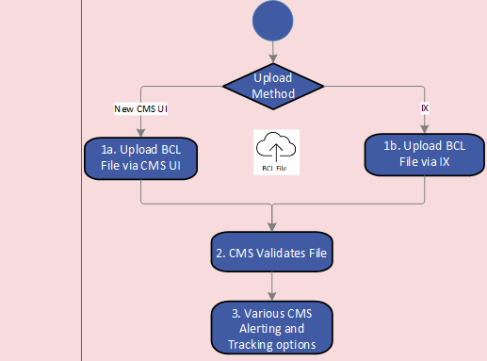

File tracking function – The success or failure of either the file or any records within the file can be viewed using the file tracking function. Once the file has been submitted, the progress of the file and record validation will be viewable, and once the validation completed two reports will be available and downloadable. One report will show the successfully logged Contact Reference Numbers (CRN) linked to the row and record in the uploaded file, and the other will show the rejected records linked to the row and record in the uploaded file, and the rejection reason(s).

File tracking screen mock-up:

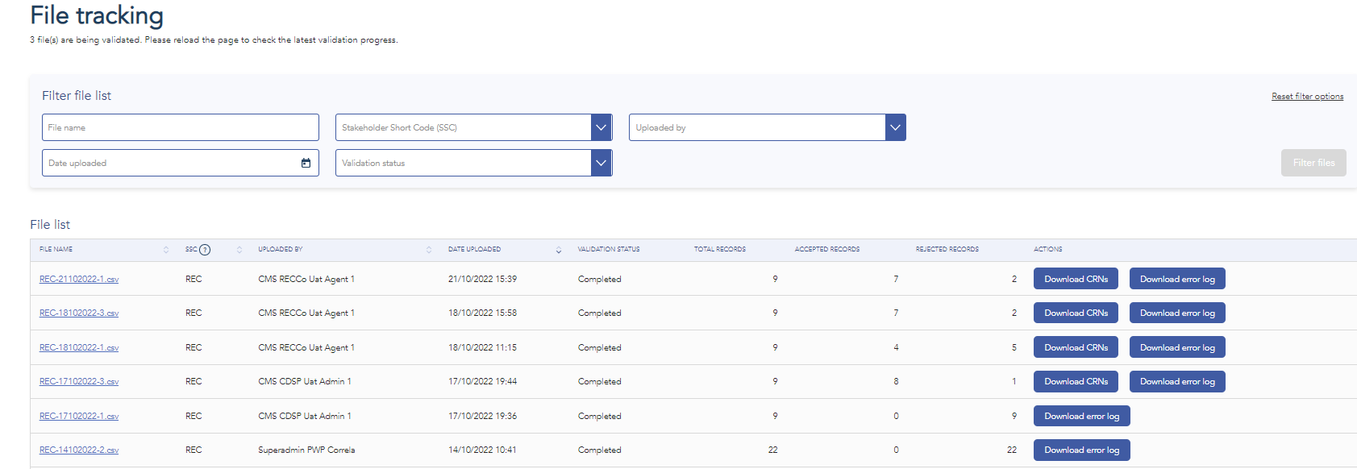
Note: the file naming convention is from a different file format and will appear differently for BCL file. An extra column will be visible which shows the name of the file that was uploaded so this can be tracked to the user’s own records

Rejected records downloaded report mock-up:

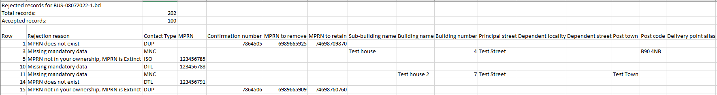

Accepted records downloaded report mock-up:

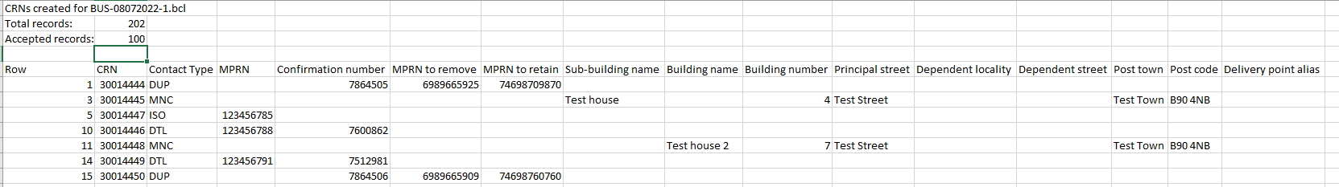

- Response files and notifications

File notification alerts – When a BCL file is uploaded via the UI a file notification alert will be triggered for the username submitted in the file. The alert will only be shown to the raising user, however everyone in the raising organisation can view the files for their organisation.

File alerts will be presented in the same location as Contact alerts, as a small bell icon in the top right corner, as shown in the screen mock-up below. When the alert is selected, they will be taken to file tracking.

Response files – When a BCL file is uploaded via the IX, and the file itself is rejected a Bulk Contact Rejection (BCJ) file will be issued to the raising organisation via IX. The file contains the rejection reasons for the file not being accepted. This file replaces the QMJ file which is issued following QMP files being loaded to legacy CMS. The file format will remain the same as the legacy equivalent QMJ file. The rejection codes will remain the same as those for the legacy equivalent QMJ file and will be published on the CMS Rebuild web page.

When the BCL file is uploaded via the IX, and the file is accepted, a Bulk R Response (BCR) file will be issued to the raising organisation via IX. The file contains detail of each of the accepted records and any rejected records with reason code. This file replaces the QMR file which is issued following QMP files being loaded into legacy CMS. The file format will remain the same as the legacy equivalent QMR file.

See attached file formats:

Contact update files - The system will send a new version of QEX file for new CMS to be named the Contact Status Change file (CSC) and a new version of the QCL file to be named the Contact Resolution Response (CRR) file.

The CSC file will provide an update of all open contacts which have had status changes over the last week providing the latest position. This file will be issued once a week on a Sunday.

The CRR file will provide detail of all contacts which have been resolved, providing detail on the outcome of the resolution. This file will be issued daily.

These files will have the same fields, to avoid unnecessary changes to systems, as the legacy files but are renamed to avoid confusion while legacy CMS and new CMS run in tandem. They do though have some minor changes to field length in a few fields. Both files will be sent via IX.

See attached file formats:

Please note maximum occurrences in response and update files have not yet been finalised, however, this will be confirmed by the CMS rebuild team following further development.

There will not a reduced email version issued for the CRR file as new CMS will in a future release expand the notification functionality to provide this detail in both emails and within the system. This functionality will be configurable to each user so they may determine how and when they are notified.

Transition:

During dual running there will be two file types for raising multiple CMS Contacts:
- Contact types that have not moved over to the new version of CMS yet should be submitted using a “.QMP” file to the older version of CMS.
- Contact types that have moved over to the new version of CMS should be submitted using a “.BCL” file to the new version of CMS.

The latest information of which Contact types have been moved over to the new version of CMS will be available on CMS Rebuild Product page.

When all Contact types have moved over to the new version of CMS the “.QMP” file type will be decommissioned.

Associated Changes
Associated Change(s) and Title(s): | XRN5556 CMS Rebuild parent

DSG
Target DSG discussion date: | 20/03/2023
Any further information: | None

Implementation
Target Release: | Q1 2023  Q3 2023 (targeting June 2023)
Status: | For approval
Please see the following page for representation comments template; responses to uklink@xoserve.com

Industry Response Detailed Design
«RangeStart:HDS»
Change Representation
(To be completed by User and returned for response)
User Contact Details: | Organisation: | «h1_organisation»
 | Name: | «h1_name»
 | Email: | «h1_email»
 | Telephone: | «h1_telephone»
Representation Status: | «h1_userDataStatus»
Representation Publication: | «h1_consultation»
Representation Comments: | «h1_userDataComments»
Confirm Target Release Date? | «h1_targetDate» |  | «h1_userDataAlternative»

Xoserve’ s Response
Xoserve Response to Organisations Comments: | «h1_xoserveResponse»

Please send the completed representation response to uklink@xoserve.com

«RangeEnd:HDS»

Change Management Committee Outcome
Change Status: | ☒ Approve | ☐ Reject |  |  | ☐ Defer
Industry Consultation: | ☒ 10 Working Days |  | ☐ 15 Working Days
 | ☐ 20 Working Days |  | ☐ Other [Specify Here]
Date Issued: | 17/04/2023
Comms Ref(s): | 3165.2 - VO - PO
Number of Responses: | 1
Solution Voting: | ☒ Shipper |  |  | Please select.
 | ☐ National Grid Transmission |  |  | Please select.
 | ☒ Distribution Network Operator |  |  | Please select.
 | ☒ IGT |  |  | Please select.
Meeting Date: | 10/05/2023
Release Date: | Adhoc

Please send the completed representation response to uklink@xoserve.com

Version Control

Document
Version | Status | Date | Author(s) | Remarks
Version 1.0 | Issued | 13.10.2022 | Laura Poole
Version 1.1 | Issued | 13.03.2022 | Richard Cresswell
Version 1.2 | Issued | 14.04.2023 | Richard Cresswell

