Detailed Design Change Pack

Communication Detail
Comm Reference: | 3364.1 - RT - PO
Comm Title: | XRN5781.2 Energy Identification Code (EIC) Change
Comm Date: | 14/04/2025

Change Representation
Action Required: | For Representation
Close Out Date: | 30/04/2025

Change Detail
Xoserve Reference Number: | XRN5781.2 This change is raised as a ‘child ‘change associated with the umbrella XRN5781.
Change Class: | Functional
*ChMC Constituency Impacted: | National Gas Transmission, Shippers, TSOs
Change Owner: | Geminiengagement@correla.com
Background and Context: | The purpose of this Change Pack is to provide detail regarding an amendment required by National Gas to change the organisational EIC (Energy Identification Code) value in the Gemini system and to share an indicative delivery timeline of the change.  National Gas require the Energy Identification Code (EIC) in the Gemini system to be updated from the National Grid EIC of 21X-GB-A-A0A0A-7 to the National Gas EIC of 55XNATIONALGASTC.  EIC Codes are a mandatory item required to facilitate the transfer of data between National Gas and PRISMA, NG’s adjacent TSO partners and potentially certain APIs used by Shippers. There is an expectation that parties who interact with impacted files and APIs will also have to make a corresponding change to the EIC Code at the same time to ensure the continued flow of data. Therefore, robust testing and clear communication of changes is vital to the success of this change.  Affected parties and systems are:  - National Gas Transmission (due to Gemini changes)  - Shippers (Who use certain impacted APIs)  - Adjacent TSOs (who interface with Gemini)  - PRISMA (who interface with Gemini)  Having consistent EICs is a pre-requisite for the completion of the system to system ‘handshake’ that facilitates a number of UNC obligated processes (as shown in the example below).  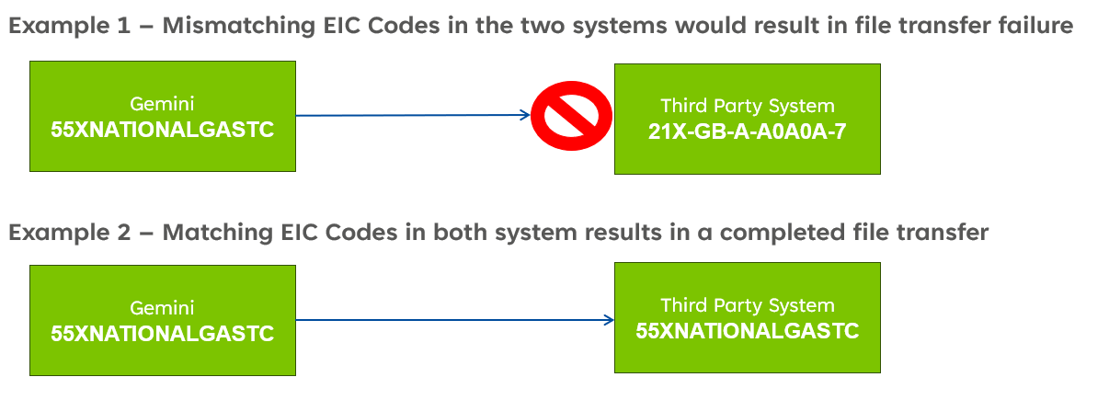  This change will be implemented as soon as feasible following the deployment of the Gemini Sustain Plus Programme. Consideration needs to be given to the need for a robust testing period that can be supported by impacted parties. It is therefore anticipated that this change will be delivered mid July 2025.  An indicative timeline has been included which demonstrates the activities needed to support this change and test phases with impacted parties that will be required ahead of implementing the change. Testing with impacted parties and alignment of the go live date across all parties will be crucial to the success of this change. The timeline also allows for engagement prior to testing to ensure that all needed prerequisites to testing are accommodated.  Following the close out of the representation period of this Change Pack, Correla will provide a further Change Pack to share a more detailed plan of activity and a confirmed deployment date for the change that can be accommodated by impacted parties.

Change Impact Assessment Dashboard
Functional: | The level of change within Gemini is minimal requiring only a data level update rather than a file format change, as the EIC Code is already included within the file format. Completion of the datafix will allow the system to consider the appropriate National Gas EIC Code for all file/message validation and exchanges with TSOs, PRISMA and Shippers. To confirm, File Format changes are not needed to support this requirement.  System Integration testing between Gemini and third party impacted systems and aligning any third-party changes will be critical to ensure the go live activity is coordinated and the risk of file failures due to mismatching EIC codes is mitigated.
Non-Functional: | n/a
Application: | Gemini
User(s): | Shippers, TSOs and PRISMA.
Documentation: | n/a
Other: | None

There are no File changes that are part of this Change Pack.
File | Parent Record | Record | Data Attribute | Hierarchy or Format  Agreed
NA | N/A | N/A | N/A | N/A

Change Design Description
- Solution Overview

Datafix activity will be undertaken on the Gemini system to change the National Grid EIC code.

There are two impacted APIs used by Shippers. In order for these APIs to successfully process once the datafix activity has completed, the EIC parameter will need to be changed to 55XNATIONALGASTC by Summer 2025. No change to the API structure is required. Exact date to be agreed and confirmed.

Shipper APIs:

  - Add Update IP Nomination API - It is used by the shipper to place EU Nominations and the EIC code is a mandatory data requirement.
  - View IP Nomination API - It is used by the shippers to view EU Nominations. The EIC code is optional, but if provided is validated.

Configuration changes will need to be made to these APIs to ensure that processing is successful once the EIC code has been updated.

There are also a number of interface files with PRISMA and TSOs which will need to be updated. These will be managed directly with the TSOs and PRISMA.

For the avoidance of doubt, all EIC code changes (Gemini and third party) will need to happen simultaneously to ensure the continued flow at data on the impacted APIs and files.

Activity within the delivery timeline includes Focus Group sessions that will be planned by the Gemini Project team to share updates on the project and review progress on readiness activities in the build up to the go live date.

Associated Changes
Associated Change(s) and Title(s): | XRN5781 ‘Parent’ XRN for inflight Gemini changes during Gemini Sustain Plus programme.

DSG
Target DSG discussion date: | Not Applicable
Any further information:

Implementation
Target Release: | To support National Gas separation activity, this change is required to be completed as soon as is feasible following the Gemini Sustain Plus implementation. A target date will be agreed for Summer 2025 and communicated in a further Change Pack for this XRN.  Due to the nature of the change, we are proposing a notification window of 3 months.
Status: | For representation.

Industry Response Detailed Design Review
«RangeStart:HDS»
Change Representation
(To be completed by User and returned for response)

Please consider any commercial impacts to your organisation that Xoserve need to be aware of when formulating your response

User Contact Details: | Organisation: | «h1_organisation»
 | Name: | «h1_name»
 | Email: | «h1_email»
 | Telephone: | «h1_telephone»
Customer decision on Change Pack: | «h1_userDataStatus»
Commercial impacts: | «h1_commercial_impacts»
Representation Publication: | «h1_consultation»
Representation Comments: | «h1_userDataComments»

Xoserve’ s Response
Xoserve Response to Organisations Comments: | «h1_xoserveResponse»

Please send the completed representation response to uklink@xoserve.com

«RangeEnd:HDS»

Change Management Committee Outcome
Change Status: | ☐ Approve | ☐ Reject |  | ☐ Defer
☐umber of Responses:
Solution Voting: | ☐ Shipper |  | Please select.
 | ☐ National Gas Transmission |  | Please select.
 | ☐ Distribution Network Operator |  | Please select.
 | ☐ IGT |  | Please select.
Meeting Date: | 01/01/0001
Release Date: | Release: Feb / Jun / Nov XX or Adhoc DD/MM/YYYY or NA

Please send the completed representation response to uklink@xoserve.com

Version Control

Document

Version | Status | Date | Author(s) | Remarks
0.1 | Draft |  | Correla | Draft for review

