High Level Solution Options Change Pack

Communication Detail
Comm Reference: | 3373.1 - KL - PO
Comm Title: | XRN5569 Contact Data Provision to IGT Customers
Comm Date: | 12/05/2025

Change Representation
Action Required: | For Representation
Close Out Date: | 27/05/2025

Change Detail
Xoserve Reference Number: | XRN 5569
*ChMC Constituency Impacted: | Independent Gas Transporters (IGTs)
Change Owner: | uklink@xoserve.com
Background and Context: | Contact data of varying types is provided to IGTs via established daily delta data flows by the CDSP for MPRNs that are contained within the respective IGTs portfolio. However, this information is only a subset of the total information help within CDSP systems.  Following the implementation of XRN4850, Xoserve receives customer contact data from energy Suppliers and Shippers, which is used to support the Broadcast and Extract Service. This data is not shared openly with IGTs and can only be accessed via specified Use Cases.  Consequently, IGT organisations do not currently have full visibility of customer contact data that is held within UK Link systems against IGT Supply Meter Points that are within the relevant IGT organisations portfolio.  The lack of visibility of this data can inhibit IGTs in being able to conduct associated business activities, which can present challenges in being able to address queries that may exist against associated properties and reduce the completeness of data that IGTs require to have access to, and use, in their role as licensed Gas Transporters.  Specifically, IGT Customers request visibility of contact data provided to the CDSP via the BRO Contact Type, as supplied by Shipper organisations within the S66 Record.  Namely the following Data items are being requested;  - MPRN  - Customer Name  - Contact Name  - Contact Telephone Number  - Contact Email address  - Customer Email 1  - Customer Email 2  - Customer Email 3  - Customer Email 4  - Customer Telephone 1  - Customer Telephone 2  - Customer Telephone 3  - Customer Telephone 4  - Customer Mailing Address  - Preferred contact Method  Following review with IGT customers, it was confirmed that any solution that is progressed should ensure only those parties that choose to receive and consume the additional customer contact data are required to adopt the solution – i.e. changes should not be universally applied to all IGTs.

Solution Options
Solution Option Summary: | IGT Customers require full visibility of their portfolio’s customer contact details. The current Broadcast and Extract Service functionality on the UK Link Portal provides a mechanism to extract these details but it is limited to a single MPRN only.  IGT organisations require an extract containing all the MPRNs data within their relevant portfolio in a bulk format.  To support the requirements that have been captured for this change, the ‘to-be’ solution would need to introduce a new, ‘Secure Delivery’ step into the existing process – which would enable customer contact data to be provided in bulk to IGT customers;  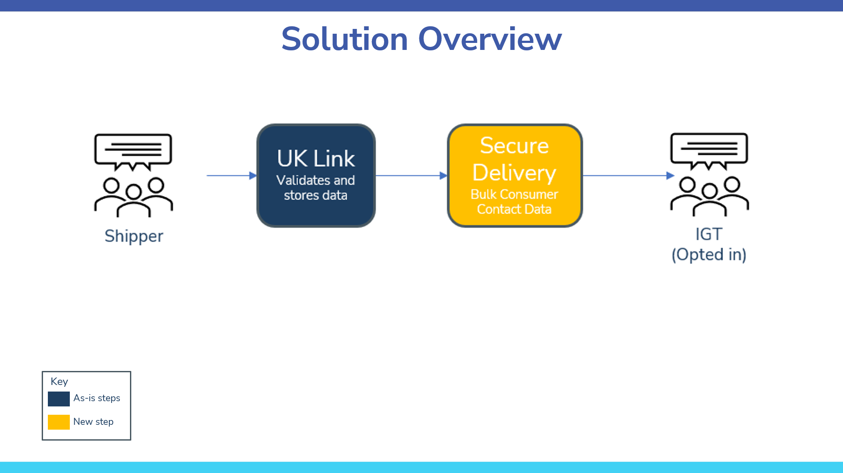  For all solution options, any files generated by the ‘Secure Delivery’ process step, will need to be sent to a predefined location. Due to the highly sensitive nature of the data, generated files can only be issued via recognised, secure file transfer methods, i.e. either EFT/IX or SFTP MOVEit.  Additionally, to satisfy the Use Case for Extract purposes, a mechanism needs to be put in place to confirm how each Extract adheres to the terms of the permitted Use Case, so that this can be captured for compliance and audit purposes.  As a result of the above, four solution options have been identified that meet the prescribed requirements of the new ‘Secure Delivery’ process step;  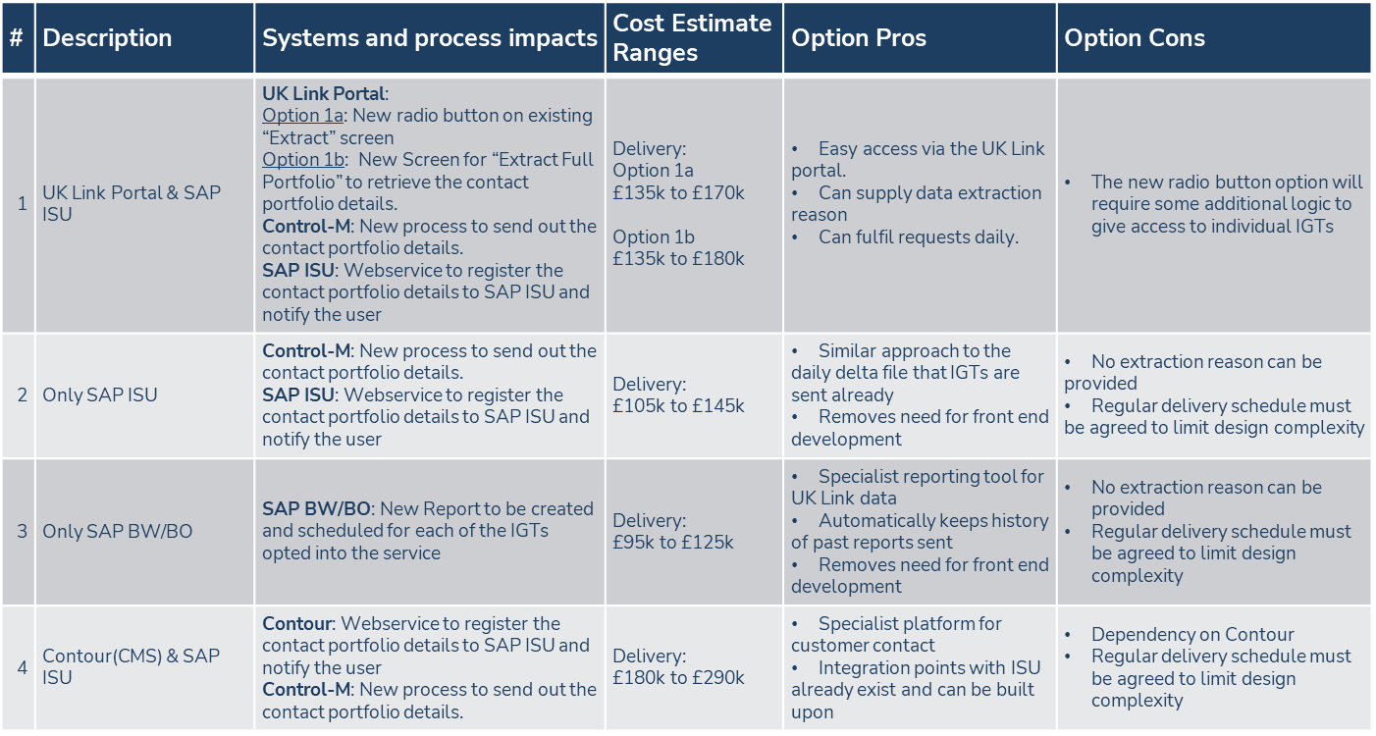  Only Solution Option 1 (a and b) and Option 4 offer a fully technical means of capturing Extract purpose per request – with Solution Options 2 and 3 needing an alternative contractual mechanism to capture and agree the Extract purpose where data has been supplied to a requesting IGT customer.  The costs for each solution option (illustrated above) are high level cost estimates, and will only be fully defined once detailed design has been performed on a preferred solution option.  Further detail on the options outlined above can be found in the presentation attached
Proposed Implementation Date: | Tbc – Dependent on agreed solution option
Xoserve preferred option:  (including rationale) | N/A
DSG preferred solution option:  (including rationale) | TBC

Service Lines and Funding – for each option
Service Line(s) Impacted - New or existing | New DSC Service Line(s) are likely to be needed to support the provision of this Service to IGT Customers
Level of Impact | N/A
Impacts on UK Link Manual/ Data Permissions Matrix | Detailed specification of the report / file format and delivery mechanism of the preferred solution option would be added to the UK Link Manual following implementation.  No impacts to the Data Permissions Matrix (DPM) have been identified

Industry Response Solution Options Review

«RangeStart:EDS»
Please consider any commercial impacts to your organisation that Xoserve need to be aware of when formulating your response
Organisation’s preferred solution option
User Contact Details: | Organisation: | «e1_organisation»
User Contact Details: | Name: | «e1_name»
User Contact Details: | Email: | «e1_email»
User Contact Details: | Telephone: | «e1_telephone»
Organisation’s preferred solution option, including rationale taking into account costs, risks, resource etc: | «e1_preferredSolutionOption»
Commercial impacts: | «e1_commercial_impacts»
Customer decision on preferred solution option: | «e1_dsgSolutionOption»
Publication of consultation response: | N/A
Xoserve’ s Response
Xoserve Response to Organisations Comments: | «e2_xoserveResponse»

«RangeEnd:EDS»

