Detailed Design Change Pack

Communication Detail
Comm Reference: | 3321.1 – LO - PO
Comm Title: | Detailed Design for XRN5784 - Modification 0862 Amendments to the current Unidentified Gas Reconciliation Period arrangements
Comm Date: | 18/11/2024

Change Representation
Action Required: | For Representation
Close Out Date: | 02/12/2024

Change Detail
Xoserve Reference Number: | XRN5784
Change Class: | Functional Change
*ChMC Constituency Impacted: | Shippers (All Classes)  *Assumed impacted parties of the proposed change, all parties are encouraged to review
Change Owner: | uklinkdelivery@xoserve.com
Background and Context: | Modification 0862 “Amendments to the current Unidentified Gas Reconciliation Period arrangements” seeks to amend the Unidentified Gas (UIG) Smear period from 12 months to the whole month(s) in which the energy was taken. Due to increased numbers of meter points being read monthly, a 12-month smear is less accurate than it has been historically.  At the point of writing, the modification is currently under review by Ofgem. More information on the modification can be found here.  There was a single solution identified to deliver the required changes to the Central Data Service Provider (CDSP) system and processes as a result of the modification and, as such, the solution and detail design are being presented together in this Change Pack. More information on this change can be found here.

Change Impact Assessment Dashboard
Functional: | UIG Reconciliation & Invoicing
Non-Functional: | Volume – ASP K91 potential record occurrence increase, within occurrence limit
Application: | UK Link (SAP ISU)
User(s): | Shippers
Documentation: | None
Other: | None

Files
File | Parent Record | Record | Data Attribute | Hierarchy or Format  Agreed
N/A | N/A | N/A | N/A | N/A

Change Design Description
For the CDSP to amend the UIG Smear period from 12 months to the whole month(s) in which the energy was taken, smear periods for LDZ Offtake, Insignificant LDZ Measurement Errors and Offline Reconciliations will be aligned the same way as proposed for the UIG Reconciliation Smear. Significant LDZ Measurement Errors Reconciliation, however, which already follows the month(s) energy was used as the logic. These Reconciliations all feed into the UIG Smear.
UIG Reconciliation Smear will use historical throughput values and AUGE weighting factors relevant to the UIG Reconciliation period. UIG will also be reconciled back to LIS and Unidentified Gas Reconciliation (UGR) Charges will be aggregated the same as today (Shipper, LDZ, EUC, Class type and Billing Period level) which are issued within the Amendment Invoice (.ASP file) and supporting information. These charges appear in the K91 record in the .ASP file and require no changes to the file format or allowable occurrence value.

To Be Process Model
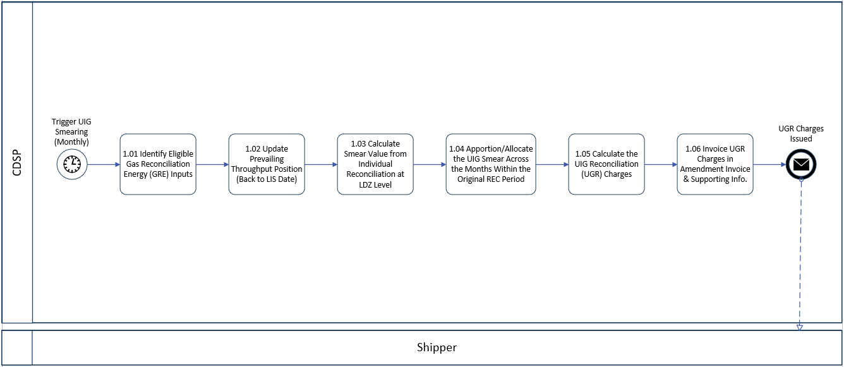
Figure 1: The To Be Process Model for the UIG Smear Period Amendments. Steps 1.03 & 1.04 are the areas which have been amended for this change.

- The UIG Smearing is triggered monthly after the tenth calendar day, post Amendment invoice cut-off date.
- As part of the Smear process applicable Reconciliations (1.01) for the billing month and updates the Throughput positions (1.02).
- Here the system will calculate the Smear Value based on the individual Reconciliations, back to LIS date (1.03) and then apportions the UIG Smear across the months of the original reconciliation period for each UIG group, within each LDZ (1.04).
- This is where the changes are being made in 1.03 and 1.04, from using 12-month smear period to months of the individual Reconciliations (month(s) when the energy was used).
- This then leads to the calculation of UGR Charges (1.05) and then Invoicing those charges to the relevant Shipper(s) (1.06) in the Amendments invoice and supporting information (.ASP file K91 record).

Due the change in the UIG Smear periods, the consequential impact to Shippers would be that they would potentially see the K91 record having more occurrences within their respective monthly .ASP file. However, as previously mentioned, the estimated volumes would still be within the 900,000 occurrence value currently defined within the .ASP File Format.
The estimate is based on full 48 months of UGR Charges in a March Amendment Invoice. using Class 3 and 4s against 702 EUCs (39 EUCs in 18 LDZs) which would total around 67k records. There are very few Class 1 and 2 sites and would make little impact on the total record count, so have not been used in the estimation.

In addition, due to this being an established service, provisions for queries and exceptions are already in place.

Cost Range & Timelines
Following detailed design, the overall size and cost of the change required to update the CDSP systems and processes have reduced from those presented in the original Rough Order of Magnitude (ROM) generated for the modification workgroup. These are as follows:

Original ROM cost range: £130K to £250K
Cost range of design proposed above: £85K to £115K

The original timeframe was assessed at 16 weeks, not including Post Implementation Support (PIS) (estimated at 4 weeks). Through further investigations during this design phase, the timeframe has been narrowed down and this is shown below:
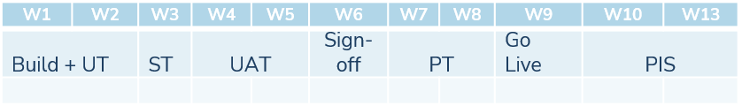

Associated Changes
Associated Change(s) and Title(s): | N/A

DSG
Target DSG discussion date: | 25/11/2024
Any further information: | To provide an overview of the changes to the detailed design

Implementation
Target Release: | Release: June 2025 or Ad hoc
Status:

Industry Response Detailed Design Review
Change Representation
(To be completed by User and returned for response)
Please consider any commercial impacts to your organisation that Xoserve need to be aware of when formulating your response

User Contact Details: | Organisation: | Centrica
 | Name: | Lee Greenwood
 | Email: | lee.greenwood@centrica.com
 | Telephone: | 07376360749
Customer decision on Change Pack: | Defer
Commercial impacts: | The inclusion of the Supply ID would result in reduced costs and streamlined administrative processes. This change would benefit other industry participants by simplifying the management of UIG and enhancing the accuracy of its allocation.
Representation Publication: | Publish
Representation Comments: | The current methodology splits UGR in a relatively arbitrary way with UGR even splits allocated across the last 12 months, shippers with multiple supply IDs may split their UGR charges between supply IDs in a similar arbitrary way.  With the implementation of this modification the invoice data now provides the information required to allocate the UGR to the settlement month (which is more cost reflective) but not between Supply IDs which we believe is an oversight.  Adding the Supply ID to the invoice fits with the aims of the modification in increasing accuracy and fairness of UGR allocation as well as streamlining administrative processes and reducing the complexity of managing UIG.

Xoserve’ s Response
Xoserve Response to Organisations Comments: | Xoserve is responding back directly with Centrica and will update the industry at ChMC

Please send the completed representation response to uklink@xoserve.com

Change Management Committee Outcome
Change Status: | ☐ Approve | ☐ Reject |  |  | ☐ Defer
Industry Consultation: | ☐ 10 Working Days |  | ☐ 15 Working Days
 | ☐ 20 Working Days |  | ☐ Other [Specify Here]
Date Issued: | 01/01/0001
Comms Ref(s):
Number of Responses:
Solution Voting: | ☐ Shipper |  |  | Please select.
 | ☐ National Gas Transmission |  |  | Please select.
 | ☐ Distribution Network Operator |  |  | Please select.
 | ☐ IGT |  |  | Please select.
Meeting Date: | 01/01/0001
Release Date: | Release: Feb / Jun / Nov XX or Adhoc DD/MM/YYYY or NA

Please send the completed representation response to uklink@xoserve.com

Version Control

Document
Version | Status | Date | Author(s) | Remarks
0.1 | Draft | 16/10/2024 | Helen Gilbert (BA) | Drafted
1 | Approved | 12/11/2024 | Helen Gilbert (BA) | Approved and uploaded

Template
Version | Status | Date | Author(s) | Remarks | Approved By
1.0 | Approved | 09/03/2022 | Rachel Taggart | Detail Design Change Pack transferred to own document | Change Management Committee on 09/03/2022
1.1 | Approved | 25/04/2023 | Rachel Taggart | Updated with new font branding | Emma Smith
1.2 | Updated | 14/08/2023 | Kate Lancaster | Updated with Representation tabs
1.3 | Updated | 25/06/2024 | Richard Hadfield | Updated to add cost range to Implementation section

