Detailed Design Change Pack

Communication Detail
Comm Reference: | 3256.4 - LO - PO
Comm Title: | XRN5719 - Provision of consolidated Specific Services Invoice and Supporting Information
Comm Date: | 12/02/2024

Change Representation
Action Required: | For representation
Close Out Date: | 26/02/2024

Change Detail
Xoserve Reference Number: | XRN5719
Change Class: | Documentation change
*ChMC Constituency Impacted: | Shippers, Distribution Network Operator (DNO), National Gas Transmission (NGT), Independent Gas Transporter (IGT)
Change Owner: | uklink@xoserve.com
Background and Context: | Each month at D+16, the CDSP issues customers with a PDF invoice attachment detailing the Specific Services that they receive. Additionally, some customers receive an additional email containing supporting information files for Must Reads and Class 1 Asset / Read charges – this is dependent on whether the charges are shown on the invoice as separate, itemised lines.  This change seeks to simplify the solution for both the CDSP and its customers by consolidating the information currently supplied to customers via multiple emails, by attaching any supporting information files to the Specific Service Invoice email. This will ensure that the customer receives all the information in one email.

Change Impact Assessment Dashboard
Functional: |  | None
Non-Functional: |  | None
Application: |  | SAP4HANA
User(s): |  | Shippers, DNO, NGT, IGT
Documentation: |  | Emails including: Specific Service Invoice, Must Read Supporting Information, Class 1 Supporting Information
Other: |  | None
File Changes
File | Parent Record |  | Record | Data Attribute | Hierarchy or Format  Agreed
None | None |  | None | None | None

Change Design Description
Change Summary
Currently circa 50 - 55 customers receive two emails per month – one which contains the invoice amount and the second reflecting their supporting information file(s). This creates additional efforts to validate and action within CDSP processes and creates similar efforts to customers in order for them to validate charges using the supporting information which is supplied separately.

The aspiration is to automate where possible, whilst ensuring a single email is generated and supplied to all customers, containing multiple attachments (i.e. PDF – Specific Service Invoice, Must Read Supporting Information, Class 1 Supporting Information)

The emails will continue to be secure (i.e. password protected zipped files and excel attachments) and delivered via the existing email mechanism. There is no expectation that the SAP4HANA system will move away from this email mechanism for the foreseeable future.
There will be testing after the planned SAP4HANA system upgrade in February to assess any impacts but there are no anticipated impacts at this time.

The distribution list will remain the same ensuring all current recipients continue to receive the information. The email will be sent on the same schedule and time as current emails, which were sent together.

It is noted that in order to accommodate consolidation of the supporting information within one email, the file names for supporting information will be longer and may contain special characters.

Customers will be consulted on any impacts the proposed changes may present, to ensure that we have a clear understanding and agreement from customers on the proposals before these are implemented to confirmed timescales. If any customers require separate emails for any reason, we can look to add as an exception, however, if the volume of exceptions is significant the change may need to be revised.

Example Email:
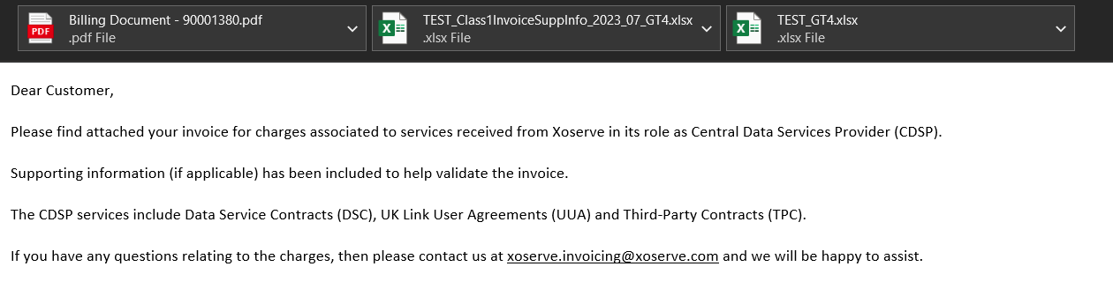

Associated Changes
Associated Change(s) and Title(s): | None

DSG
Target DSG discussion date: | 19/02/2024
Any further information: | To discuss any comments provided from the Detailed Design Change Pack representations.

Implementation
Target Release: | April 2024
Status: | For approval

Industry Response Detailed Design Review
«RangeStart:HDS»
Change Representation
(To be completed by User and returned for response)
Please consider any commercial impacts to your organisation that Xoserve need to be aware of when formulating your response

User Contact Details: | Organisation: | «h1_organisation»
 | Name: | «h1_name»
 | Email: | «h1_email»
 | Telephone: | «h1_telephone»
Customer decision on Change Pack: | «h1_userDataStatus»
Commercial impacts: | «h1_commercial_impacts»
Representation Publication: | «h1_consultation»
Representation Comments: | «h1_userDataComments»

Xoserve’ s Response
Xoserve Response to Organisations Comments: | «h1_xoserveResponse»

Please send the completed representation response to uklink@xoserve.com

«RangeEnd:HDS»

Change Management Committee Outcome
Change Status: | ☐ Approve | ☐ Reject |  |  | ☐ Defer
Industry Consultation: | ☐ 10 Working Days |  | ☐ 15 Working Days
 | ☐ 20 Working Days |  | ☐ Other [Specify Here]
Date Issued: | Click here to enter a date.
Comms Ref(s):
Number of Responses:
Solution Voting: | ☐ Shipper |  |  | Please select.
 | ☐ National Grid Transmission |  |  | Please select.
 | ☐ Distribution Network Operator |  |  | Please select.
 | ☐ IGT |  |  | Please select.
Meeting Date: | Click here to enter a date.
Release Date: | Release: Feb / Jun / Nov XX or Adhoc DD/MM/YYYY or NA
Please send the completed representation response to uklink@xoserve.com

Version Control

Document
Version | Status | Date | Author(s) | Remarks
V0.1 | Draft | 06/12/2023 | Benjamin Snell | Initial draft

