Detailed Design Change Pack

Communication Detail
Comm Reference: | 3216.1 – VO - PO
Comm Title: | XRN5651 - Updates to Class 3 and 4 Inner Tolerance Ranges used in Meter Read validation process – Detailed Design – For Information
Comm Date: | 30/08/2023

Change Representation
Action Required: | For Information
Close Out Date: | 12/09/2023

Change Detail
Xoserve Reference Number: | XRN 5651 | Xoserve
Change Class: | Functional
*ChMC Constituency Impacted: | Shippers, all Classes  *Assumed impacted parties of the proposed change, all parties are encouraged to review
Change Owner: | uklinkdelivery@xoserve.com
Background and Context: | Meter Read Tolerance Ranges are defined within the Uniform Network Code Validation Rules (UNCVR), which sets out the determined tolerances and ranges, based on the Supply Meter Points (SMP) Annual Quantity value, that are to be used by Shippers (and for the purpose of Class 1 Supply Meter Points the Daily Meter Service Provider) to determine that Meter Readings are Valid. These Meter Read Tolerance Ranges are also used by the CDSP to assure the Meter Reads received adhere to the UNCVR prior to processing into the Supply Point Register.  XRN5651 has been raised to improve the appropriateness of current Inner Tolerance Ranges for Class 3 & 4 Supply Meter Points, which have been confirmed as no longer meeting their original objectives due to a disproportional volume of read rejections being experienced during periods of increased consumption e.g. winter. These rejections in turn have resulted in increased manual processing effort for Shippers in order to correctly Validate the reads, and re-submit Readings where necessary, using Read Override functionality.  The change proposes that the following benefits should be achieved by customers;  - Improved Meter Read Acceptance Rates and Shipper Read Performance  - Reduced volume of Meter Read Rejection requiring re-work  - Improve timeliness of consumption calculation  Due to the nature of the proposed change, the solution option and detail design information are being presented together in this Change Pack. For reference the Change Proposal can be viewed here.

Change Impact Assessment Dashboard
Functional: | None
Non-Functional: | Update to Inner Tolerance Ranges applied in Meter Read Validation processes (configuration and parameterisation)
Application: | None
User(s): | Shippers, all classes
Documentation: | None
Other: | None

Files
File | Parent Record | Record | Data Attribute | Hierarchy or Format  Agreed
N/A | N/A | N/A | N/A | N/A

Change Design Description
Solution Definition
The solution and design proposed to meet the requirements of XRN5651 is aligned to the change description – in that any changes to the current UNC Validation Rules will be applied to central systems as soon as reasonably practicable.

For clarification, following August’s UNC Committee, the following updates to the UNC Validation Rules document (annotated in the table below) have been approval for implementation by UNCC;
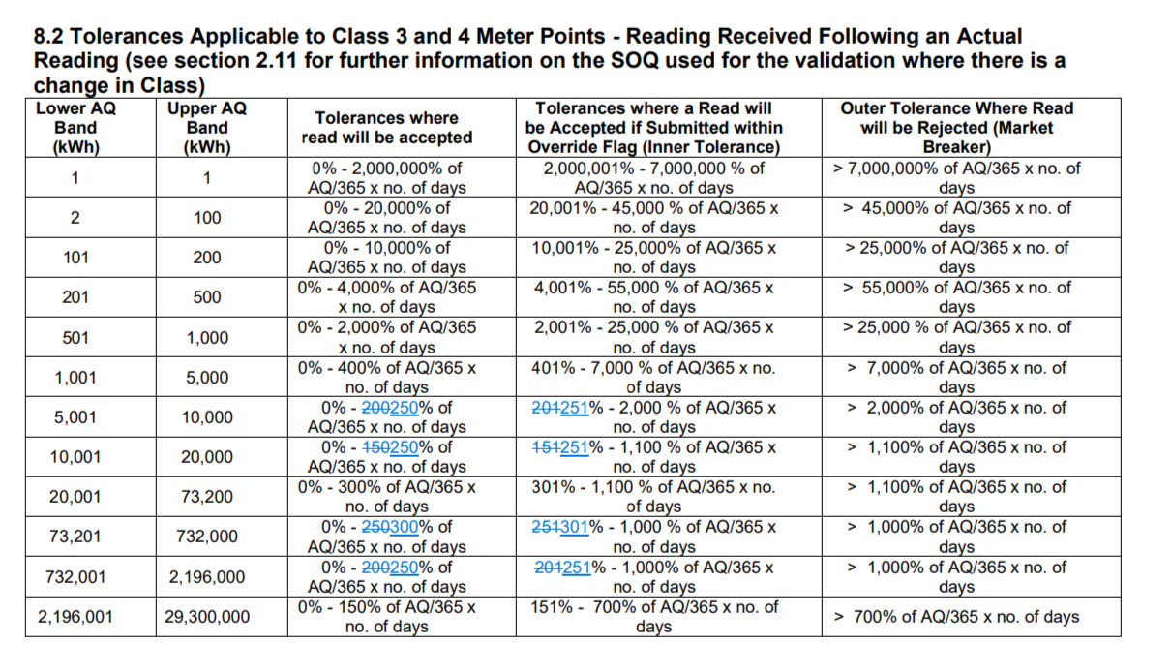
As detailed in the table, Class 3 and 4 Supply Meter Points with an Annual Quantity of between 5,000 and 20,000 kWh will have an increased upper Inner Tolerance Range to 250% of AQ/365 x no. of days. As a result of these changes, a corresponding increase to the percentage by which a Meter Read Override Flag will be accepted also will be revised from the current value to 251% accordingly.

In addition, Class 3 and 4 Supply Meter Points within AQ bands 73,201 – 732,000 and 732,001 – 2,196,000 will also see an increased upper Inner Tolerance Range to 300% and 250% respectively.

Full details of the approved modifications to the UNC Validation Rules document can be found here.

It has been confirmed that the new Inner Tolerance Ranges will remain under review on an ongoing basis to ensure these remain fit for purpose. Should any further opportunities be identified to improve the Inner Tolerance Ranges applied in the Meter Read validation processes, these will be discussed and agreed with customers via the agreed governance process.

Implementation Point and Lead Time
To ensure that the new, approved Inner Tolerance ranges are in place ahead of the next winter period it is proposed that changes are implemented within our September Minor Release, which is targeting implementation on 22nd September.

It is understood that Shipper Users who requested and endorsed the necessary changes to the UNC Validation Rules, would equally support implementation as soon as reasonably practical. Should customers have any feedback or commentary based on the proposed implementation date then this should be fed back by way of responding to this Detailed Design Change Pack.

As the proposed solution utilises existing process and system functionality there are no additional costs for customers.

Associated Changes
Associated Change(s) and Title(s): | N/A

DSG
Target DSG discussion date: | 01/01/0001
Any further information: | N/A

Implementation
Target Release: | Minor Release Drop 11 – 22nd September 2023
Status: | Approved

Industry Response Detailed Design Review
Change Representation
(To be completed by User and returned for response)

Please consider any commercial impacts to your organisation that Xoserve need to be aware of when formulating your response

User Contact Details: | Organisation: | SSE Energy Supply Limited
 | Name: | Mark Jones
 | Email: | mark.jones@sse.com
 | Telephone: | 07467646256
Customer decision on Change Pack: | approved
Representation Publication: | Publish
Representation Comments: | We agree with the new tolerances.

Xoserve’ s Response
Xoserve Response to Organisations Comments: | Thank you for your representation, we will feed this into ChMC for a final decision.

Please send the completed representation response to uklink@xoserve.com

Change Management Committee Outcome
Change Status: | ☒ For information | ☐ Reject |  |  | ☐ Defer
Industry Consultation: | ☐ 10 Working Days |  | ☐ 15 Working Days
 | ☐ 20 Working Days |  | ☒ Other 9 Working Days
Date Issued: | 30/08/2023
Comms Ref(s): | 3216.1 – VO - PO
Number of Responses: | 2
Solution Voting: | ☐ Shipper |  |  | Please select.
 | ☐ National Gas Transmission |  |  | Please select.
 | ☐ Distribution Network Operator |  |  | Please select.
 | ☐ IGT |  |  | Please select.
Meeting Date: | 13/09/2023
Release Date: | Minor Release 11

Please send the completed representation response to uklink@xoserve.com

Version Control

Document
Version | Status | Date | Author(s) | Remarks
1.0 | For Approval | 30.08.23 | Paul Orsler | Baselined following UNCC approval

Template
Version | Status | Date | Author(s) | Remarks | Approved By
1.0 | Approved | 09/03/2022 | Rachel Taggart | Detail Design Change Pack transferred to own document | Change Management Committee on 09/03/2022
1.1 | Approved | 25/04/2023 | Rachel Taggart | Updated with new font branding | Emma Smith

