Change Pack

Communication Detail
Comm Reference: | 3139.4 - VO - PO
Comm Title: | XRN5379 – Class 1 read service – Transitional arrangements
Comm Date: | 13/02/2023

Change Representation
Action Required: | For Information
Close Out Date: | 27/02/2023

Change Detail
Xoserve Reference Number: | XRN5379
Change Class: | Transitional arrangements
*ChMC Constituency Impacted: | Shipper Users (specifically with Class 1 Supply Meter Points (SMPs))
Change Owner: | Ellie Rogers  Regulation Change Manager  +441212292185  ellie.rogers@xoserve.com
Background and Context: | The link to Change Proposal XRN5379 can be found here.  Modification 0710S and IGT Modification IGT148, were raised to obligate the CDSP to take on Class 1 Read Service provision on behalf of Shippers. This was to transfer the obligation to provide the Class 1 Supply Meter Point Read Service from the Transporters to the CDSP.  As a result of Modification 0710S (and IGT148), it will be an ongoing responsibility of the CDSP to appoint a Service Provider on behalf of Shippers, to provide the Class 1 Daily Read Service from 01 April 2023 onwards. XRN5379 was raised in order to proceed with the procurement exercise to procure a Service Provider for the Class 1 read service and successfully transition the service under a new contract managed by the CDSP.  The Detailed Design was approved for XRN5379 at the November 2022 Change Management Committee (ChMC). Within that Detailed Design Change Pack, it stated the analysis to ensure a successful transition from current contract to the new contract was being undertaken.  This Change Pack has been raised for information only, to confirm the transitional arrangements that Shipper Users (specifically with Class 1 SMPs) should be aware of.

Change Impact Assessment Dashboard
Functional: | N/A
Non-Functional: | Transitional activities, process amendments
Application: | N/A
User(s): | Shipper Users (specifically with Class 1 Supply Meter Points), DMSP
Documentation: | No UK Link Manual documentation is expected to be impacted, but the below document will be included in the UK Link Documentation (Section 4 – Guidance Documents) which does not form part of the UK Link Manual, to provide guidance on the transitional process.  Document can be found here
Other: | N/A

Files
File | Parent Record | Record | Data Attribute | Hierarchy or Format  Agreed
N/A | N/A | N/A | N/A | N/A

Change Design Description
The information below details the transitional arrangements DSC customers should be aware of in terms of XRN5379 going live. This is to account for the transition from the current service under the Transporter and DMSP contracts to the new service and contract between the CDSP and the Class 1 service provider.

Consumption Adjustments

The UNC Section M states in the circumstances provided in the Code, an adjustment (“Consumption Adjustment”), to metered consumption shall be made in determined the amount of gas offtaken from the Total System at a Supply Meter Point.

There is currently a process in place to allow a Consumption Adjustment to be undertaken for Class 1 Supply Meter Points (SMP), where the circumstance allows and up to Line in the Sand (LiS)

This can be triggered by the Registered Shipper raising a DMQ (Daily Metered Query) within Contract Management Service (CMS). To confirm, a DMQ is a request for the Daily Metered Service Provider (DMSP) to investigate the daily read / consumption information of daily read equipment.

From 01 April 2023, the existing contracts between the DNOs and the current Class 1 service provider will end and a new contract will be in place for the Class 1 read service between the CDSP and the appointed Class 1 service provider.

As DMQ queries can be raised back to LiS, there is a possibility that a DMQ could be raised for the period managed under the existing contracts between the DNOs and DMSPs.

Below we’ve highlighted these scenarios and the proposed management of them for the transitional period. Please note, the below process will be in place until LiS from 01 April 2023, however, based on the nature of the queries raised under this process, we are expecting short-term use of the transitional arrangements.

Scenario 1: Adjustment start & end dates are wholly before (Gas Flow Day) GFD 01 April 2023

Instead of raising a DMQ query via CMS, the Shipper should raise the request via an ‘Invoicing query’ on the Xoserve website (please see below details on how this can be actioned).

Upon receipt of the request, the CDSP will contact the Shipper raising the request if further information is required to investigate and resolve.

The adjustment will be reflected within UK Link where the request is upheld. Please note, a DMQ contact will not be raised.

The steps involved in this process are detailed below and are captured in a guidance document which can be located in folder 4 of the UK Link Documentation SharePoint. Link here to the UK Link Documentation site:

  - From 01 April 2023, for DMQ queries for the period pre-01 April 2023, the request needs to be raised by the Shipper on the Xoserve website via an ‘Invoicing query’. This process will technically be in place up to LiS from 01 April 2023 but as previously highlighted, we expect queries to be raised relatively quickly which would make this a shorter term process.
    - On the Xoserve website, please go to Help Centre > Raise a Support Request.
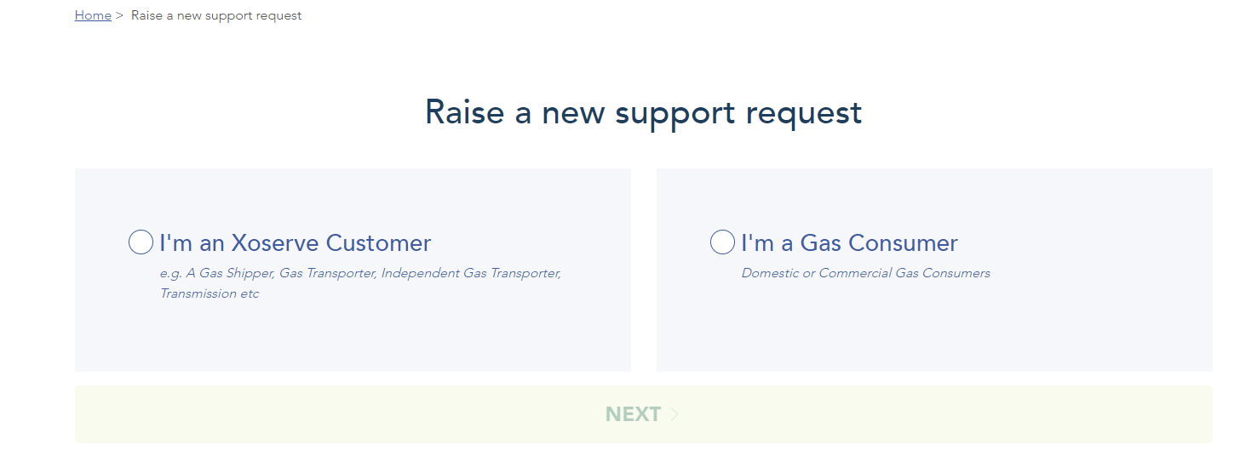
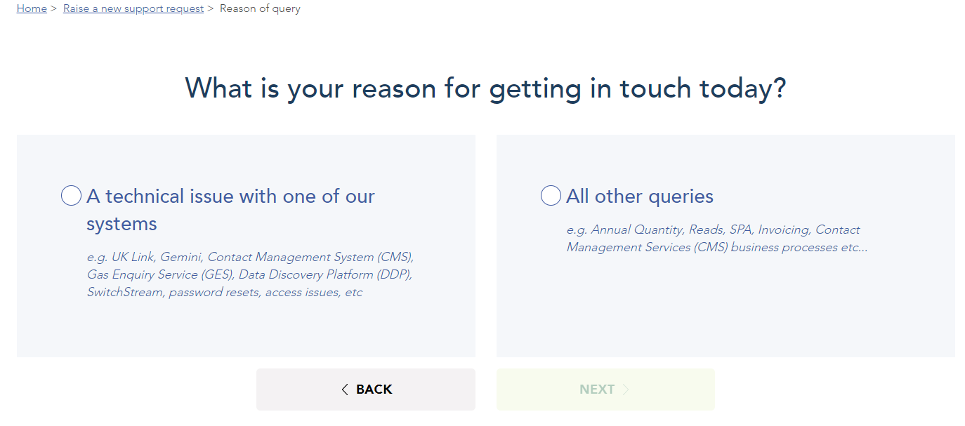
    - The following screen will appear, and the Shipper should select ‘I’m an Xoserve Customer’ and ‘Next’:

    - The following screen will appear, and the Shipper should select ‘All other queries’ and ‘Next’:

    - The following screen will appear, and the Shipper should select ‘Invoicing’ and ‘Next’. This should lead you to the Invoicing query section where you can populate the request:

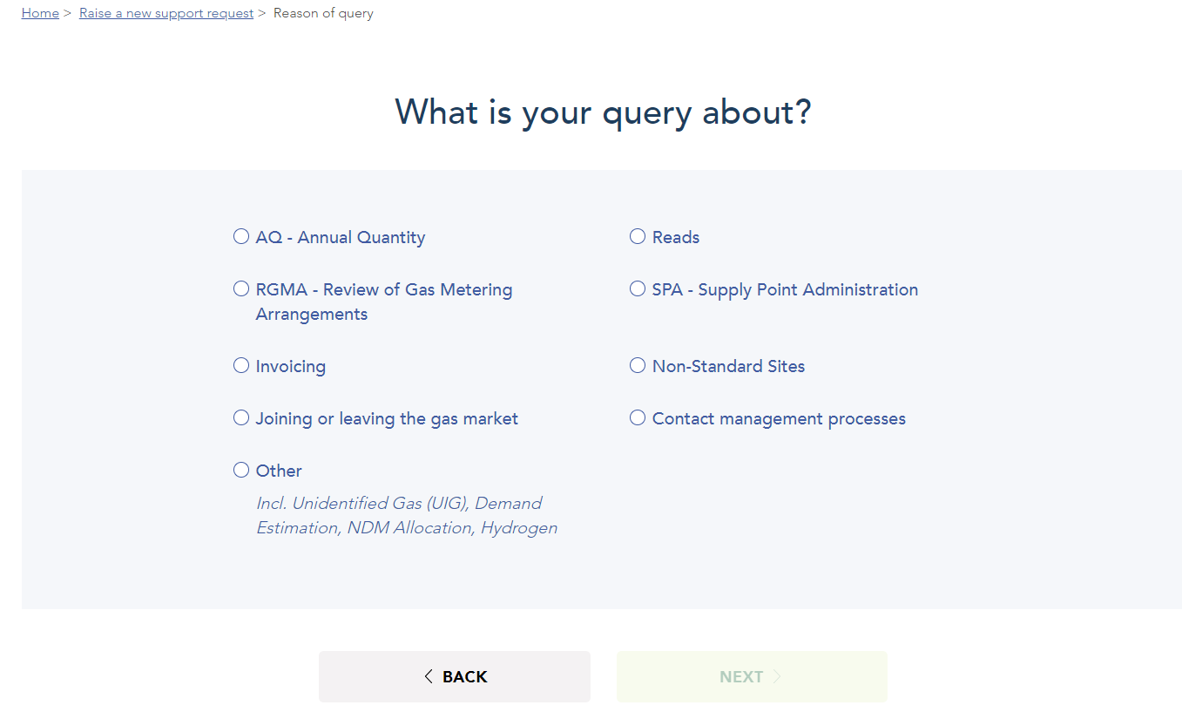

    - When populating the query description, please reference Class 1 Consumption Adjustment Query and provide the following information:
      - MPRN
      - Adjustment Query Start Date
      - Adjustment Query End Date
      - Reason for Adjustment Request
      - Supporting Information for Adjustment Request
        - Previous Site Visit Information
        - Reads
        - Asset Information

  - If further guidance is needed, please contact the recandrbd.billing@xoserve.com box account for support.
  - In the Description, please include all information to support the adjustment request as detailed above.
  - Notification of the outcome of the request will be provided by email to the originator.

Please note: Do not raise DMQ requests in CMS for queries that are wholly prior to 01 April 2023. If a DMQ is raised for a period completely prior to 01 April 2023, the request will be rejected by the new DMSP, with an instruction to raise the query via the above route.

Scenario 2: Adjustment start date is pre GFD 01 April 2023 and adjustment end date is post GFD 01 April 2023

The DMQ should be raised in CMS by the Shipper (as per the current process). Where additional information is required for the period prior to 01 April 2023, the CDSP may contact the Shipper for further information. Where the DMQ is upheld, the Class 1 service provider will raise the RFA (Request For Adjustment) for the adjustment to be processed and reflected in UK Link.

Please note: The current DMQ process for submission and resolution within CMS will remain as is.

Scenario 3: Adjustment start & end date is GFD 01 April 2023 onwards

The DMQ should be raised in CMS by the Shipper, and it will be routed to the Class 1 service provider in place from 01 April 2023.
The Class 1 service provider will assess the DMQ request and where required, raise the RFA for an adjustment for the adjustment to be processed and reflected in UK Link.

Please note: There is no change proposed to the existing process in this scenario. BAU activities should continue.

Continuity of Class 1 read information

To confirm, the transition from the current contracts and service to the new contract and service on 01 April 2023 will not impact the continuity of Daily Metered Class 1 SMP reads being obtained and provided to the CDSP (and onward to the Registered Shipper).

Under the existing contract, the service providers are responsible for providing a read every day for all Class 1 SMPs in scope of the service. As per the UNC, daily reads can be provided up to GFD+5 close-out.

From the 01 April 2023, the service provider will be responsible for providing the daily read file for the Class 1 SMPs in scope from this point onwards.

As per current process, the read files will be sent by the service provider to the CDSP and the Shipper will continue to receive the MDR – DAILY DATALOGGER READINGS FILE (.MDR), from the CDSP, confirming the information submitted for the SMP by the service provider.

Continuity of current optional Class 1 read services

Under the current service, parties can request a within-day read service to be provided by the service provider which gives more granular read information (hourly data).

Ahead of the 01 April 2023, any Shipper User and Gas Transporter receiving the within-day service under the current contract will be contacted by the CDSP to confirm they would like this service to be provided by the new Service Provider. Providing we receive confirmation on the service continuing by 10 March 2023, the CDSP will arrange with the service provider to continue providing the relevant service from 01 April 2023.

Please note, for parties that do not currently receive the additional services (within-day read service), to request this service to be provided by the new Service Provider, please send the request to the CDSP who will manage this with the Service Provider. The request should be sent to the following email address: class1reads@xoserve.com

Charges for this service have been shared at Contract Management Committee and are published here within the CDSP DSC Annual Charging Statement 2023-24:

Transitional invoicing arrangements

Please note, the new approach for invoicing for the service and crediting incentives will not commence until a full month of the service under the new contract has occurred. With this in mind, the implementation for XRN5379 is scheduled for 01 April 2023, therefore the first time the new charges will be issued via the DSC Specific Service Invoice will be May 2023.

This means the charges for the last month under the current service (March 2023), will be issued in April 2023 via the existing UK Link Invoices.

The last month under the current service in terms of liabilities (March 2023), will be issued in May 2023 via the existing UK Link Invoices as currently liabilities are issued 2 months in arrears.

Testing

To ensure a smooth transition to the new contract / service, the CDSP will be conducting test activities with the service provider. This is to ensure the daily read files sent by the service provider can be received and processed successfully from a central system perspective.

For the additional optional Class 1 read services (within-day read service), sample files provided by the new DMSP will be shared as part of a broadcast Communication nearer to Go Live with those parties currently using the service. we may look to test the files between the service provider and the customer (Shipper / Gas Transporter). This is not a mandatory activity but if conducted, we would look to reach out to those parties currently receiving the service to understand if any testing is required.

If you are interested in participating – please contact the following box account:

Class 1 SMPs with existing ‘Fault Flags’

The ‘Fault Flag’ can be utilised by the Registered Shipper or DMSP, to highlight where there is an issue at the site. This may relate to a fault with the Meter, Corrector or Data Read Equipment (DRE). This suspends the reads for the period the fault flag is raised. Once the issue is resolved either by an exchange via the RGMA process (Shipper) or an exchange of the DRE (DMSP) the previous reads for the fault period will remain suspended and the new reads will be processed as normal. If it is identified that the fault has been raised in error, the removal of the flag via the appropriate party will result in the suspended reads becoming unsuspended and processed in the normal way.

On transition Fault Flags that have been raised by the Shipper or DMSP prior to 01 April will remain. The faults can be removed as per the usual process identified in the paragraph above by the new DMSP and appointed Shipper.

Under the current service, the outgoing DMSPs will be notified of all Class 1 SMPs with an open ‘Fault Flag’ which they have raised. This is so they can confirm it is still valid or take action to close if possible.

As of 01 April 2023, under the new service, the new DMSP for the Class 1 read service will be aware of any Class 1 SMPs that have an open ‘Fault Flag’.

Associated Changes
Associated Change(s) and Title(s): | UNC Modification 0710S - CDSP provision of Class 1 read service (and the IGT equivalent, IGT Modification 148 - Provision of Class 1 meter read service on IGT networks by the CDSP)

DSG
Target DSG discussion date: | 20/02/2023
Any further information: | n/a

Implementation
Target Release: | Ad hoc March 2023 release for implementation on 01 April 2023
Status: | For information

Industry Response Detailed Design Review
RangeStart:HDS»
Change Representation
(To be completed by User and returned for response)
User Contact Details: | Organisation: | «h1_organisation»
 | Name: | «h1_name»
 | Email: | «h1_email»
 | Telephone: | «h1_telephone»
Representation Status: | «h1_userDataStatus»
Representation Publication: | «h1_consultation»
Representation Comments: | «h1_userDataComments»
Confirm Target Release Date? | «h1_targetDate» |  | «h1_userDataAlternative»

Xoserve’ s Response
Xoserve Response to Organisations Comments: | «h1_xoserveResponse»

Please send the completed representation response to uklink@xoserve.com

«RangeEnd:HDS»

Change Management Committee Outcome
Change Status: | ☐ Approve | ☐ Reject |  |  | ☐ Defer
Industry Consultation: | ☐ 10 Working Days |  | ☐ 15 Working Days
 | ☐ 20 Working Days |  | ☐ Other [Specify Here]
Date Issued: | Click here to enter a date.
Comms Ref(s):
Number of Responses:
Solution Voting: | ☐ Shipper |  |  | Please select.
 | ☐ National Grid Transmission |  |  | Please select.
 | ☐ Distribution Network Operator |  |  | Please select.
 | ☐ IGT |  |  | Please select.
Meeting Date: | Click here to enter a date.
Release Date: | Release: Feb / Jun / Nov XX or Adhoc DD/MM/YYYY or NA

Please send the completed representation response to uklink@xoserve.com

Version Control

Document
Version | Status | Date | Author(s) | Remarks

