High Level Solution Options Change Pack

Communication Detail
Comm Reference: | 3394.1 - KL - PO
Comm Title: | Inclusion of IGT MPRNs into specified existing DSC Processes
Comm Date: | 14/07/2025

Change Representation
Action Required: | For Representation
Close Out Date: | 28/07/2025

Change Detail
Xoserve Reference Number: | XRN 5732
*ChMC Constituency Impacted: | Independent Gas Transporters (IGTs)  *Assumed impacted parties of the proposed change, all parties are encouraged to review
Change Owner: | uklink@xoserve.com
Background and Context: | XRN5732 has been raised by IGT parties to address a gap in service coverage that has existed against IGT Supply Meter Points since both IGT039 Use of a Single Gas Transporter Agency for the common services and systems and processes required by the iGT UNC, and UNC Modification 0440 - Project Nexus – iGT Single Service Provision were implemented in June 2017.  Consequently, DSC processes that cover arrangements introduced under UNC Modifications such as 0424 and 0425, which relate to the management Unregistered Supply Meter Points, do not cater for IGT Supply Meter Points. This statement is equally applicable for services provided to Distribution Network customers relating to GS(I&U)R obligations.  This creates disparity in treatment and services afforded to IGT Supply Meter Points and prevents recognised processes that enable accurate data being recorded in the Supply Point Register from being applied to the entirety of Supply Meter Points recorded in Central Data Service Provider (CDSP) systems.  In the absence of central service functionality, IGTs have retained offline, bilateral processes with Shippers to highlight where discrepancies have been identified whilst fulfilling GS(I&U)R obligations and have had to retain separate records of this activity for compliance purposes.  It has become increasingly apparent that benefits could be achieved for Shippers and IGTs if these services can be mutualised and disparity in the treatment of IGT Supply Meter Points can be remedied from all specified processes.

Solution Options
Solution Option Summary: | Following detailed analysis of all specified existing DSC processes, two outstanding processes have been identified that do not currently support IGT Supply Meter Points. These have been confirmed as GSR (Gas Safety Regulation) and MUS (Manage Unregistered Sites) processes.  The proposed solution seeks to extend provision of these services to IGTs and IGT Supply Meter Points in an identical way to the way in which they are managed for Distribution Networks and GT Supply Meter Points.  To achieve this, the following aspects of the current solution have been highlighted as being impacted;  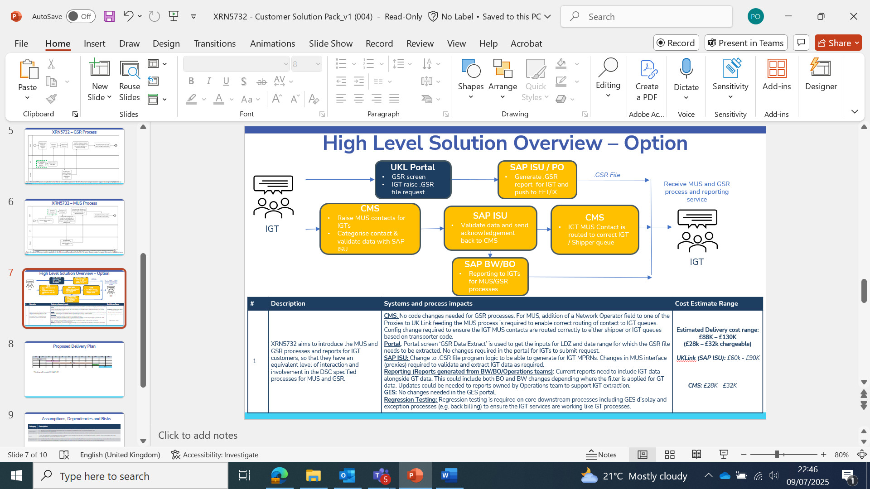  Detail confirming the type of changes required to each of the components of the solution and their related costs is available in the table below;  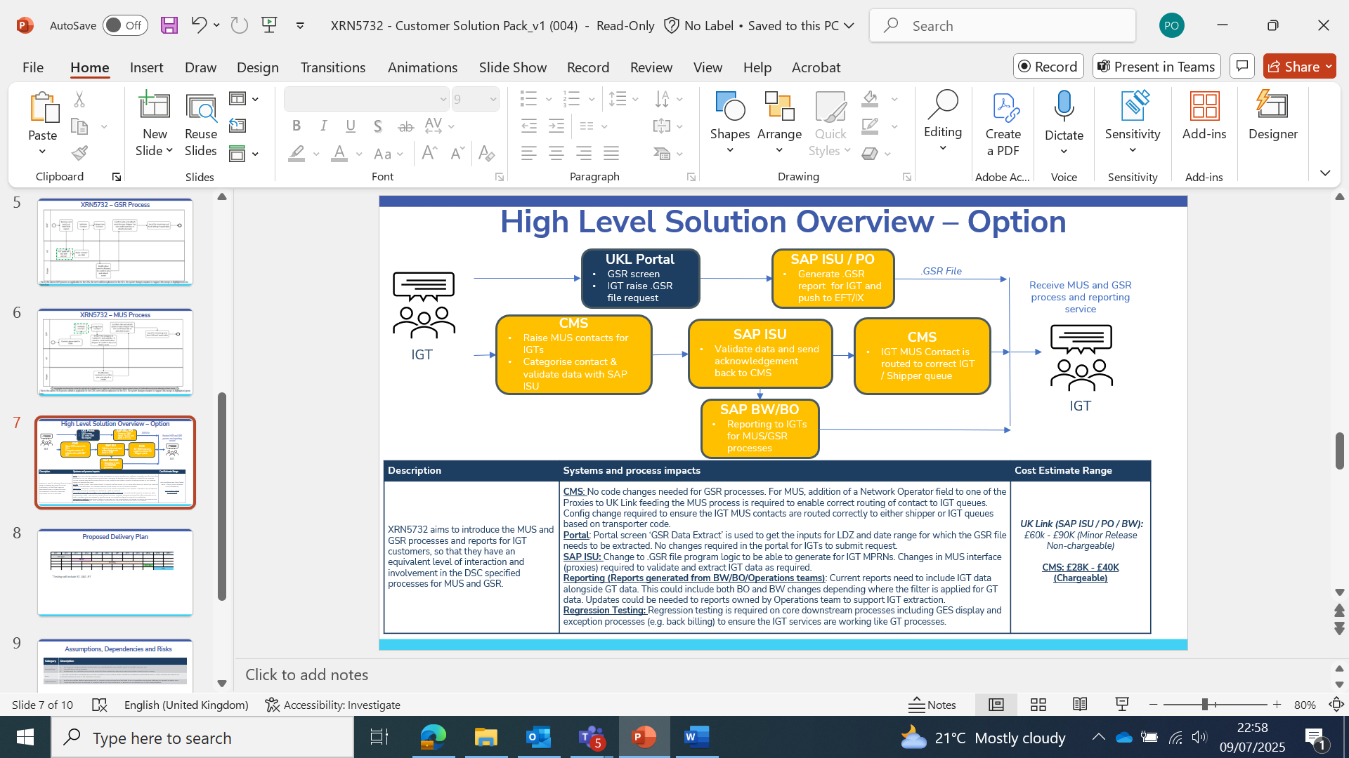  By progressing with the above solution, IGTs would be able to adopt a centralised service which would capture their Gas Safety visit information and use this to retain more accurate registration and meter asset details within the Supply Point Register.  An illustration of the ‘to-be’ process, reflecting the interactions and activities that take place to support GSR and MUS processes is available below;  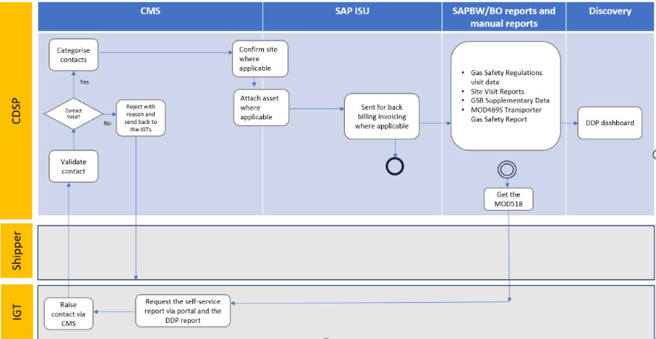  To ensure changes are successfully implemented, onboarding and IGT training sessions will be arranged ahead of go-live, with close monitoring of first usage and service uptake by operational support teams.  Additionally, a Detailed Design Change Pack will be issued, confirming all of the relevant transactions and reports that are to be modified and used by IGTs to support adoption of the service once implemented. This is intended to be produced in September 2025 for IGT review.
Proposed Implementation Date: | TBC - Currently viewed as combined UK Link Minor Release and CMS Release with an approx. 12 week delivery timescale.
Xoserve preferred option:  (including rationale) | N/A
DSG preferred solution option:  (including rationale) | TBC

Service Lines and Funding – for each option
Service Line(s) Impacted - New or existing | Existing DSC Service Line(s) will be extended to IGT parties.  These will remain under the existing Service Areas
Level of Impact | N/A
Impacts on UK Link Manual/ Data Permissions Matrix | N/A  No impacts to the Data Permissions Matrix (DPM) have been identified

Industry Response Solution Options Review
«RangeStart:EDS»

Please consider any commercial impacts to your organisation that Xoserve need to be aware of when formulating your response
Organisation’s preferred solution option
User Contact Details: | Organisation: | «e1_organisation»
User Contact Details: | Name: | «e1_name»
User Contact Details: | Email: | «e1_email»
User Contact Details: | Telephone: | «e1_telephone»
Organisation’s preferred solution option, including rationale taking into account costs, risks, resource etc: | «e1_preferredSolutionOption»
Commercial impacts: | «e1_commercial_impacts»
Customer decision on preferred solution option: | «e1_dsgSolutionOption»
Publication of consultation response: | N/A
Xoserve’ s Response
Xoserve Response to Organisations Comments: | «e2_xoserveResponse»

«RangeEnd:EDS»

Version Control

Document
Version | Status | Date | Author(s) | Remarks
1.0 | For representation | 10/07/2025 | Paul Orsler | For issue

