High Level Solution Options Change Pack

Communication detail
Comm Reference: | 3407.1 - KL - KG
Comm Title: | XRN 5805 - Alternative solution to address instances where VBA macros are present in DN templates
Comm Date: | 18/08/2025

Change Representation
Action Required: | For Representation
Close Out Date: | 02/09/2025

Change Detail
Xoserve reference Number: | XRN 5805
*ChMC Constituency Impacted | Distribution Networks
Change Owner: | Paul Orsler
Background and Context: | Wales and West Utilities (WWU), Alongside other DN customers, have identified an issue with several templates and spreadsheets provided by CDSP to DNs for the purposes of performing various processes. The issue relates to the presence of MS Excel Visual Basic for Applications (VBA) macros being embedded within the related spreadsheets and templates.  This presents an IT security risk to the party asked to accept them, as parties are required to enable VBA macros which is not recommended from an IT security perspective, due the potential dangers of allowing code to run on a device that is hosted on that organisations IT estate. Whilst the code contained within the templates has been evidenced as being safe to use and run, the presence of these protected formulas requires DNs to receive internal approval to deviate from the security standards that would otherwise be applied.  This issue has existed for several months and has created a high degree of customer operational impact and dissatisfaction.  As a consequence, alternative functionality is sought by DNs to remove any VBA macros in place for those related templates and processes.  An illustration of the ‘As-Is’ process has been provided below for context;  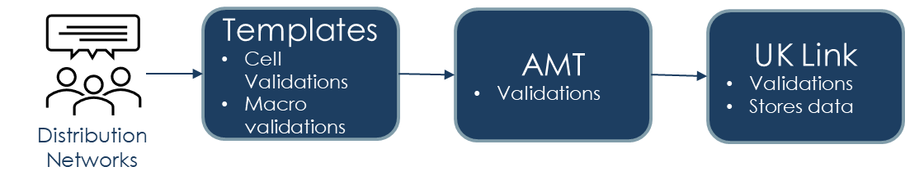

Solution Options
Solution Option Summary: | A variety of solutions have been identified to remedy the issue that has been raised by this change. All of which move away from the incumbent reliance on VBA macros to populate the required spreadsheets and templates, so that the relevant processes can use the data supplied by DNs to operate successfully.  Each solution has called out considerations for DN parties, in the form of both pros and cons, that aim to assist DNs in deciding on a preferred solution.  Solutions also reflect indicative cost estimates, degree of complexity to implement, level of customer impact, and indicative delivery timescales - which will be ratified once the chosen solution has been fully designed and agreed.  The below tables provide a comparison of the solution options that have been assessed with the relevant information against;  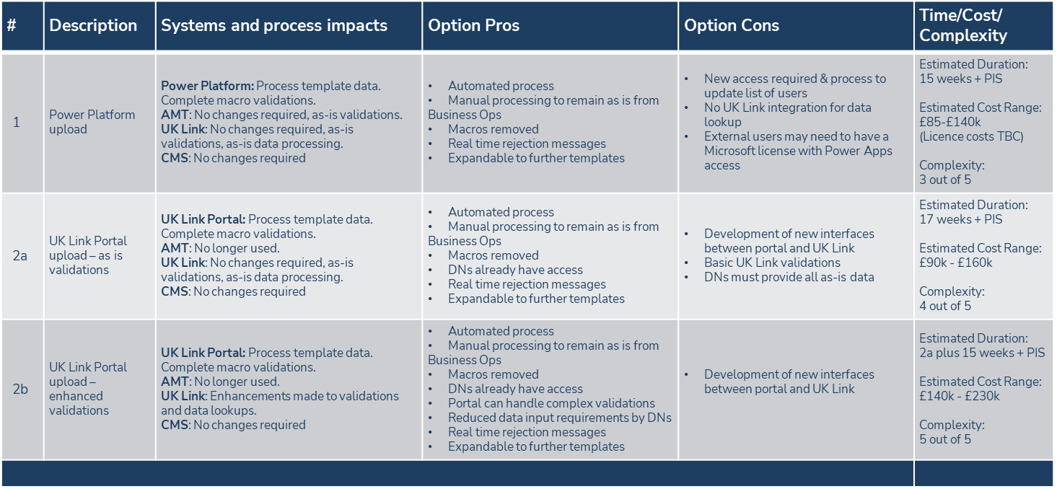  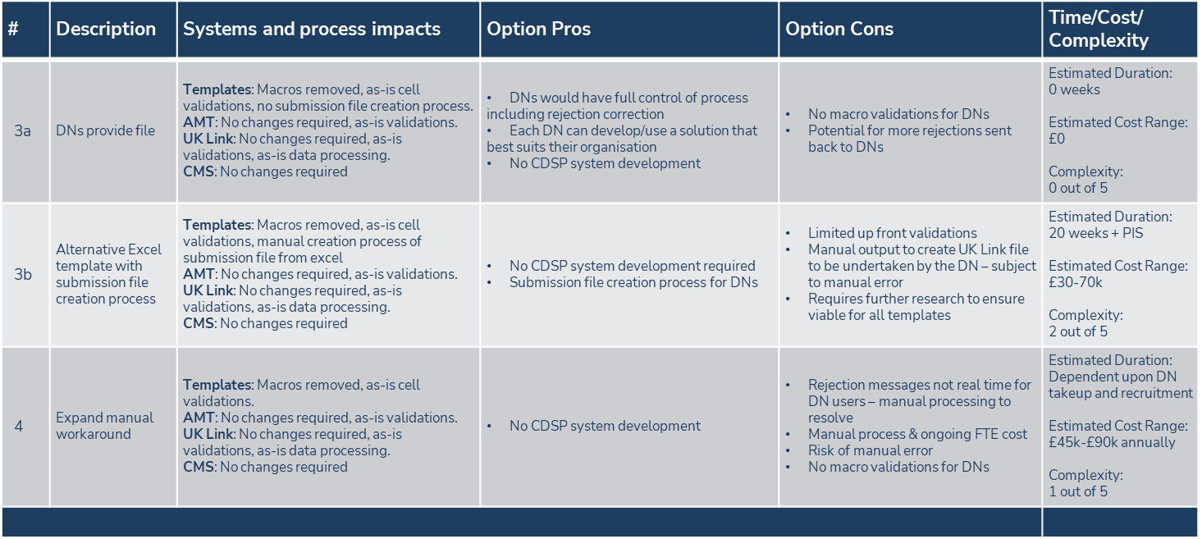  When assessing solutions, it has been confirmed that capability from tools such as Power Platform (Solution 1) would enable a shift away from VBA macros, however these still pose a potential impact to customers as licensing and number of users requiring access to the relevant tools would need to be administered by both CDSP and each organisation. In addition, this option would does not provide any integrated capability with UK Link, which is where the related processes are performed.  With respect to Solution 2, it should be noted that Solution 2a would seek to provide ‘like for like’ functionality using UK Link Portal to replace existing spreadsheets and templates, whereas 2b would look to streamline the processes in such a way that DNs would be able to achieve operational improvements.  With respect to Solution 3a, this places dependency on DNs to provide data in a predefined specification, akin to the way a UK Link File Format would be supplied, so that the process is able to operate without spreadsheets or templates being used, whereas Solution 3b would introduce into the relevant spreadsheets, a set of logic that would enable DNs to generate the proposed files to the required specification.  Finally, a tactical solution (Solution 4) has been assessed. This would introduce enhanced CDSP operational support to manually generate files on behalf of DNs, using the data provided by DNs and processing this through the existing VBA macros spreadsheets.  Further detail on the solution options, included an explanation of the proposed process each would put in place, is available in the attached presentation.  To confirm, the above information has been socialised and discussed with DNs at the August DN Constituency meeting (7th August 2025).
Proposed Implementation Date: | Tbc – dependent on preferred option
Xoserve preferred option:  (including rationale) | N/A
DSG preferred solution option:  (including rationale) | Tbc

Service Lines and Funding – for each option
Service Line(s) Impacted - New or existing | N/A
Level of Impact: | N/A
Impacts on UK Link Manual/ Data Permissions Matrix | N/A

Industry Response Solution Options

Please consider any commercial impacts to your organisation that Xoserve need to be aware of when formulating your response

Organisation’s preferred solution option
User Contact Details: | Organisation: | Northern Gas Networks
User Contact Details: | Name: | Helen Chandler
User Contact Details: | Email: | hchandler@northerngas.co.uk
User Contact Details: | Telephone: | 07580704123
Organisation’s preferred solution option, including rationale taking into account costs, risks, resource etc: | At this point NGN does not have a preferred solution. The initial macros issue did not impact us so we are open to a solution that do not have a significant impact of the current process. We have concerns regarding a UK Link solution and that user access should have a specific "role type" so other screens can not be accessed.
Customer decision on preferred solution option: | approved
Publication of consultation response: | N/A

Xoserve’s response
Xoserve Response to Organisations Comments: | Thank you for your response, this will be discussed at ChMC in September.

Please consider any commercial impacts to your organisation that Xoserve need to be aware of when formulating your response

Organisation’s preferred solution option
User Contact Details: | Organisation: | SGN - Scotland and Southern Gas Networks
User Contact Details: | Name: | Sally Hardman
User Contact Details: | Email: | sally.hardman@sgn.co.uk
User Contact Details: | Telephone: | 07970019027
Organisation’s preferred solution option, including rationale taking into account costs, risks, resource etc: | SGN's prefered solution will be that of 2a or 2b providing an automated process for DN's to interact with via UKLink. We would like to gain a better understanding of how these are likely to work to establish the impact to our business users.
Customer decision on preferred solution option: | approved
Publication of consultation response: | N/A

Xoserve’s response
Xoserve Response to Organisations Comments: | Thank you for your response, this will be discussed at ChMC in September. When a preferred solution progresses through the detailed design phase we will be sure to work with DNs and fully set out how the solution would be adopted by the respective team members.

Please consider any commercial impacts to your organisation that Xoserve need to be aware of when formulating your response

Organisation’s preferred solution option
User Contact Details: | Organisation: | Wales & West Utilities
User Contact Details: | Name: | Tom Stuart
User Contact Details: | Email: | tom.stuart@wwutilities.co.uk
User Contact Details: | Telephone: | 07964937739
Organisation’s preferred solution option, including rationale taking into account costs, risks, resource etc: | At this stage of change development WWUs preference is option 2a, however we would like to request some points of clarity about how the solution would interact with other existing Xoserve systems and whether it could maintain specific functions of existing processes, particularly as several processes would utilise one system.  Our preference is 2a because:  - Interaction with UK Link would improve efficiency  - live on screen rejections would provide a real benefit, and remove the current back and forth to correct errors  - Saves on user authentication development  - Seems to provide the greatest cost/benefit when considering all options  - is there an option for 2b to be considered as a second phase of development if required?  Points of clarity:  - What security would be implemented to protect the portal against threats?  - How would systems such as CMS interact with this system? It is not clear to us whether the portal would be used instead of CMS in some instances  - How might a portal support functionality specific to processes, for example, it’s not currently clear how supporting information provided as part of an RTB submission would be handled.  - User roles should be implemented to restrict unnecessary access.  - Can a portal support submission receipts  - Will a portal have the ability for a user to review and amend submissions  Finally, we think a workshop with SMEs to discuss some of the more detailed process points is necessary.
Commercial impacts: | We do not foresee any impacts
Customer decision on preferred solution option: | approved
Publication of consultation response: | N/A

Xoserve’s response
Xoserve Response to Organisations Comments: | Thank you for your response, this will be discussed at ChMC in September.  We can confirm that the additional features identified within Option 2b can be progressed at a later date, providing option 2a is initially selected by DNs. In terms of security credentials and protection against threats, we will adopt the standards and controls that are in place for UK Link Portal, with access only being authorised and configured based on customers needs. With respect to online, portal Solutions, these create a new front end for the DN user, with any successful requests feeding the relevant systems such as CMS - effectively replacing the current .xls templates in circulation which are supplied to designated box accounts or locations by DN users. With respect to the remaining points of clarification that have been requested, we would look to clarify and develop the solution by working with DNs throughout the detailed design phase once a preferred solution option is selected.

Version Control

Document
Version | Status | Date | Author(s) | Remarks

